Development of a learning outcomes assessment plan for Geological Sciences

Description – a team of faculty and students, working with DAT facilitators, assessed what skills are taught across our major-track curriculum, evaluated how the dominant skills compare to what faculty think are the most important skills to develop, and prepared a plan to develop a long-term, sustainable learning outcomes assessment for the Department’s undergraduate program.

Challenge addressed with this project.
Geological Science has historically avoided any meaningful discussions of content and goals for its undergraduate curriculum. Over the last 30 years, we have enacted 3 revisions of the major requirements, but the discussions never went beyond the titles of courses. We have no history of looking deeper and exploring what we want to do across the major, what we are in fact doing, and whether it was working with respect to student learning outcomes.

Describe desired result.
Desired result is multifold. (1) Determine the skills emphasized across our curriculum; (2) assess if the skills emphasized are aligned with the faculty’s collective intents, (3) evaluate whether skill development is progressive through the major-track curriculum, and (4) develop a long-term learning assessment plan focused on the skills judged most important by the faculty.

Describe the project. What did you do?
- August 2017 - I visited with ~12 faculty colleagues to explain the DAT concept, hear their ideas for a curriculum project, and encourage their participation.
- September/October, 2017- The DAT formed with an initial 8 faculty participants and we discussed possible topics. After 3 meetings (six weeks) we agreed to focus on skills development and their assessment, and the faculty involved stabilized at 6 individuals (ranging from assistant to full professors). Ultimately the focus on skill assessment was driven in response to the ARPAC process that the Department begins next fall. Assessing learning outcomes is a part of the ARPAC self-study that Geological Sciences had heretofore not considered.
- Balance of the fall 2017 term – discussing how to proceed; what limits to place on our efforts, assessing what other geoscience departments were doing for learning outcome assessments, and evaluating the type of validated assessment tools that already exist.
- January, 2018 – one faculty member left the committee due to a conflict with meeting times, and another left due to paternity leave. They were replaced with a new faculty colleague (a discipline-based education researcher), a graduate student and an undergraduate student. The DAT also split into two subgroups – a “skills team” to do the analysis of skills across our curriculum, and a “plan team” to focus on development of an assessment plan. The latter group still hoped to run a pilot assessment in April, 2018.
- February thru April, 2018 - The skills team collected documents on class activities, assignments, homework, and labs from 16 classes. From the course materials we identified 17 separate skills being taught to varying degrees. We hand coded (with good interrater reliability) 8 sets of course materials to document relative frequency of each skills’ occurrence. The graduate student wrote a Python code that allowed us to automatically identify skills in all 16 courses (the code relies on a library of ~400 terms). The automated outcomes match the hand coded results reasonably well, but are not as accurate for 3 skills; thus we consider it to just capture a representative sample of skill emphasis. With those results, we identified the top 6 skills emphasized across the curriculum, the relative emphasis of all 17 skills in individual courses, and differences in skill emphasis in required 2000 vs. upper division electives vs. capstone courses.
- End of spring term – we asked faculty to identify the top 5 skills (of the 17 identified) that they thought most important (good match on 4 of their 5 relative to frequency of skills actually emphasized) and we interviewed two student focus groups to obtain their insight (they identified coding for common computing tools (Python, MatLab, R) as an important skill sought by employers but not in the 17 skill identified in class materials. When this result was shared with the full faculty, a spirited discussion ensued and addressing the problem with a new course was put on the Department’s agenda for 2018-2019.
- A report to the faculty was written and presented at a faculty meeting on May 8th. The report included recommendations on how to proceed with the development of a 4-pronged learning outcome assessment focused on skill development. Faculty voiced strong support and the project will continue over the summer and into the 2018-2019 AY.

Describe the outcome. What worked, what didn’t work, lessons learned.
- Engaging individuals in one-on-one conversations in August laid the groundwork for success. Those conversations insured that there was a cadre of individuals willing to take on the project.
- The DAT facilitators were very helpful in the fall term when we were discussing what to do and how to do it. They insured all voices were heard and that there was no rush to any decisions. They also proposed splitting into teams, which increased efficiency and gave everyone an opportunity to focus on what they thought most important to our efforts. In essence the facilitators helped keep all on board and avoid any potential conflict over differences in opinion.
- That said, there efforts to train us on how to get along got tiresome as it was a solution to a problem that did not exist.
- I also played a significant leadership role in the background, which I think helped insure success. This included bringing on the new additions in January to insure we had the right people for the skills team; nudging all to do the tasks assigned between meetings, and interfacing with the facilitators so that they understood issues related to Departmental culture.
- Everything worked, we just did not get as far as some hoped when we started. Documenting the current state of the curriculum consumed our time and we were unable to draft and pilot a possible assessment tool.

Reflect on your experience in the Faculty Fellows program and working on your project.
- When I applied to be a Faculty Fellow, my goal was to improve my ability to drive change in my Department with respect to our undergraduate teaching mission. I enjoyed and benefited from the 1st year of group meetings, but without the subsequent project the training and expansion of campus contacts would have had minimal impact. The project was what made it all worthwhile.

Condensed version of the DAT project report to the Dept. of Geological Sciences

Department of Geological Sciences Assessment Plan, Undergraduate Curriculum

Vision

The purpose of any learning assessment is to better understand how well the student has achieved specific learning goals for an educational environment, and this assessment plan is designed to help the Department of Geological Sciences evaluate how well we are meeting our goals in educating our undergraduate majors. This assessment plan is intended to provide: a) an opportunity to reflect on curriculum and course goals, instructional methods and expected learning outcomes and b) informative feedback with the goal of improving teaching and learning in courses for the majors.

Background

The structure of the departmental majors follows a trunk-and-branch system (Table 1). The program consists of 1000-level courses that introduce the student to the discipline (Tier 1), a second level (lower trunk, Tier 2) that covers fundamentals of the geosciences plus ancillary math, physics and chemistry, and a third level of upper division coursework (upper trunk, Tier 3) that provides breadth across the discipline. Major requirements are completed using elective, branch coursework from both Geological Sciences and other departments, including undergraduate field modules.

In Fall 2016, the departmental Curriculum committee also assessed the concepts and skills taught in the Tier 2 trunk courses (GEOL 2001, 2005, 2700), with the goal of determining whether the skills and concepts covered in those courses were aligned with the expectations of instructors of 3000- and 4000-level “branch” classes. The results of that analysis are shown in Appendix B, and served as a starting point for the development of this assessment plan.

In the 2017-2018 AY, a committee of seven faculty that represented the breadth of interest subgroups within the Department, plus one graduate and one undergraduate student, self-organized with the purpose of assessing the development of skills throughout the curriculum. The goal was to determine what skills were being developed, ascertain if any courses were particularly focused on any subset of the skills, and evaluate whether there was a progression in skill development from trunk through branch and field courses. The results of that study are detailed in Section 3 below.

Skills and Learning Outcomes in the GEOL major
Students' skills are developed through a variety of opportunities to practice. Instructors may communicate these opportunities to their students verbally or in printed form. Tasked with identifying the skills developed in our major-track courses, the

Table 1. Geology Major Requirements

Tier 1
Any 1000-level GEOL course
(GEOL1010-Exploring Earth; GEOL 1012-Exploring Earth for Scientists; GEOL 1020-History of a Habitable Plant, GEOL 1040-Geology of Colorado, GEOL 1060-Global Change: An Earth Science Perspective, GEOL 1150-Water, Energy and Environment, GEOL 1170-Our Deadly Planet, or GEOL 1180-Microbial Planet)
GEOL1030-Introduction to Geology Laboratory

Tier 2 Lower Trunk Courses
GEOL 2001-Planet Earth
GEOL 2005-Earth Materials
GEOL 2700-Introduction to Field Geology

Chemistry 1 & 2, Calculus 1 & 2, Physics 1 & 2, and Experimental Physics lab

Tier 3 Upper Trunk Courses
One from Solid Earth group
One from Surface Processes group
GEOL 3030-Hydrogeology
GEOL 3320-Geochemistry
GEOL 3410-Paleobiology
GEOL 3430-Sedimentology & Stratigraphy
GEOL 3820-Fluid Earth
GEOL 4060-Oceanography
GEOL 4070-Paleoclimatology
GEOL 4160-Biogeochemistry
GEOL 4241-Geomorphology
GEOL 3010-Mineralogy
GEOL 3020-Petrology
GEOL 3120-Structural Geology
GEOL 3320-Geochemistry
GEOL 3430-Sedimentology & Stratigraphy
GEOL 4130-Geophyics

One from Quantitative group
GEOL 3010-Mineralogy
GEOL 3030-Hydrogeology
GEOL 3820-Fluid Earth
GEOL 4130-Geophyics
GEOL 4241-Geomorphology

Branches, Geology Option Branches, Geophysics Option
Two 4000-level field courses All of the following not used for Tier 3 requirement GEOL 3010-Mineralogy
Additional courses not used for Tier 3 to bring GEOL 3120-Structural Geology
total UD hours to at least 27 credits. Options GEOL 4130-Geophysics
include nearly 60 courses from GEOL or 14 GEOL 4714-Field Geophysics
other departments GEOL 3020-Petrology or 3320-Geochemistry
2nd year Physics & Math sequences
Two additional UD physics or math courses

subcommittee chose to examine printed course materials. The rationale for doing so: (a) printable course materials are often used by instructors to communicate the skills students are expected to learn, (b) printable assignments/exercises are often the main vehicle through which students develop key course-related skills, and (c) the skills that appear in such assignments or exercises are considered representative (not comprehensive) of the skills cultivated in a standard/typical course. In addition, this approach imposed only a small investment of time from our colleagues who were asked to email their course materials to the subcommittee.
To determine what skills are being cultivated in our major-track courses, copies of syllabi, homeworks, in-class activities, and lab assignments were collected for 16 courses, representing major-track courses from the 2000 to the 4000 level. Material from eight of those courses were examined in detail by members of the subcommittee. From their examination of course materials, 17 different categories of skills were identified as per the skills rubric in Table 2. Using the skills rubric, each set of course materials was examined by two or three members of the subcommittee to identify the skills cultivated in each course. A comparison of their independent code assignments showed excellent interrater reliability (i.e., agreement) between these evaluators.

Of these 17 categories of skills, the following were ranked by our faculty, in a departmental survey, as being the top five categories of skills that our undergraduate majors should have by the time they graduate:
(a) scientific approach, (b) interpretation, (c) data analysis,
(d) reasoning, and (e) observation and recording.

Table 2: Skills Rubric
Code | Skill | Description of Skill
1 | Observation & recording | Make and record observations of qualitative and/or quantitative data. Observations are evidenced by describing what is experienced through the five senses (seen, touched, tasted, smelled, and/or heard). Descriptions of observations include: describing states and patterns; comparing/contrasting data, and recognizing/identifying/naming features. Data observations are of the field, specimens, photos, numerical program outputs, and equations.  [Note: Making observations of maps, graphs, tables, figures, is under code #12.]
2 | Data presentation | Use raw data to create graphs, plots, maps, etc.  [Note: This is specific to presenting data. It does NOT include general PPT presentations – use code #7 for that.]
3 | Data analysis | Analyze qualitative and/or quantitative data. Analyses of data include: performing calculations, deriving and explaining equations, and making correlations. Correlations may be statistical, lithological, etc.
4 | Interpretation | Interpret or draw inferences from results of data analyses.  (Example A: The data analysis shows the concentration of dissolved M⁺ decreases over time – one interpretation is that it is being adsorbed to a mineral surface, another possible interpretation is that it is forming an aqueous complex, etc. Example B: A data analysis reveals that the relative of abundance of diatom assemblage A fluctuates with depth – one interpretation is that nutrients varied over time, another interpretation is that the water temperature varied, etc.)
5 | Reasoning | Provide reasoning for a claim. That is, draw on evidence and explain how it supports a claim. This code also applies to instances of spatial reasoning. Examples of reasoning may also include making and explaining a decision, describing one’s logic, justifying why X choice/ option is the best/worst/adjective of possible outcomes/solutions/etc.
6 | Communication | Prepare grammatically correct and properly formatted written reports, annotated bibliography, or more than ~1-page summaries/essays. (Does not include response to any open-ended question.) Deliver polished oral presentations, including PowerPoint presentations.
7 | Professional skills | Exhibit professional behaviors, such as: general participation, punctuality, time management, and quality work. Come prepared (e.g., bring specified materials for discussion, class work, field work, etc.).
8 | Interpersonal skills | Building relationships, collaborating with peers, working in a team/group, group/class discussion, supervising others, leading others, etc.
9 | Specific / Content knowledge | Recall specific facts or content knowledge
10 | Tool use | Use tools such as computer software, field equipment, lab instruments, library resources, etc.
11 | Metacognitive skills | Be self-reflective learner who asks questions like: How do I know what I know? What do I still not know that I need to know? How do I find out what I need to know?
12 | Map, graph, etc. reading | Read or derive meaning from visual presentations of data such as graphs, plots, maps, etc. that are provided.
13 | Scientific reading comprehension | Read scientific text and answer questions about it, summarize it, and/or paraphrase it.
14 | Work with uncertainty and/ or error | Address uncertainty and/or error in data analysis, presentation of data, data interpretation, reasoning, etc.
15 | Synthesis | Use multiple sources of information to create something new, such as: a report, a field guide, etc. [Note a: This does NOT apply to making maps, graphs, plots, etc. – use code #2 for that.]  [Note b: This is does NOT apply to making interpretations or references – use code #4 for that.]
16 | Scientific approach | Pose research question, generate a hypothesis, test a hypothesis, develop a research plan, describe an actual/thought experiment, conduct an actual experiment, and play out a thought experiment.
17 | Drawing/ Sketching | Draw/Sketch a picture, model, diagram, or qualitative graph of some concept, phenomenon, etc. Draw/Sketch the whole thing OR add onto a provided image.  [Note: Code #17 does not involve plotting or working with data – use code #2 for that.]

On the basis of the hand-coding, a library of ~400 key terms that correspond to specific skills also was compiled. With this library of terms, the graduate student member of the subcommittee developed a Course Material Auto Coder (CMAC) algorithm with Python. The CMAC was then used to characterize the skills represented in all class materials for the 16 courses for which data was gathered (the code will also allow other classes to be added to the data base over time with minimal effort).

A comparison of results based on hand coding versus automated coding shows that both approaches identify skills 1 to 6 as the most persistent across the curriculum (Fig.1). Four of the five skills highly valued by faculty are within those top six identified in the CMAC results. The notable exception is development of the scientific approach (skill 16), which rarely appears in course materials. This disconnect may result because students are asked to pose research questions, make hypotheses, design experiments, etc., in ways that were not recorded in printable materials (i.e., they were given verbal instructions in class to carry out these activities).

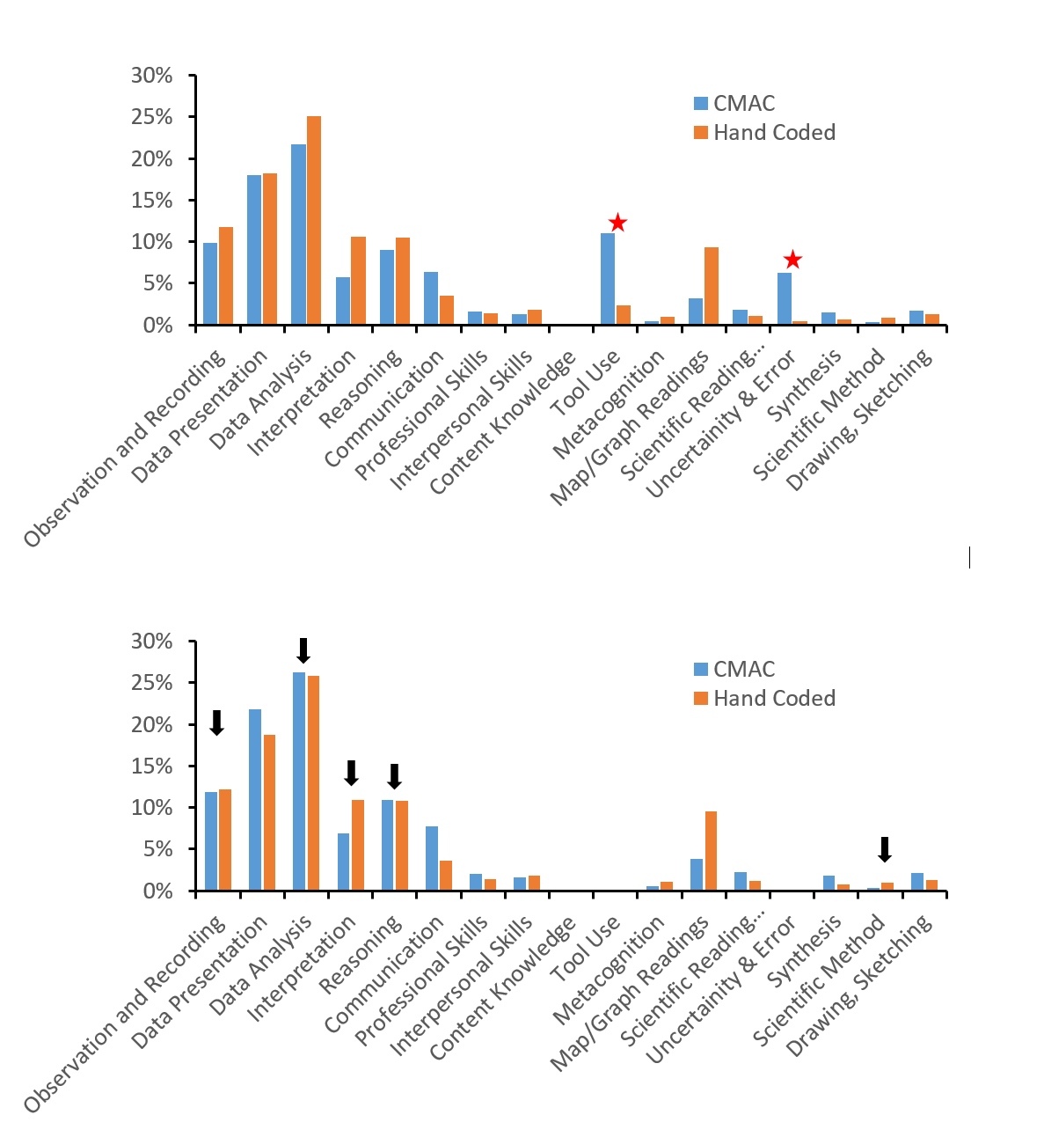
Figure 1. TOP: Comparison of relative proportion of skill development in eight courses hand coded and those coded using the CMAC automated process. In neither case were content knowledge included. Two skills with large discrepancies (red starts) are probably the result of hand coders counting a skill once (e.g., assignment uses tool X) whereas the CMAC recorded each occurrence of “tool X” throughout the assignment. BOTTOM: Same data but renormalized after removing the two skills with red stars in the top figure. Arrows denote the five skills most highly valued by faculty.

There are differences in skills practiced between individual classes (Appendix D). However, based on the automated coding of all 16 classes, we found evidence for only a slight progression in which cognate skills dominate at the 2000 level versus the 3000/4000 level (Fig. 2). The most notable difference is less observing and measuring. There are more differences in non-cognate skills.
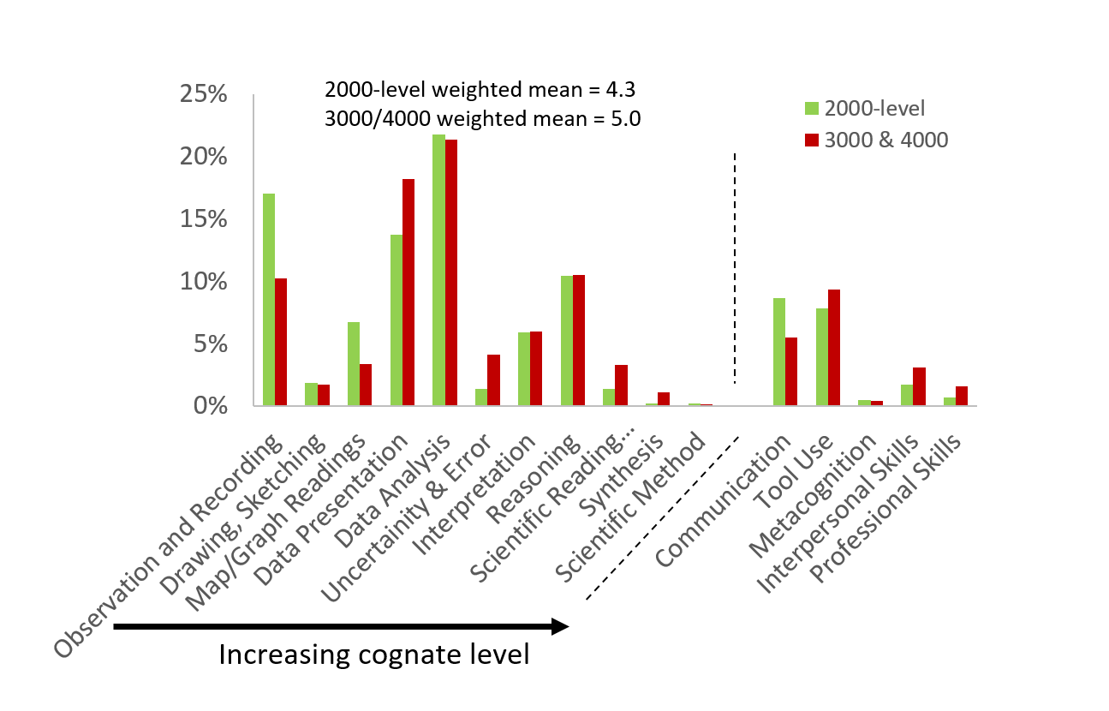
Figure 2. Comparison of skill emphasis in 2000-level truck courses versus upper division, 3000- and 4000-level courses (including 4000-level field courses). The cognate skills are arranged from those representing lower cognate level (1, left) to highest cognate levels (11, right). Less emphasis on observing and measuring in the upper division courses results in a slightly greater weighted mean skill level in upper division courses. The five skills to the right of the dashed lines are non-cognate skills and are slightly more persistent in the upper division courses.

Assessment Goals & Methods

The committee’s next step is to develop an assessment(s) of the development of students’ skills as they matriculate through the geology program. The categories of skills that will be the focus of the assessment(s) will be informed by the faculty’s “top 5” and will be selected based on the criteria that all courses in the major teach these skills to some extent, recognizing that the specific tasks or exercises vary between classes. In addition, we expect that successive courses will build on those skills taught in earlier classes at a less sophisticated level.

The overarching goal of an assessment plan is to implement an integrated program designed to help this department evaluate how well we are meeting our goals in educating our undergraduate majors in the skills detailed in Table 2. We aim to quantifying the development of those skills in our students as they progress through the major and provide ongoing feedback with the goal of improving teaching and learning in courses for the majors.

The committee recommends that a suite of assessment tools be used to determine both the current status of the effectiveness of skills instruction and the progression in improvement of those skills as the students’ progress through the major. Possibilities include the following:
  - In-course exercises designed to track skills through specific courses in the major.
  - Evaluation of capstone courses and products.
  - Exit surveys and/or interviews, offered every year.
  - A specially designed assessment tool to be administered in a specific set of majors courses every year.
The goal is to produce a data set that provides evidence detailing how well the students in the major are learning the relevant skills both as they travel through the major and how that is changing with time, as the department modifies and focuses its curriculum.
During the development of this assessment plan, it was determined that no existing, off-the-shelf assessment tools exist that will meet the goal of assessing the skills of the students as they progress through the major, nor can we assess how we, as a faculty, are improving those learning outcomes as we modify courses and curriculum. As a result, a number of different tools will need to be developed to meet 4(a) through 4(d), above.
The exercises in (a) will be designed in future years and integrated into a set of courses chosen based on the general path through the major. Evaluation of capstone course products, including selected exams and essays, will be evaluated every year, as will exit surveys and/or interviews which, again, will be designed and implemented in future years.

Development timeline

Summer 2018:

1. An assessment development team will meet over the summer, with Departmental Action Team (DAT) facilitation. The summer team should include graduate students on hourly appointments through the department and one or more faculty members. The team will review the literature to learn what makes assessments effective; draft an assessment(s); and develop a proposal for how, when, and to whom the assessment(s) will be administered.
2. Identification of faculty assessment coordinator (see section 5 below).

Fall 2018 – Spring 2019:
Implementation of first complete round of assessment.
End of summer 2019:
Evaluation of first assessment

Future Sustainability

To ensure that the procedures and goals outlined in this proposal are maintained and improved as part of an ongoing program, resources in the form of personnel and organizational support must be allocated to these efforts. It is recommended that one faculty member be assigned the oversight of this program as part of their teaching duties. In the early stages (Fall 2019-Spring 2019), an ad hoc committee should be formed to assist with the development of new assessment tools and their evaluation. Ideally, some or all members of the summer assessment development team will be willing to serve on this ad hoc committee. In the longer term, a designated faculty assessment coordinator will oversee the activities listed in Section 4 on a regular basis, with the assistance of designated office staff. S/he also will ensure that feedback on the assessment results is communicated in a clear manner to both individual instructors and the faculty overall.

Recognizing that this will involve considerable effort in order to organize and manage this effort, it also is recommended that special consideration be awarded that individual, most likely in the form of reduced teaching load; i.e. the management of this assessment program would correspond to one half-course per year of teaching credit.

It is recommended that the department investigate partnering with other organizations at the University of Colorado Boulder to assist with the development and implementation of the tools listed in Section 4, above. This includes, but is not limited to, the Center for STEM learning, the Outreach and Education team at CIRES, and OIT’s Academic Technology Design Team (ATDT).

Appendix A.
Examples of skills practiced in individual upper division courses. See Table 2 for key to skills (data from hand coding; content specific skill 9 excluded).

