Faculty Fellows Project Report (Karnauskas)

ATOC Data-Driven Learning Library

Brief description: The ATOC Data-Driven Learning Library (DDLL) is a virtual library of discipline-specific modules, ready for integration into the classroom. “Like a closet full of physics apparatus, but for data and models.”

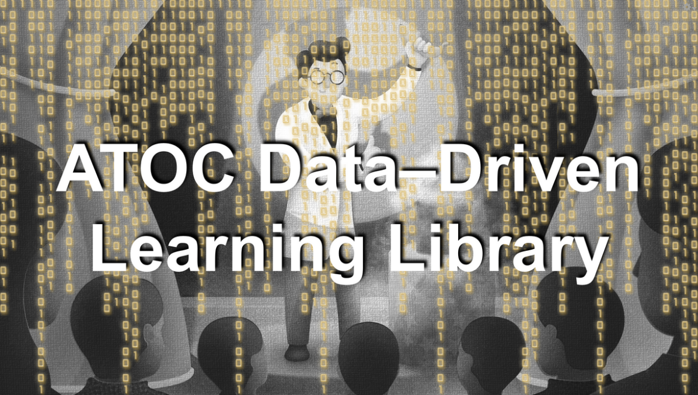

Describe the challenge you addressed in your department with this project.

Many ATOC faculty members have specific expertise and familiarity with research-quality observational data sets and Earth system models that have successfully translated into teaching tools or materials for their classrooms.

Technology plays a major role in the field of atmospheric and oceanic science. This is especially true in our research. The breadth of climate research conducted by ATOC faculty and students involves space-based satellite measurements, remote in situ observing technologies such as AUVs (autonomous underwater vehicles) in the ocean and UAVs (unmanned aerial vehicles) in the atmosphere, comprehensive global data sets, one-of-a-kind instruments, and state-of-the-art numerical models of the weather, marine ecosystems, climate change, and ocean currents.

There are ~15 T/TT faculty members in the ATOC department, yet the number of courses we offer is considerably more than 15. Therefore, while each of us certainly have “favorite” courses that perhaps grew out of our own research expertise and competencies, and individual faculty members may teach them regularly, we do rotate classes around quite broadly among faculty members. Most of us already leverage cutting edge research and bring the associated technology into the classroom. Since most of us are also world class researchers and leaders in our particular discipline, this is an enormous intangible benefit to the students.

However, the data sets, models, and technology that each individual faculty member decides to bring into their classroom is driven by what they are already familiar and comfortable with themselves. Whether high or low tech, our research technologies are highly discipline-specific and there are usually only one or two faculty members who know what they’re doing with any one of them. Given how busy faculty members are, it is a daunting prospect to take up the task of learning enough about other tools and technologies used by our departmental colleagues to feel comfortable actually using them in practice and integrating them into our own classrooms.

Describe (desired) result.

The modules served on the DDLL, contributed by faculty and curated by the Technology Committee, are designed to be readily accessible to any faculty member teaching the same or similar courses so that all students may benefit from the full breadth of expertise on the ATOC faculty, independent of who is the instructor at the time.

The modules are not complete lesson plans, which would be more prescriptive than the intent of the DDLL. The modules are meant to be a kernel, upon which an instructor can overlay a lesson plan, homework assignment, in-class activity, lab/recitation exercise or even semester project.

Describe the project. What did you do?

I worked with multiple colleagues in my department to generalize one of their favorite exercises into an online module that should be accessible by any other faculty member. After a brief consultation with the faculty members, during which we determined what data sets and what types of ways the students can interact with them, I worked to ensure that the online modules are entirely self-contained, providing all of the necessary data, code and pedagogical suggestions. I also populated a set of metadata to facilitate their selection and appropriate application.

Describe the outcome. What worked, what didn’t work, lessons learned.

Whether or not this outcome will be successful will be determined over the next several years. I will make sure the faculty are aware of this resource; I will periodically and informally ask whether it is being used, and try to add a couple of modules per semester. The more people contribute, the more useful it will be to all.

Reflect on your experience in the Faculty Fellows program and working on your project.

My experience in the FFP was well worth the time investment. My cohort of Faculty Fellows and the FFP leaders assisted in proposing an achievable and useful project that addressed my overall goal of increasing the use of research-quality data and technology in the undergraduate classrooms, in particular those relevant to our newly launched major.

If appropriate, please include other artifacts and visuals (data, weblinks, pictures, write-ups)

https://www.colorado.edu/atoc/ddll

Example module appropriate for all undergraduates:

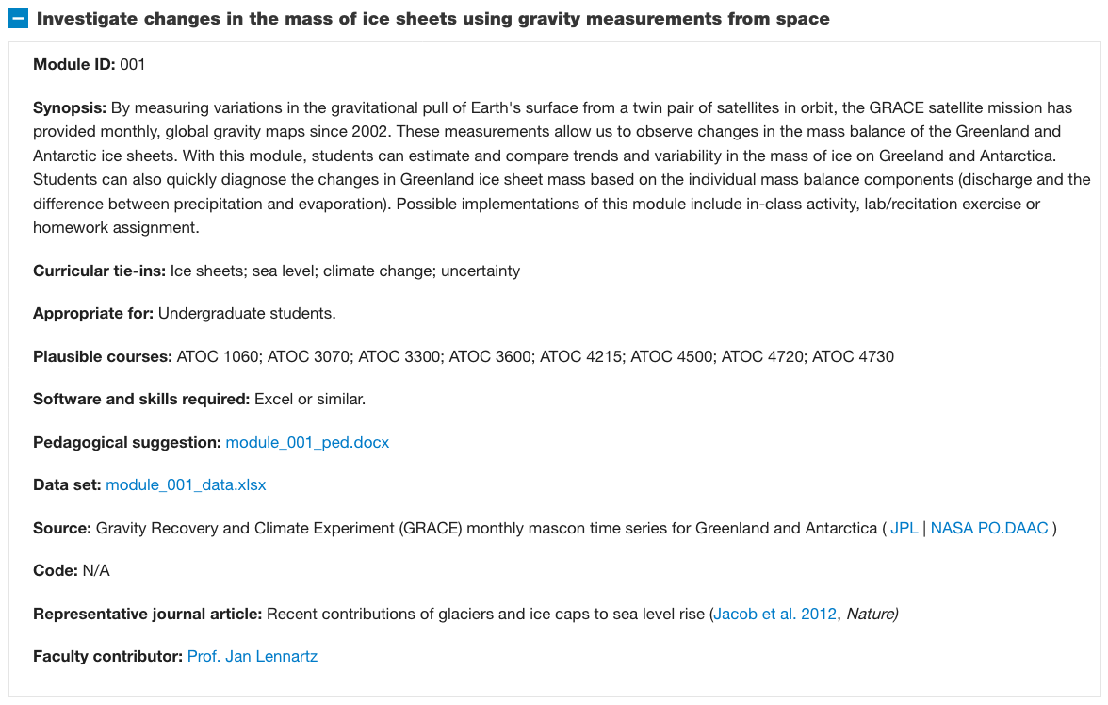

Example module appropriate for advanced undergraduates and graduate students:

