Accessibility Checker Practice Document
There are two purposes to this document: one, it will provide a space to practice manually catching accessibility issues in a document, and two, it will demonstrate how automated accessibility checkers often fail to catch all the issues in a document.
This document assumes you know the following 5 accessibility best practices:
- Use heading styles and avoid skipping heading levels
- Don’t use visual style to convey meaning
- Ensure sufficient color contrast using a color contrast checker
- Provide appropriate alt text for images
- Use descriptive link text
For an overview of these five best practices, consult our Understanding Word Accessibility resource.
Are you ready to get started? Great! Let’s begin.
Note: This document should be opened in the Word desktop app.

Running the Automated Accessibility Checker
First, run the automated accessibility checker in Word. You can do so on both Mac OS and Windows by navigating to the Review tab in the ribbon, and then selecting the Check Accessibility button. This will run the checker.
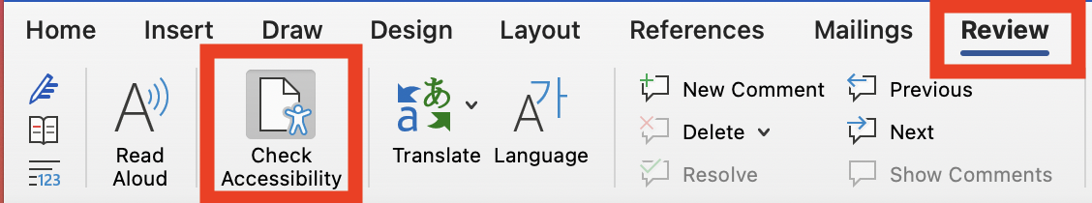
Did the accessibility checker come up with any errors? No? There are at least five accessibility errors in this document that the checker has not caught. Try checking the document manually for any accessibility issues! Read through this document for some tips along the way.

Check the Heading Styles and Don’t Skip Heading Levels

Check Heading Styles
Do all headings have a heading style applied? Headings shouldn’t just look like headings (with bold, larger text, different font etc.); they also need to have a heading style applied in Microsoft Word in order to be read properly as headings by assistive technology. You can add a heading style by opening the Styles Pane in Word.
If you’re on a Mac, to open the Styles Pane:
- Select the Home tab
- Select the Styles Pane button.
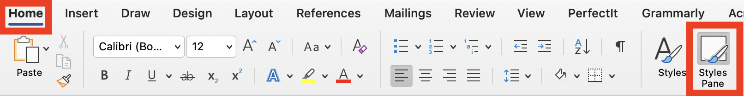
Tip: Select the Show styles guide checkbox on the Styles Pane to display all the styles in the document.
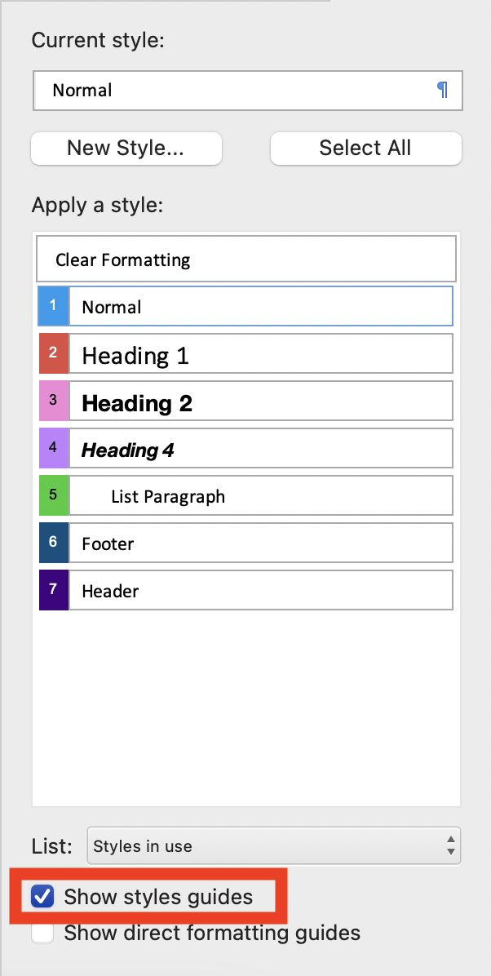
If you’re on a PC, to open the Styles Pane:
- Click the Home tab
- Find the Styles section
- Select the pop-out arrow button in the bottom right corner to open the Styles Pane.
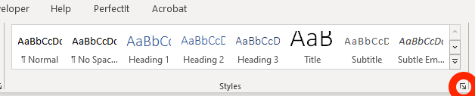
On a PC, there is no style guide to view all your heading levels in the document at once. Instead, to determine whether a heading style has been applied to a particular piece of text, select the text and then check which heading level is selected in the Styles Pane. The Navigation Pane also displays heading levels.

Check Heading Structure
Every heading is assigned a numerical level from 1-6 to indicate its relative importance or scope compared to other headings on the page. Heading level 1 is the broadest topic, heading level 2 should be applied to the main sections of the page, and so on. You should only increase the heading level by 1 when you are moving from a broader section into a subsection. Never skip a level by nesting a Heading 4 directly beneath a Heading 2, for example. For more on headings, click here.

Don’t Use Visual Style to Represent Meaning
“Visual style” refers the use of any of the following:
- Italics
- Bolding
- Underlines
- Punctuation
- Spatial positioning or text spacing
- Colors
You can of course use visual style in your document (as we have in this one!), but visual style should never be the only way that you are conveying meaning.
For more information on the accessible use of visual style, click here.

Check for Sufficient Color Contrast
Color contrast refers to the contrast between the background color and foreground color of digital content. Use a color contrast checker to determine if the color contrast is sufficient. Remember from our color contrast newsletter that the Web Content Accessibility Guidelines (WCAG) establish minimum ratios of contrast for small and large text. Aim to pass the WCAG AA requirements for your text size. A color contrast checker will tell you if the contrast is sufficient to meet these requirements.
Check for Alt Text in Images
All images in this document should have alt text. Alt text (or alternative text) should be a short, concise description of the meaningful content in the image. It should not be longer than 1 or 2 sentences. To check if an image has alt text, right-click the image and select Edit Alt Text.
Word’s automated checker will notify you if there are images missing alt text or if an image has auto-generated alt text, which is often inaccurate. However, the automated checker will not evaluate the quality of the alt text. This means it only checks to see if text is present, but it does not have the functionality to determine if the alt text describes the image appropriately or not.

Use Descriptive Link Text
We wrote a newsletter on How to Make Link Text Accessible a while back, but as a refresher, below are some examples of good and bad link text. Bad examples are red and good examples are green.
To read more about link text, click here.
Read the How to Make Link Text Accessible newsletter.
Read this newsletter about link text or this other source about link text.
Read the How to Make Link Text Accessible newsletter. Or, for more information, read the Content Fundamentals Link Text article.
Read the newsletter on link text: https://www.colorado.edu/digital-accessibility/newsletter/accessibility-minute-september-2020
Read the How to Make Link Text Accessible newsletter.
Read this PDF on CU Boulder Campus Standards for the Accessibility of Information and Communication Technology Plan.
Read this PDF on CU Boulder Campus Standards for the Accessibility of Information and Communication Technology Plan.

Bonus Accessibility Issue!
Did you check the color contrast of the header and footer images in this document?

