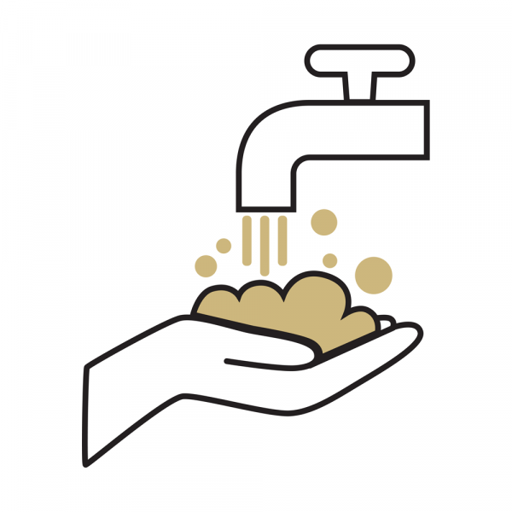

COVID-19 Operational Risk Mitigation Plan

Cleaning, Disinfecting & PPE

General Hygiene Principles

All students, faculty, staff, and visitors should continue to wash and disinfect their hands with the increased vigilance expected from everyone since the start of the pandemic. Frequent hand washing, combined with wearing face masks or coverings, social distancing, and self-isolating when feeling ill, remain the most impactful methods for reducing the risk of spreading and contracting COVID-19.

Changes to Current Cleaning Practices

Under the supervision, organization and financial support of campus—and in coordination with building proctors—custodial cleanings will increase to twice-a-day (from the current once-a-day service) for high-touch and certain common space areas (e.g., main entry door handles, elevator buttons, stairwell railings) come the start of the Fall 2020 semester. This may vary by building; building proctors are encouraged to consult with their Facilities Management Program Manager assigned to their building.

Common areas, restrooms, and classrooms will continue to be deep cleaned by custodial services only once per day in the evenings.

Campus is standing up a bottle exchange program to provide free disinfectant spray for those areas in buildings that may not be cleaned by custodial staff and/or will not be near disinfecting wipe stations.

Individuals are responsible for cleaning the interiors of their office or workspace surfaces [in open office environments], including their office door handles, and are encouraged to do so at least on a daily basis.

Drivers of campus vehicles will accomplish the following:
Follow all safety protocols outlined for other staff (e.g., hand hygiene, cloth face coverings);
- Clean and disinfect vehicles in accordance with CDC guidelines at the beginning and end of each shift

