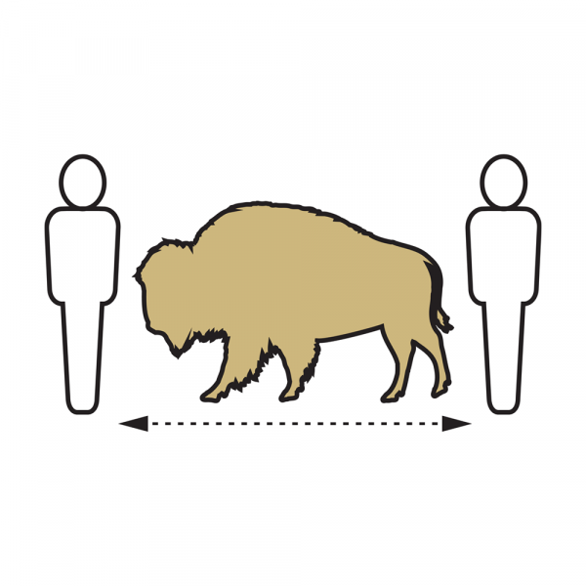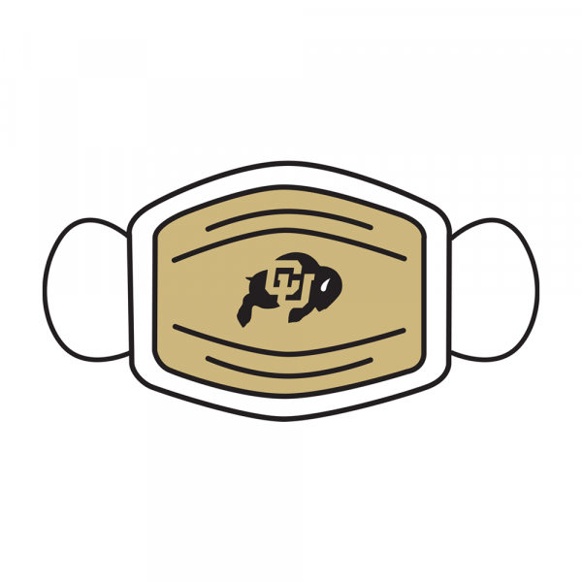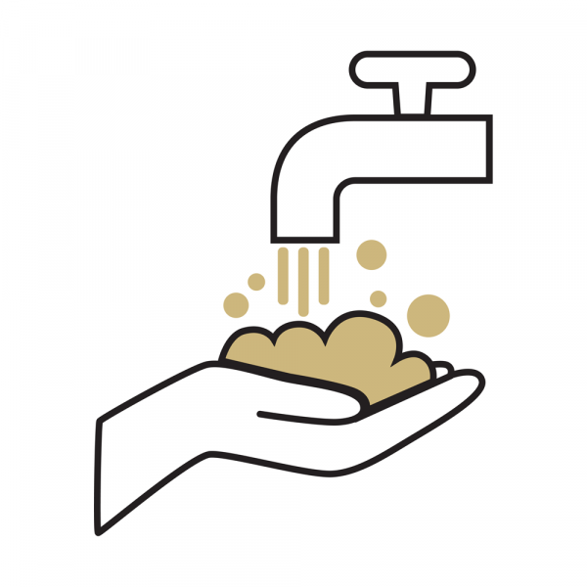



**COVID-19 Operational Risk Mitigation Plan**

**Engineering Controls**

***Reconfigure or remodel labs, office spaces, reception & waiting areas, classrooms and common spaces***.

* Classrooms will follow the 8’ octagonal spacing requirements to ensure proper social distancing.
* If possible, remove enough seating from reception, waiting and common areas to promote proper distancing.  If removal of the seating is not possible, install signage designating seats to be occupied/unoccupied.
* Seating within office spaces housing multiple occupants should be configured to meet the 8’ octagonal spacing requirements.

***Post signage for traffic flow and occupancy***

* Signs will be placed to guide occupants as they enter, travel through, occupy and exit buildings.  Common areas such as entry doors, corridors, lobbies and elevators will have signs with reminders of safe practices.
* Building occupants moving through corridors should stay to the right and avoid congregating.

***Install Plexiglas barriers where appropriate***

* Barriers will be installed at customer service desks and points of sales to minimize contact. Campus has furnished and installed barriers at locations within the Engineering Center, ATLAS, Aerospace building and JSCBB.
* Barriers should be cleaned and maintained by the primary users.

***Identify areas that can remain closed off or partitioned***

* Gravity’s south café (near the ECCR wing) will remain closed during Fall 2020.  Other cafes will be open, serving grab-and-go items.

***Manage pedestrian traffic flow into and out of facilities/buildings to reduce risk***

* Circulation signage will be furnished by Campus. Building managers should work with the project manager to arrange for labor to install the signage.

***Consider adapting larger spaces to create to work areas that accommodate physical distancing***

* Larger spaces designated as work areas will be configured to allow the minimum 8’ octagonal spacing.  Consult with your designated Facilities Management project manager for assistance.