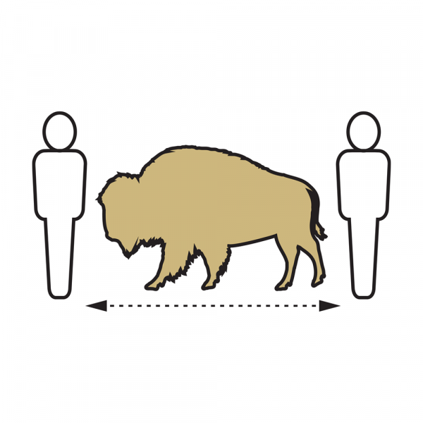

COVID-19 Operational Risk Mitigation Plan

Social Distancing

For campus guidelines on social distancing see the Protect our Herd website.

Wear a face covering
Wear a face covering to help protect others in case you’re infected with COVID-19 but don’t have symptoms.
Use Physical Distancing
We’re a community that looks out for each other. Together, we will engage in physical distancing practices and also support our peers and colleagues in this practice.
- Physical distancing and limiting face-to-face contact with others is the best way to reduce the spread of COVID-19. Keeping at least 6 feet apart is one of our best tools to stay healthy.
- Follow signs that direct traffic flow in hallways and stairwells.
- Follow capacity limits for campus transportation and buildings.
- Follow elevator signs for capacity. Board an elevator only if you feel comfortable with occupancy.
- Eliminate physical contact (skip those introductory handshakes).
Keep Hands Clean
Handwashing is a powerful prevention tool and is even more effective when combined with additional protections like wearing a face covering.
Keep Spaces Clean
We’ll clean and disinfect high-traffic, high-touch areas frequently. You can help by cleaning your own space and keeping common areas clean.
Cover your cough or sneeze
- Cover your mouth and nose with a tissue or use the inside of your elbow. You should cover your face when sneezing or coughing, even if you are wearing a face covering.

Building Access Policy
Any individual entering a CU Boulder building is required to:
- Complete a Health Questionnaire prior to coming to campus and/or entering any building.

