Experimental Study of Microwave Heating in Mixed Waste Materials
Jack A. Molles¹, Megan C. Robinson¹, and Zoya Popović ¹
¹University of Colorado, Boulder, CO, USA
Keywords: power combining, solid-state power amplifiers, heating, mixed waste
INTRODUCTION
Pyrolysis, defined as “the thermochemical decomposition of organic material at high temperature and in the absence of oxygen or in an atmosphere of inert gases”, has been investigated for feasibility in the municipal solid waste (MSW) sector, where convection-based heating methods for a wide variety of materials have been used [1]. Limited work with microwave heating has shown improvement in thermal efficiency, increased speed of reactions, and, in some cases, advantageous modifications of the breakdown process when used for pyrolysis [2]. Previous work has described simulated and measured heating of a uniformly loaded cylindrical cavity, with power delivered from one or two GaN solid-state power amplifiers (SSPAs) driven with a variable relative phase [3]. This paper discusses experimental results using loadings consisting of various mixtures of food waste materials. We show that spatial power combining offers increased uniformity of heating throughout the cavity volume compared to circuit combining, despite the changes in mode distribution due to non-uniform electrical properties in the load.
methOdoloGy
The purpose of this work is to investigate microwave heating of mixed waste volumes using the experimental setups shown in Fig. 1. We present a 1.4-L cavity loaded with several different waste mixtures heated with two 2.45-GHz 70-W efficient SSPAs using both circuit combining with an impedance tuner and spatial power combining. To investigate the effects of nonuniform waste materials on heating, measurements are performed for three mixed food waste scenarios: (1) three materials (meat, bread, and paper) layered vertically, Fig. 2a; (2) two materials (meat and bread) layered radially, Fig. 2b; (3) various food waste random mixtures, low ε_{r}, (coffee grinds, paper, oats), medium ε_{r} (coffee grinds, paper, oats, bread), and high ε_{r} (paper, bread, meat), fully filling the cavity, Fig. 2c.
The measurements are performed with approximately 120W of total applied power (taking reflection into account) obtained from about 65% efficient GaN SSPAs. The temperature within the cavity is monitored near the top and at the center of the loaded cavity using thermocouples.
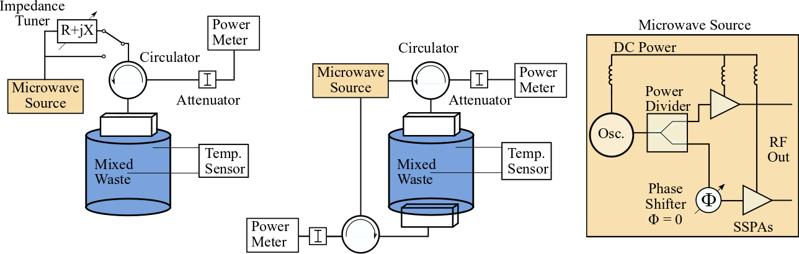
(a) (b) (c)
Figure 1. Simplified schematic of microwave heating cavity showing setup (a), a single port excitation with an impedance tuner and setup (b), a two port excitation used for spatial power combining. (c) Block diagram of SSPA microwave source.

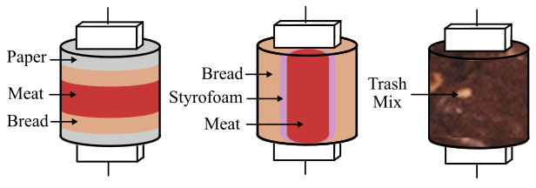
(a) (b) (c)
Figure 2. Diagram showing three different cavity loading cases: (a) vertically layered paper, meat, and bread; (b) radially layered meat and bread with styrofoam separator; (c) mixed waste vith
variable relative permittivity.

RESULTS
The results for cases (1) and (2) are shown in Fig. 3a and Fig. 3b, respectively. These measurements show that the temperature at the top thermocouple is heating faster with the circuit power combining and a single-probe feed than with dual-feed spatial combining. However, spatial combining heats the center portion of the waste volume significantly faster, as shown by the more uniform temperature in the center and top of the cavity. Notice that the temperature difference between the two thermocouples is reduced in Fig. 3b for the circuit combined case. This is likely due to the slower heating rate because in this case the lossier meat loading is located directly below the excitation.
In case (3), the cavity is filled with low, medium, and high permittivity mixtures. Two sets of measurements are presented: one with a single feed with an impedance tuner (Fig. 4a); and the other with two feeds and phase adjustment for best match (Fig. 4b). Similar to the cases presented in Fig. 3, spatial power combining demonstrates better heating uniformity compared to a single-port excitation, with the exception of the low-permittivity mixture case.

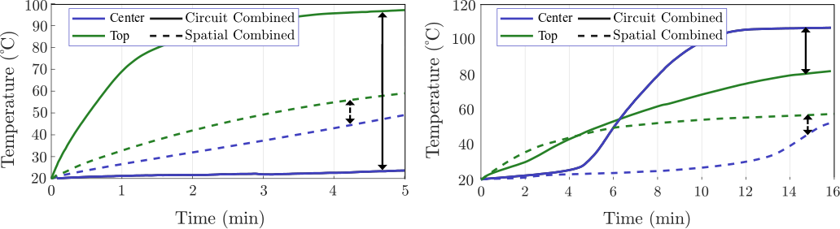
(a) (b)
Figure 3. Measured temperature change over time for top and center thermocouples using (a) vertically layered loading shown in Fig. 2a and (b) radially layered loading shown in Fig. 2b.

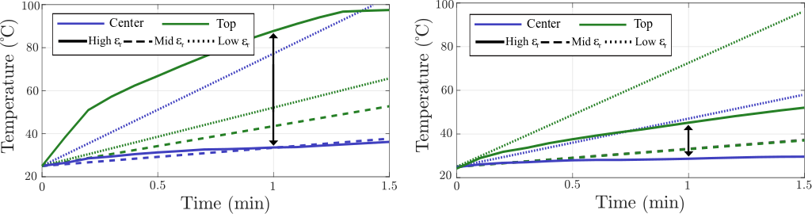
(a) (b)
Figure 4. Measured temperature change over time for top and center thermocouples using (a) circuit combining and (b) spatial power combining for low, medium and high ε_{r} loadings.
DISCUSSION
Measurements show that spatial power combining provides increased heating uniformity compared to circuit combining using an impedance tuner to match to mixed waste loadings with variable and non-uniform dielectric properties. However, there is not a significant difference between the two methods of power combining for a low ε_{r} loading, likely due to the increased coupling between feed ports and larger penetration depth.
Conclusion
It is found that spatial power combining of SSPAs improves uniformity of microwave heating when the heating cavity is loaded with nonuniform mixed food waste.
REFERENCES
- Czajczyńska, D., Nannou, T., Anguilano, L., Krzyżyńska, R., Ghazal, H., Spencer, N. and Jouhara, H., 2017. Potentials of pyrolysis processes in the waste management sector. Energy Procedia, 123, pp.387-394.
- Fernández Díez, Y., Arenillas de la Puente, A. and Menéndez Díaz, J.Á., 2011. Microwave heating applied to pyrolysis. InTech.
- Robinson, M., Yakovlev, V., Popovic, Z., “Experimental and computational study of microwave heating in single-stream waste processing,” IMPI 2021, Savannah, June 2021.

