INTERNET AIRFARE PURCHASE PROCEDURES

Quotes for international travel have to be provided by a CBT agent as employees to not have access to international quotes in Concur.

Domestic quotes can be pulled in Concur, there are a couple ways to do this.

* Print/email options
  1. Run a search for flights that match the criteria of the internet options
  2. At the top of the screen, click “Print/Email” to email the list that can be added to the expense report.

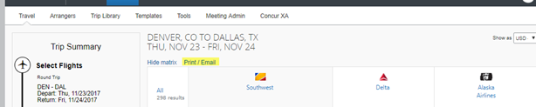

* 1. Once the email is received be sure the dates/times/pricing show on the emailed options.
* Screen shot
  1. Run a search for flights that match the criteria of the internet options
  2. Once you have the dates and times selected, take a screenshot that shows all the information that needs to be documented: 1. Travel Dates and 2. Times within an hour of internet option.
  3. 