Guide to Pre-Processing Using SCI Software
In this guide we will go over how to:
- Create geometry including walls, inlets and outlets;
- Define the mesh;
- Create the input.cfd file.

- Begin by opening SCI_FFD.exe. SCI will open.

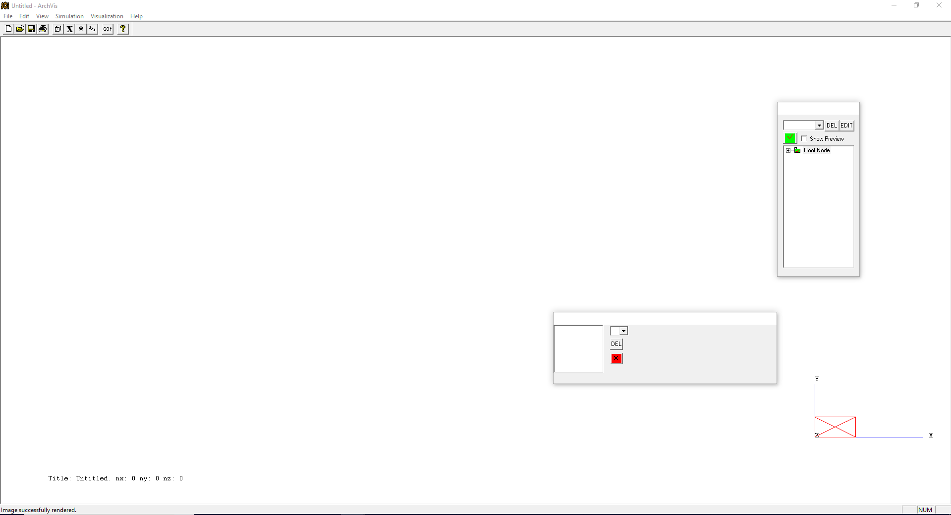

- Start by adding six new boundaries that will be the walls. Select “Root Node” in the tree, click the drop-down menu above it and select “New Boundary.” An untitled boundary will appear in the tree under “Root Node.” Repeat this five more times to add a total of six boundaries.
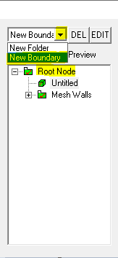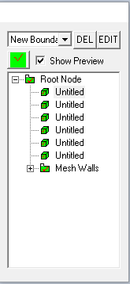
- To name a boundary, click on its current “Untitled” name in the tree so it is highlighted, then click on it again. When it looks as shown below on the left, its name can be edited. Name the six boundaries “North,” “South,” “East,” “West,” “Ceiling” and “Floor.”

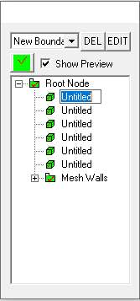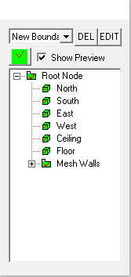

- To edit a boundary, click on its name and select “EDIT.” Start with “North.”

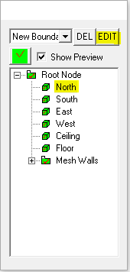
- In the drop-down menu it shows the default boundary as “Blockage.” Click on this drop-down menu and change it to “Wall.” The next step is to define the dimensions of this wall. The overall domain of all the geometry will be a box 1 m x 1 m x 1m. The “North” wall will be in the y = 1 plane, so the starting and ending Y values will both be 1. The X and Z values will both start at 0 and end at 1. After inputting these values, select “OK.”

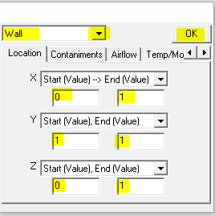

- Repeat this with the remaining five walls as shown below. The “North” and “South” walls will be in the X-Z plane; the “East” and “West” walls will be in the Y-Z plane, and the “Ceiling” and “Floor” will be in the X-Y plane. The images below and on the following page are ordered as: “South,” “East,” “West,” “Ceiling” and “Floor.”

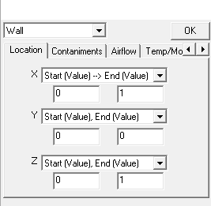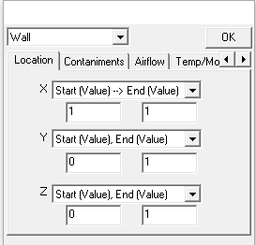
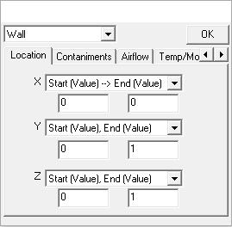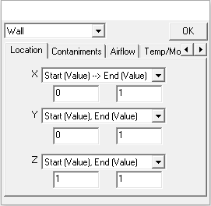

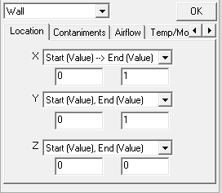

- Next, add an inlet and outlet. Under the “Root Node” tree add two more boundaries and name them “Inlet” and “Outlet.”

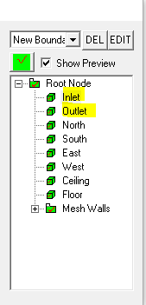
- First, edit the inlet. This time in the drop-down menu change “Blockage” to “Inlet.” The inlet will be located at the top of the “West” wall, so edit the X, Y and Z values as shown and select “OK.”

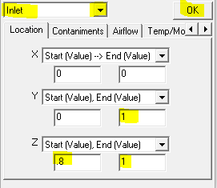

- The outlet will be located at the bottom of the “East” wall. Edit the outlet as shown, and don’t forget to change it from “Blockage” to “Outlet.”

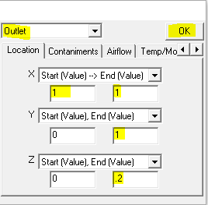

- Next, define the mesh. Begin by clicking the “Mesh Definition,” which has a box icon in the top menu as shown. The mesh definition window will appear.

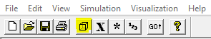
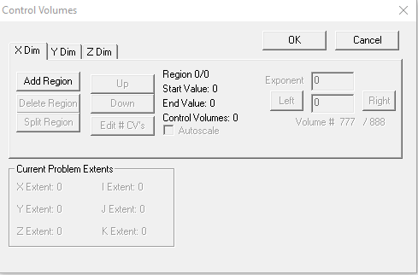

- To define the mesh, divide each X, Y and Z dimension into cells by specifying a certain number of divisions. One option is to create a uniform grid with equally sized cells throughout the domain. However, a non-uniform grid where the cells are not always the same size is often needed. A finer mesh (smaller cells) near boundaries like walls, inlets and outlets is preferred, while coarser mesh (larger cells) is alright to have away from boundaries. We will make a non-uniform grid.

- Start with the X dimension. Click “Add Region” to create the first region which will be near the “West” wall. This region will extend from 0 to .2 m and have four “Control Volumes” (divisions). Since a finer mesh near the walls is desired, this region will have a cell length half of the length of the cells further away from the wall. Once this region is defined, select “OK.”

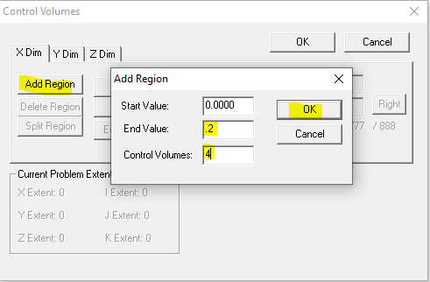
- Add another region in the X dimension by clicking “Add Region” again. This region will be the middle section away from the “West” and “East” walls, so it will have a coarser mesh as shown. The last region extended .2 m and had 4 divisions, giving a cell length of .05 m. This region extends .6 m and has 6 divisions, giving a cell length of .1 m. Edit the region as shown and select “OK.”

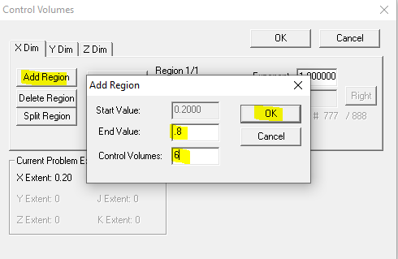

- Add the final region in the X dimension which is near the “East” wall, so a finer mesh is required again. It will be the same size mesh as near the “West” wall.

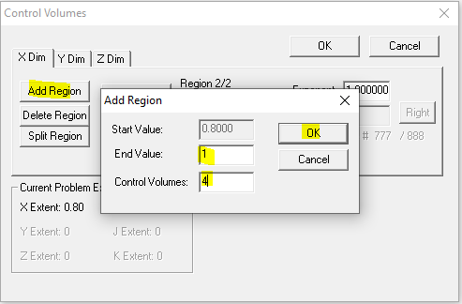
- Since the overall domain is essentially a cube, repeat the same process for defining the mesh in the X dimension with the Y and Z dimensions. Once finished, select “OK.”

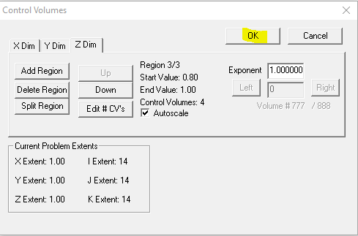

- To view the created mesh, navigate to the wide rectangular box, select the drop-down menu, and click “M.” Click the red “X” and it will turn in to a green check and the mesh will appear. 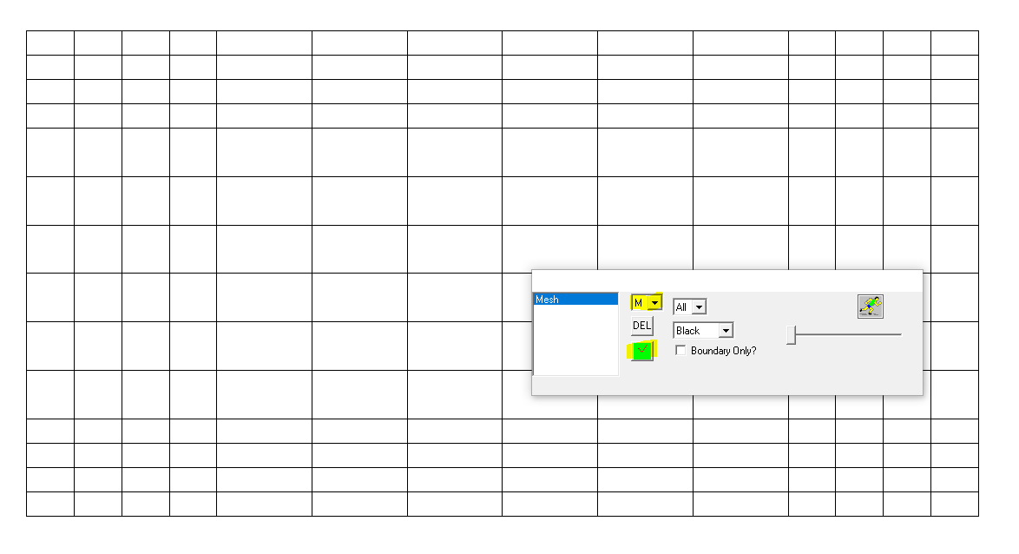

- The geometry and mesh are now finished. Save the file by going to File>Save as… The default seems to be to save it as 1. (with no file extension).

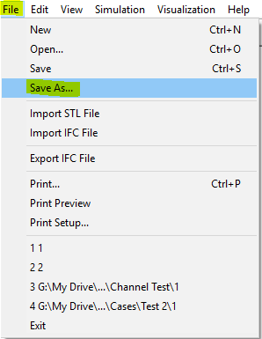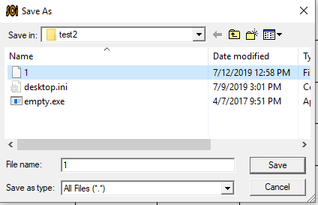

- Next, generate the input.cfd file. Click on the “GO!” icon in the top menu and a “Choose Solver Type” window will open. Select FFD from the drop-down menu and click “Next .”

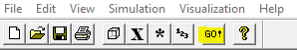

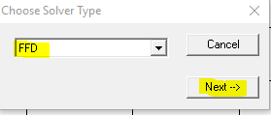
- Make sure you have the empty executable “empty.exe” in your folder. Select that and click “Open.”

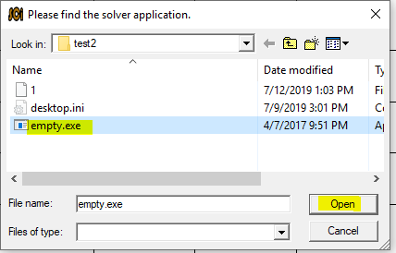

- The error shown below may open. DO NOT CLICK OK OR CLOSE THIS POP-UP, JUST LEAVE IT THERE. The input.cfd file has been created in your folder but clicking “OK” or closing the window will delete the input.cfd file. If needed, navigate to your folder and save the input.cfd file somewhere safe. If the SCI application closed after opening the empty.exe, check to see if the input.cfd file was created in your folder because it likely was.

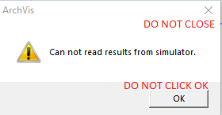

- The input.cfd file has been created in your folder. Congratulations, you have now completed pre-processing with SCI!

