Guide to Compiling ISAT in Windows
Compiling with free MinGW compilers, CMake, and Visual Studio
Disclaimer: This method, while seemingly unconventional, is used to handle the Fortran code in the ISAT libraries. MinGW provides a free Fortran compiler, gfortran, to compile the Fortran code. CMake then uses Visual Studio tools to make the ISAT library compatible with Visual Studio compilers, which is convenient since Dymola defaults to using Visual Studio compilers in Windows.
- Before beginning, MinGW, CMake, and Visual Studio need to be installed.
  - 32-bit MinGW can be installed from http://www.mingw.org/ and 64-bit can be installed from https://sourceforge.net/projects/mingw-w64/. 64-bit is recommended.
  - CMake can be installed from https://cmake.org/download/. Downloading the installer is recommended for ease of installation.
  - Visual Studio can be installed from https://visualstudio.microsoft.com/downloads/. The community edition is free and is sufficient for the purpose of compiling this code.

- After installing MinGW, add the MinGW bin containing gcc.exe, gfortran.exe, etc. to the system path. For more information on adding to the PATH in Windows, please see this link: https://www.architectryan.com/2018/03/17/add-to-the-path-on-windows-10/.

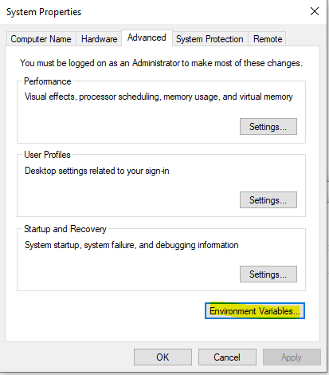
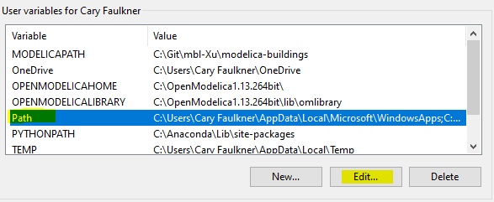

- Next, open the CMake GUI by searching for CMake from the Windows start menu.

- Select the “Buildings/Resources/src” folder in the Buildings Library as the folder containing the source code. Also create a build folder, for example in src/ISAT, to use to store the CMake build files. Select this folder as your directory to build the binaries.

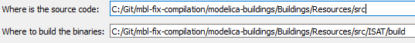
- Copy the “CMakeLists.txt” located in Buildings/Resources/src/ISAT/MinGW to the folder selected for the source code, in this case Buildings/Resources/src.

- Rename the “modelica_ffd_common.h” file in src/FastFluidDynamics to something else or save this file safely elsewhere.

- Copy the “modelica_ffd_common.h” file located in src/ISAT to the src/FastFluidDynamics folder.
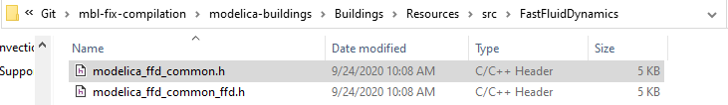

- Also, remove the “cosimulation.c” file located in src/FastFluidDynamics or save it to another location.

- On the lower-left side of the CMake GUI, click “Configure.” Then, select “MinGW Makefiles” as the generator and choose to use default native compilers. Select finish.
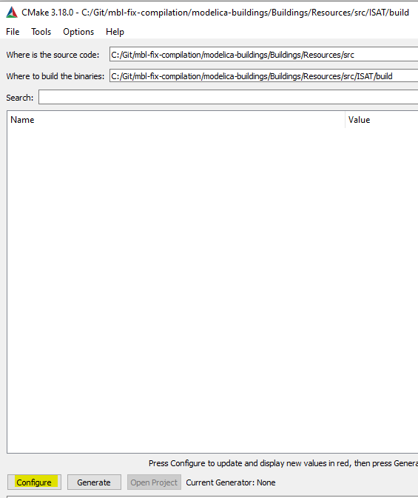

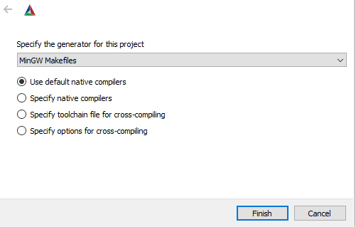
- After configuring, make sure to check the boxes for “BUILD_SHARED_LIBS” and “CMAKE_GNUtoMS.” Click “Configure” again until these turn from red to white.

- Click “Generate.” The command line should now look as shown below. A “makefile” has now been generated to compile the library.

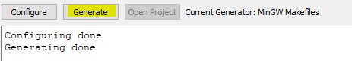

- Open a command prompt and navigate to the build folder.
- Call the “mingw32-make.exe” executable to run the makefile. This can be called by entering the path to this executable into the command prompt as shown below.

- The code should compile and generate the libraries.
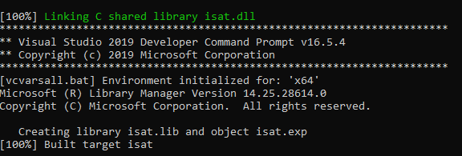
- Lastly, copy the “isat.dll” and “isat.lib” files from the build folder to the corresponding Library folder in the Buildings Library, for example Buildings/Resources/Library/win64. The ISAT models will now use these recompiled libraries!

