Guide to Compiling FFD Code Using Visual Studio
This guide covers:
- Compiling the CPU code in Visual Studio.
- Compiling the GPU code in Visual Studio.
Compiling the CPU code
- Begin by opening Visual Studio and selecting “Create a new project.”

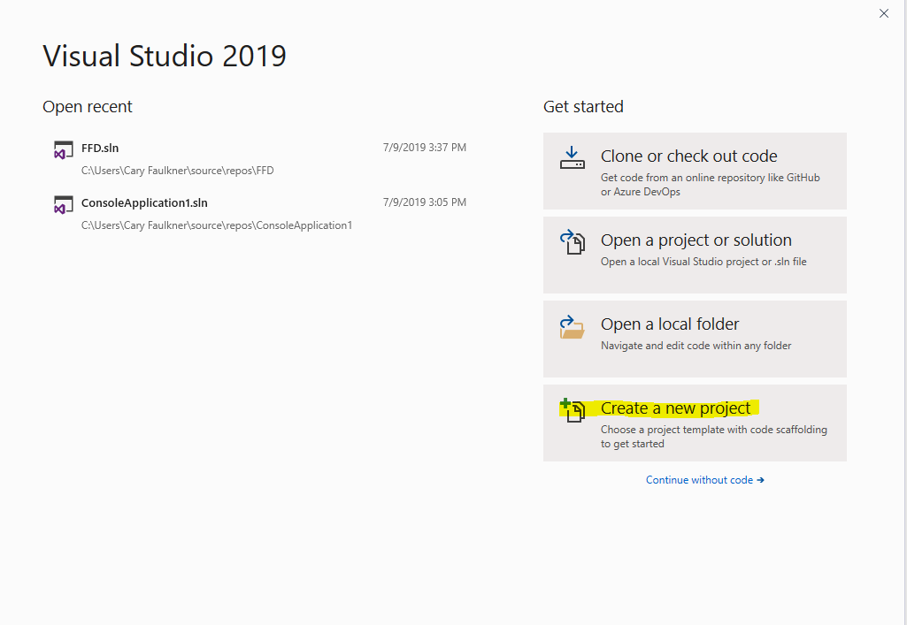

- Select “Console App” and click “Next.” NOTE: If Console App is not installed see Appendix A for instructions on how to install it.

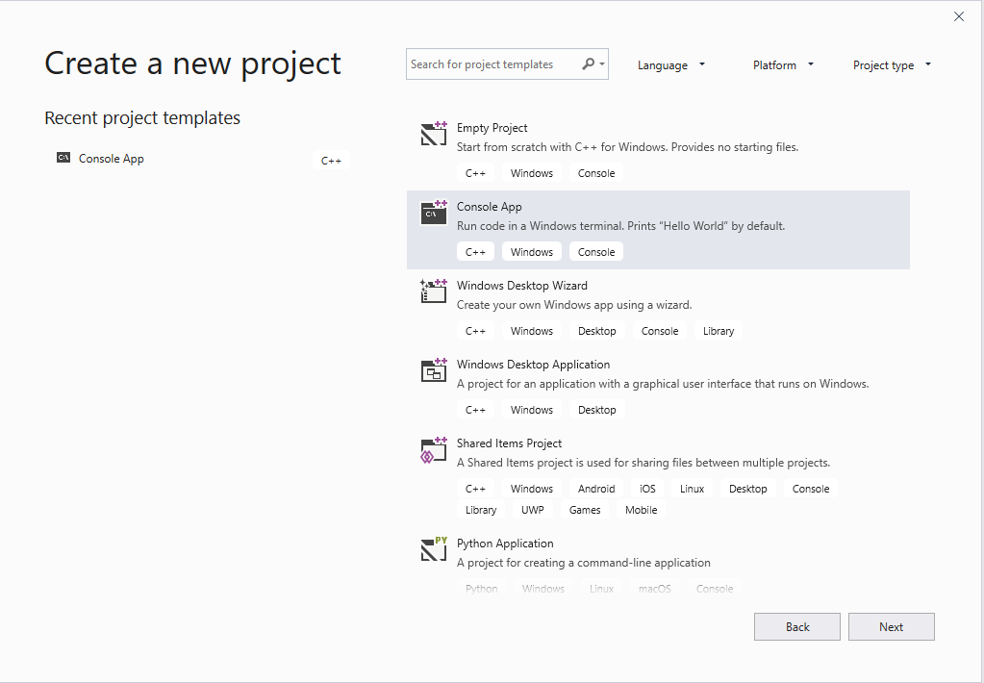

- Name your project and select its location.

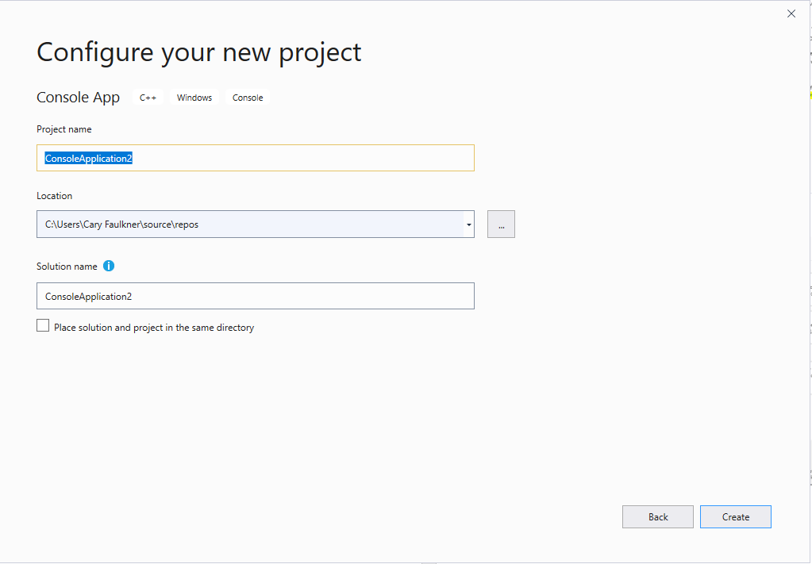

- The project will open, and we will now add the FFD CPU source code. Right-click on “Source Files” on the right side of the screen. Go to “Add” and select “Existing Item…”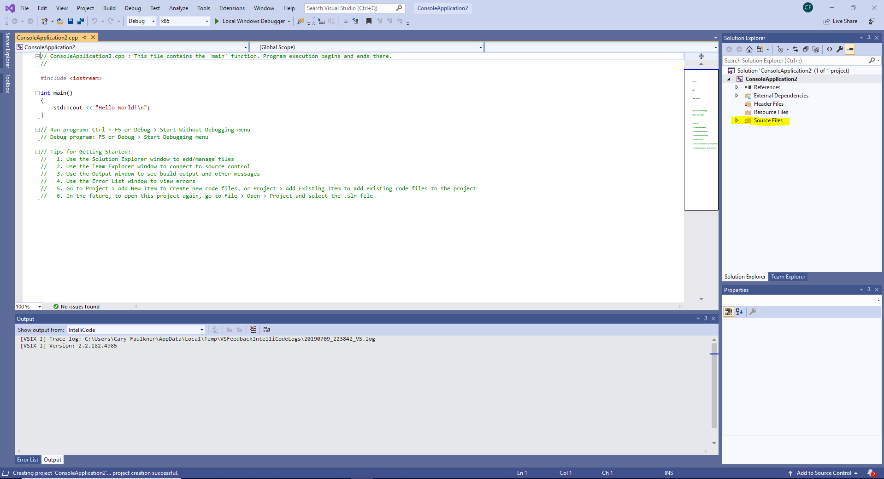 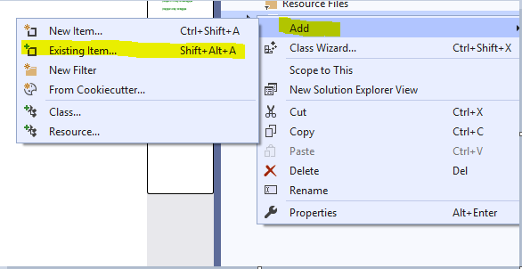

- Make sure to add all the FFD source code files for using FFD on CPU. You will see all the files appear on the right side under “Source Files.”

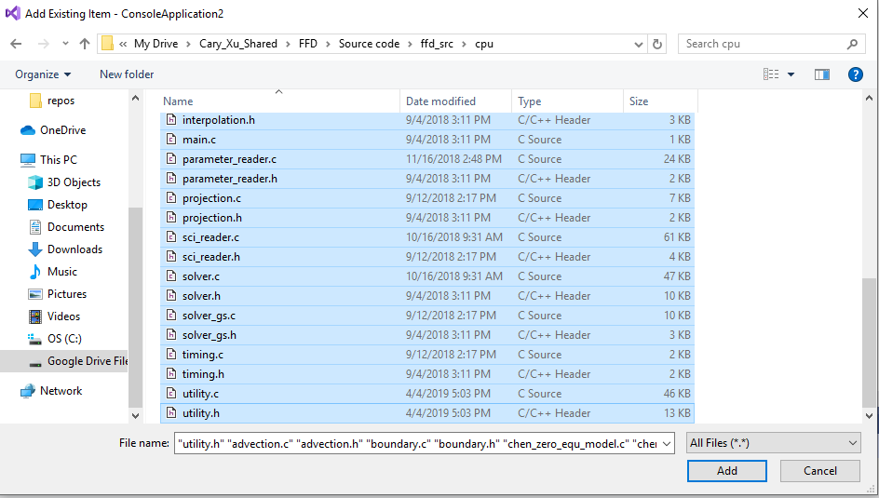

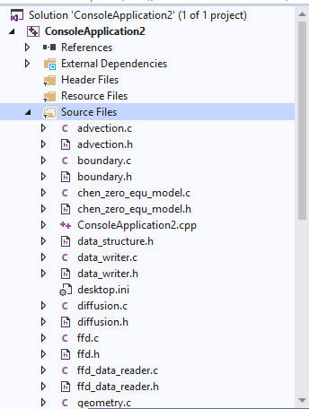

- It is also important to delete or comment out the default “main” function that was created when you first opened the project, as this may cause errors when compiling the code. Use “//” to comment out code.

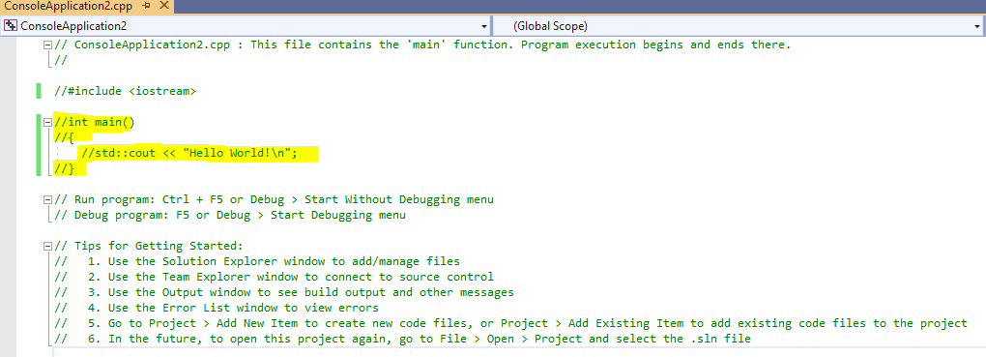

- To compile the code, select “Build” from the menu in the top left, and click “Build Solution.”

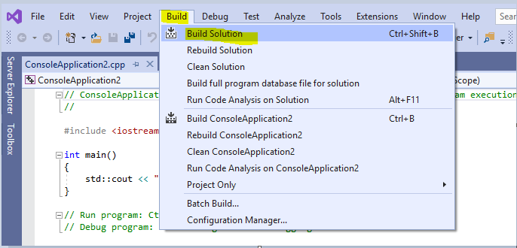

- The code should, hopefully, compile with no errors and the output should look as shown below.

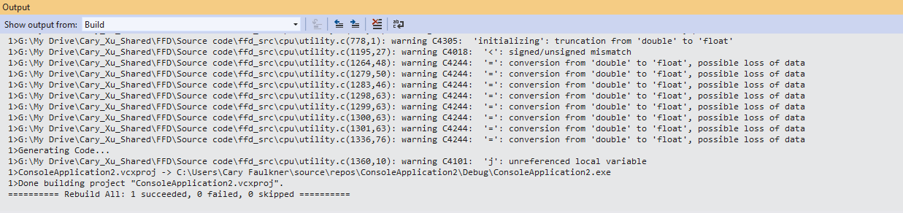

- You may receive many errors with the same description, as shown below. See Appendix B on how to fix this.

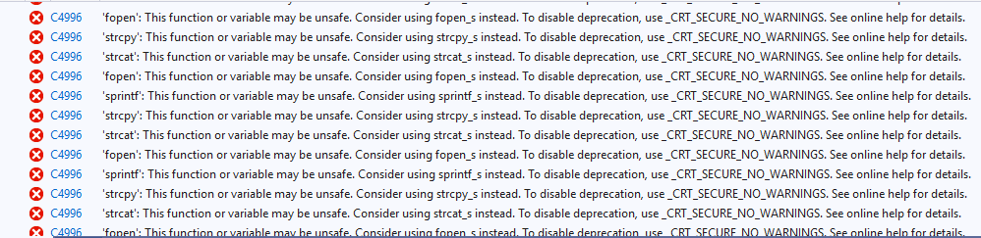

Compiling the GPU Code
- To begin, repeat steps 1-6 from compiling the CPU code, except in step 5 make sure to add the source files for using FFD on GPU rather than CPU. If the following files are added, remove them as they will cause errors: opencl_iso_main.c, main.c, and platform_device_detect.c. Do NOT remove opencl_main.c.

- Try compiling the code as shown in step 7 of the CPU section. If you get the same set of errors as shown in step 9 of the CPU section, follow the directions in Appendix B and recompile the code. After doing this, you will likely get the error shown below:

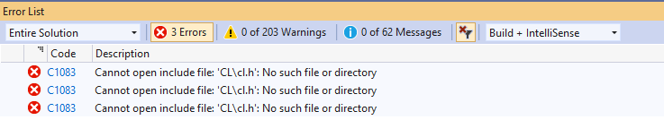

- To fix this error we need to first install OpenCL. The version of OpenCL you install is based on your GPU. My GPU is AMD Radeon, so I installed OCL_SDK_Light_AMD.exe from: https://github.com/GPUOpen-LibrariesAndSDKs/OCL-SDK/releases. If your GPU is NVIDIA, you can find it here: https://developer.nvidia.com/opencl. Otherwise, simply Google search your GPU + OpenCL to find the right version of OpenCL for your GPU.

- We now need to add the path of OpenCL. Right-click on the name of your project on the right side and select “Properties.”

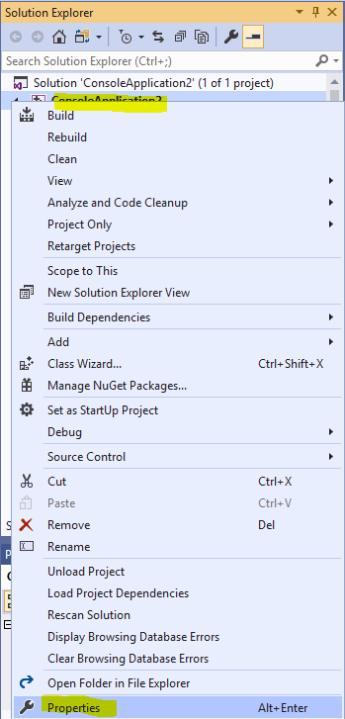

- Under C/C++, select “General” and click the drop-down menu for “Additional Include Directories” and select <Edit…>

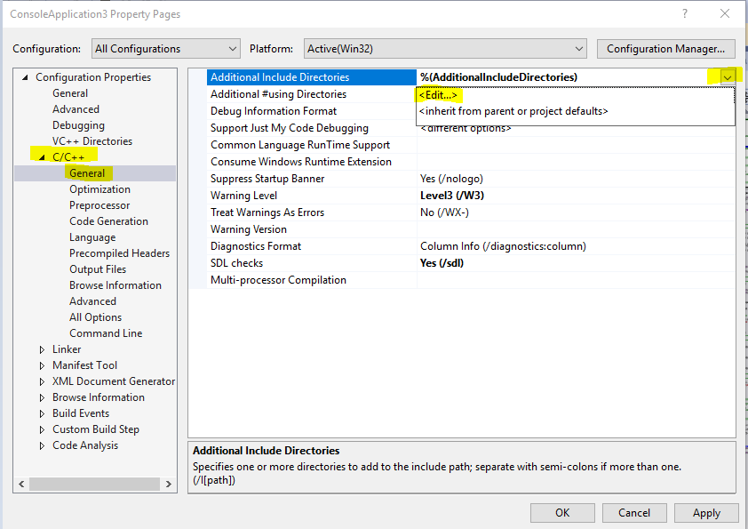

- Click the folder icon and the three dots to add a new path. We now need to select the path for our CL folder which contains cl.h. For me this is in C:\Program Files (x86)\OCL_SDK_Light\include. Once you have located the folder, click “Select Folder” and then “OK.”

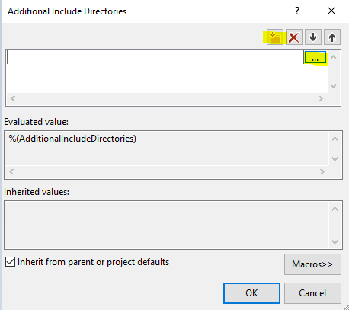
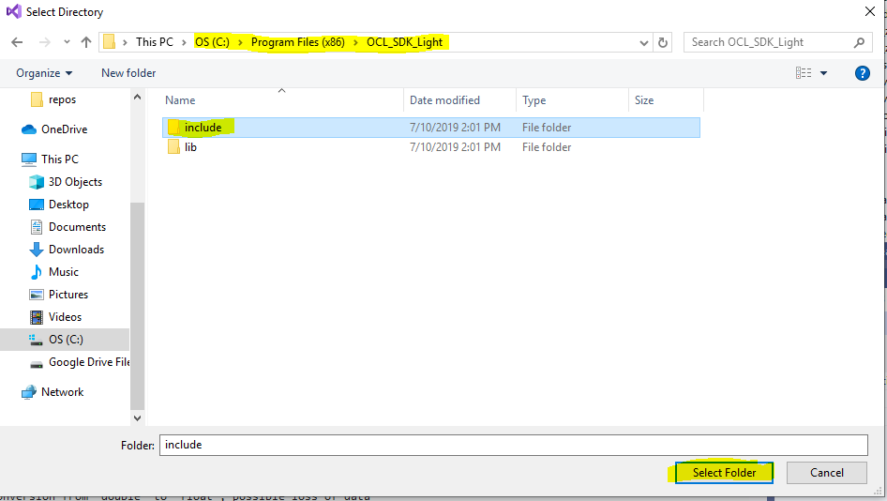

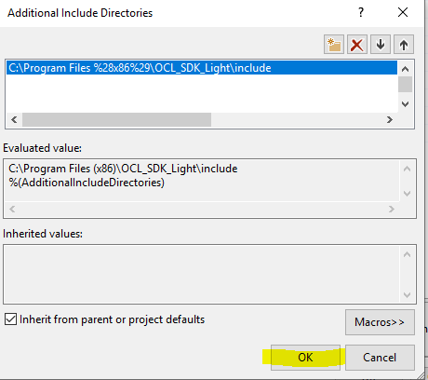

- Under “Linker”, select “General” and click the drop-down menu for “Additional Library Directories” and click <Edit…>. Once again, click the folder icon and the three dots. This time we will select the path for the opencl.lib file. For me this is in C:\Program Files (x86)\ OCL_SDK_Light\lib\x86. Click “Select Folder” then “OK.”

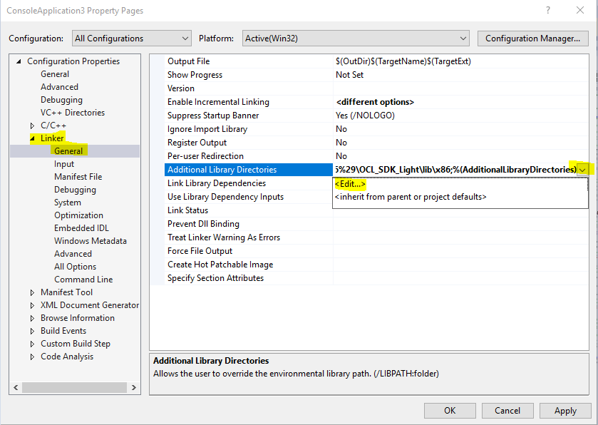

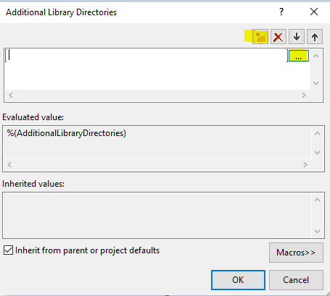
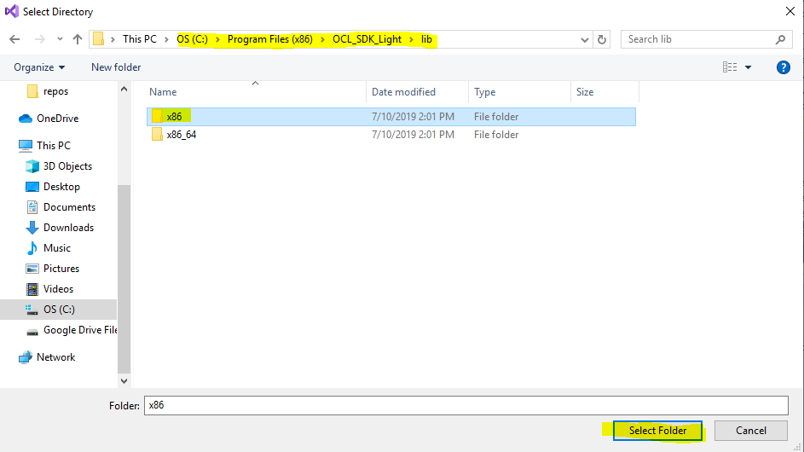

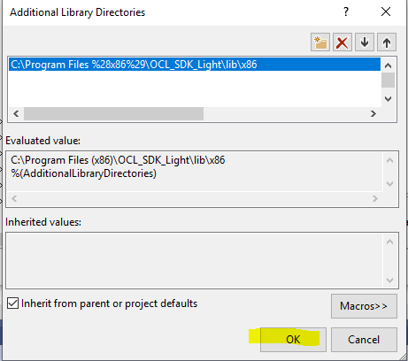

- Under Linker again, select “Input” and click the drop-down menu for “Additional Dependencies” and click <Edit…>. Type in opencl.lib and click “OK.”

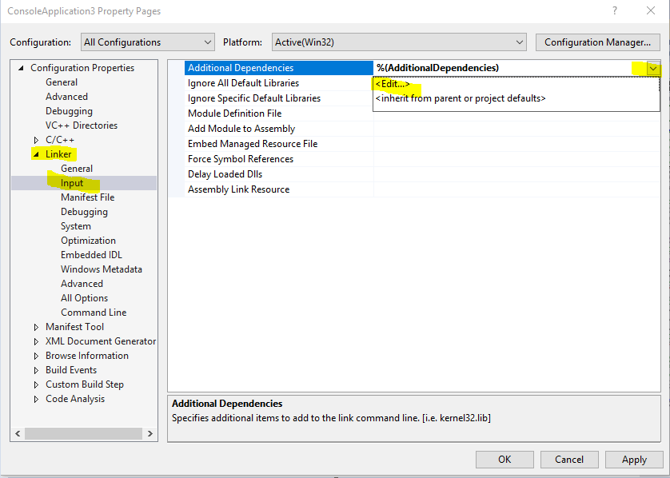

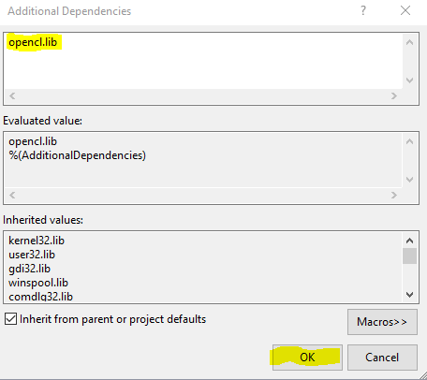

- Click “Apply” then “OK”. When you recompile the code there should be no errors.

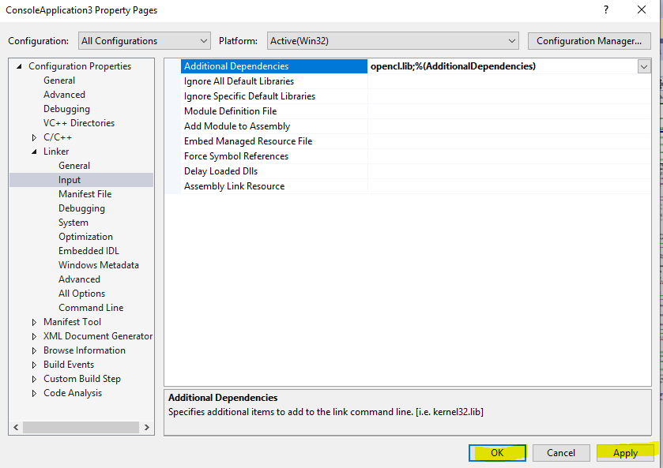

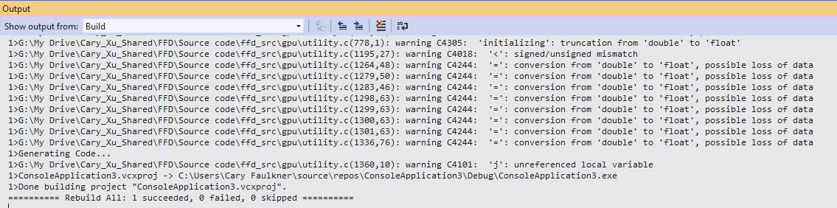

Appendix A: Installing the Console App

- If the Console App is not installed, scroll down and select “Install more tools and features”

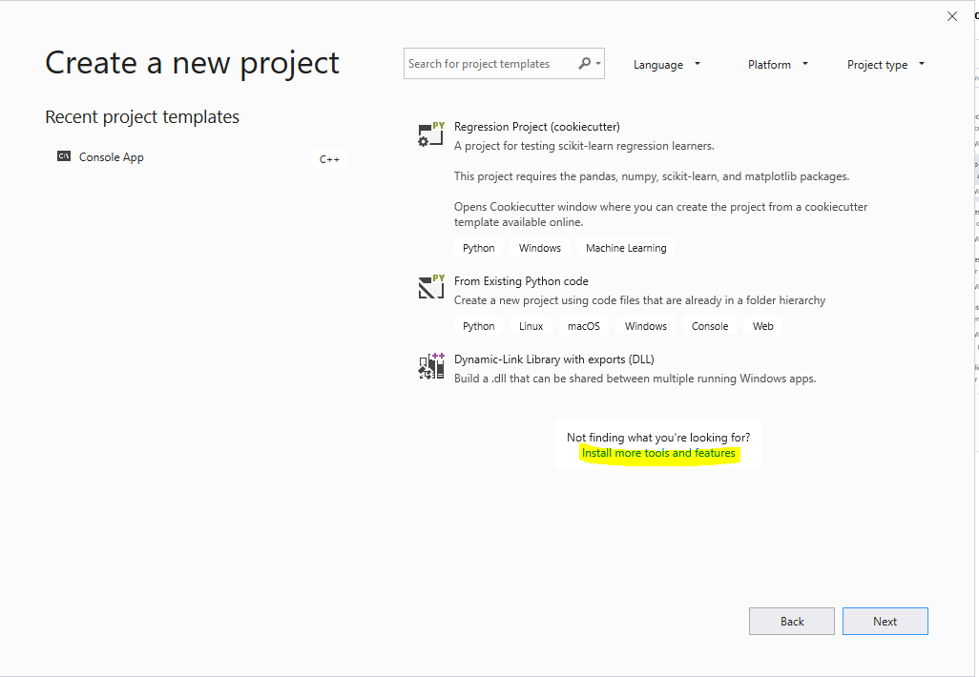

- Check “Desktop development with C++” and click “Modify” in the bottom right corner. The package will install, and it may ask you to restart your computer. Once completed, return to step 2 of the main section.

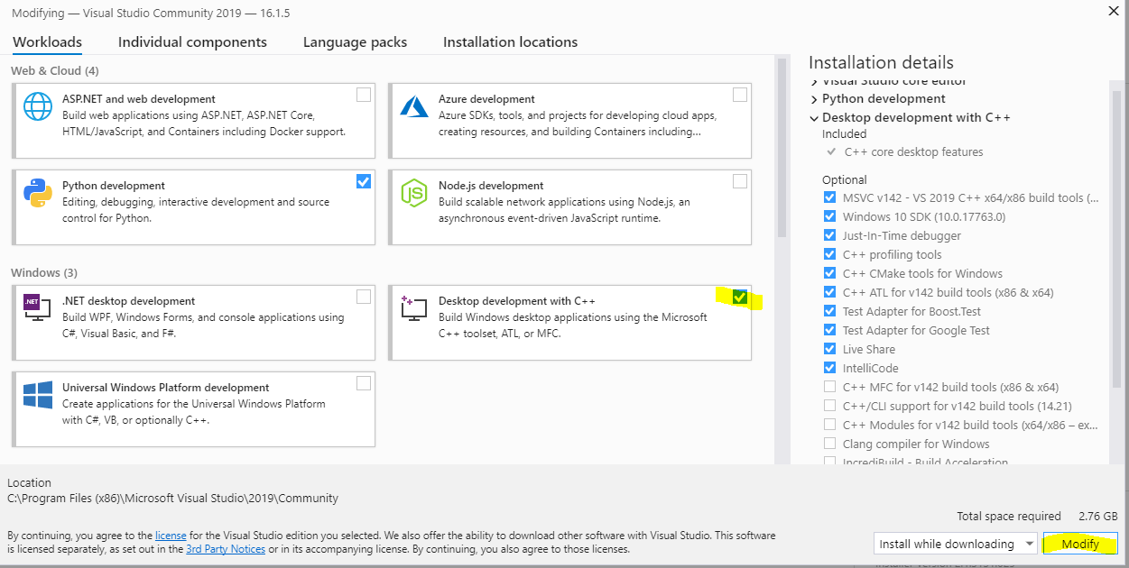
Appendix B: Disabling “_CRT_SECURE_NO_WARNINGS” Errors

- To disable these errors, right-click on the name of your project on the right side and select “Properties”

- Select “Preprocessor” on the left side under C/C++, select the drop-down menu for “Preprocessor Definitions” and click <Edit…>.

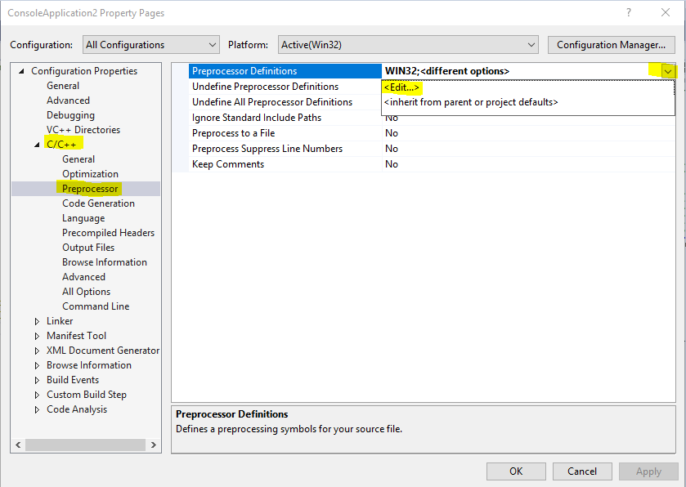

- Type in _CRT_SECURE_NO_WARNINGS as shown and click “OK.” On the properties page, select “Apply” then “OK.” When you rebuild the solution now (recompile the code), these errors will not appear.

