20 Jan 25

From: Colorado Meet Officer in Charge, Naval Reserve Officers Training Corps, University of Colorado

To: All Hands

Subj: LETTER OF INSTRUCTION FOR 2025 COLORADO MEET

Encl: (1) Hospital Map and MEDEVAC Procedure

(2) Registration and Payment Procedure

(3) Overall Scoring Breakdown

(4) Opening & Awards Ceremony

(5) Operational Risk Management (ORM)

(6) CU Campus Map

(7) Official Schedule

(8) Inclement Weather Guidelines

(9) Opening Ceremony & Bracket

(10) After Action Report

1. Orientation. The 2025 Colorado Meet will commence 7 through 8 March 2025 at the University of Colorado Boulder campus with the center of operations at 2400 Colorado Ave, Boulder, CO 80302 Gate 6.

a. Weather Outlook. The Colorado Meet staff will monitor the weather in the time leading up to the event and will implement inclement weather plans if needed. Snowfall and snowstorms are common in early March in Colorado; therefore, teams must prepare accordingly.

b. Elevation Awareness. The city of Boulder is at an elevation of 5430 feet. Due to high elevation, the air pressure is much lower, and the amount of effective breathing oxygen is lower. As a result, those who are not acclimated may experience altitude sickness and shortness of breath while visiting Boulder. To prepare for and prevent altitude sickness, teams should adequately hydrate and consume proper nutrients.

2. Situation.

a. Higher’s Mission. The Commanding Officer’s mission is to host an invitational meet where schools from across The United States attend and compete in multiple events, inspiring camaraderie, building leadership, and strengthening future Naval and Marine Corps officers.

b. Support. The University of Colorado Boulder Naval Reserve Officers Training Corps (CU NROTC) will host () teams competing in six events. The University of Colorado NROTC Battalion will staff the Colorado Meet as an all-hands event; members of the battalion will work where they are needed most. Any Colorado Meet personnel who are not members of the CU NROTC Battalion will remain in contact with their respective event's OIC and AOIC. All other personnel will direct their inquiries to the Colorado Meet OIC and AOICs.

c. Attachments and Detachments.

(1) Attachments. All NROTC Units who attend and compete in the Colorado Meet are considered attachments of the University of Colorado Boulder NROTC Unit. No other attachments will be designated.

(2) Detachments. None.

3. Mission. Our mission is to create a prestigious and transformative national NROTC Competition that fosters a spirit of excellence, camaraderie, and professional growth among Midshipmen, MECEPs, and OCs from across the nation. Through dedication to teamwork, leadership, and challenge, we aim to empower the next generation of Naval and Marine Corps officers.

4. Execution.

a. Commander’s Intent.

(1) Purpose. The primary objectives of the 2025 Colorado Meet are to instill confidence in future professional military officers, provide an environment for a safe and challenging competition, build, and strengthen camaraderie among both ROTC and JROTC units, and ensure that Colorado Meet remains the premier ROTC competition in the country.

(2) Endstate. All participants of the 2025 Colorado Meet challenged within a competitive, safe, and worthwhile environment; bonds between ROTC and JROTC participants strengthened; connections between ROTC, JROTC, CU, and the Boulder community enhanced; and all participants safely returned to their home stations.

b. Concept of Operations. The University of Colorado NROTC Battalion and Colorado Meet personnel will successfully conduct The Colorado Meet on 7-8 March 2025. The Colorado Meet execution is divided into three separate phases: (1) Organization and Preparation, (2) Event Execution, (3) Conclusion and Awards.

c. Scheme of Maneuver.

(1) Phase 1: Organization and Preparation. Attending and competing teams are expected to prepare throughout the academic year for the events they intend to participate in. Furthermore, all facilities used for the Colorado Meet will be reserved and prepared accordingly before the Colorado Meet. Schools who wish to attend and compete are required to register no later than 8 February 2025. See enclosure (2) for more details on registration procedures. Prior to arrival, schools must contact their respective liaisons.

(2) Phase 2: Event Execution.

(a) 6 March 2025 - first teams arrive in Boulder, meet their liaisons, and check into their hotels.

(b) 7 March 2025 - remaining teams arrive in Boulder, meet their liaisons, and check into their hotels. Shooting competitions will begin in the morning. The opening ceremony guest of honor is RADM Mattingly. The Knowledge competition will begin in the evening. The opening ceremony will be held in the afternoon at 1400 on Farrand Field.

(c) 8 March 2028 - All competitions will take place from 0600 to 1500. All scores will be finalized by 1515. See enclosure (3) for a thorough description of scoring rubrics.

(3) Phase 3: Conclusion and Awards. The awards ceremony will commence at 1600. Teams are dismissed after the awards ceremony.

d. Tasks.

(1) Meet OIC. The Meet OIC will oversee the evolution of the Colorado Meet in its entirety and ensure a fair competition takes place.

(2) Meet AOIC. The Meet AOIC will assist the OIC in ensuring a successful evolution of the Colorado Meet. All personnel will refer questions and information to the Meet AOIC in the absence of the Meet OIC.

(3) Hospitality OIC. The Hospitality OIC is responsible for planning and executing the ceremonies as well as coordinating food and sustenance for the Colorado Meet. Furthermore, the Hospitality OIC will organize lodging information for teams and any other information pertinent to their stay in Boulder and provide liaisons for each attending team.

(4) Supply OIC. The Supply OIC will ensure all competing teams have the supplies they need to carry out a fair and effective event. The Supply OIC will oversee and track the usage of all CU NROTC gear and equipment as visiting teams check out and check in gear.

(5) Drill OIC. The Drill OIC will plan and execute the Drill and Color Guard Competitions. The Drill OIC is also the point of contact for all competing drill captains.

(6) Shooting OIC. The Shooting OIC is responsible for planning and executing the Rifle and Pistol Competitions. The Shooting OIC is the point of contact for all competing shooting captains.

(7) Endurance Race OIC. The Endurance Race OIC oversees planning and executing the Endurance Race Competition and will be the point of contact for all competing Endurance Race team captains.

(8) Knowledge Competition OIC. The Knowledge Competition OIC is responsible for the overall planning and execution of the Knowledge Competition and will be the point of contact for all competing knowledge team captains.

(9) Iron 4/C Competition OIC. The Iron 4/C Competition OIC is responsible for the overall planning and execution of the Iron 4/C Competition and will be the point of contact for all competing knowledge team captains.

(9) Public Affairs Officer (PAO). The PAO is responsible for documenting the Colorado Meet and disbursing photos of the competition to their respective teams. The PAO is also responsible for coordinating videography for the Drill Competitions to ensure a fair competition. The PAO is also responsible for a Colorado Meet slide show which will be played during the Awards Ceremony.

(10) Safety OIC. The safety OIC is responsible for coordinating and overseeing all volunteers involved with event safety to include RSO’s at the range, pool supervisors, safety van drivers, and endurance race guides and checkpoint stations, as well as relaying any pertinent information to the Colorado Meet OIC.

e. Coordinating Instructions.

(1) Each event OIC will be in direct contact with Midshipman 2/C Culverhouse, SSgt Hillyer, and Midshipman 2/C Huttenhower via radios and then cell phones to address any questions and report potential problems.

(2) Team captains from each school will be in direct contact with their respective event OICs and liaisons via face-to-face communication, cell phones, and email as needed.

5. Administration and Logistics.

a. Administration.

(1) Transportation. All teams are responsible for their own transportation to and from events in the Colorado Meet. For the shooting competitions, teams will have to muster at Folsom Field Gate 6 30-minutes prior to their scheduled competition time to transport all necessary personnel and gear to the Boulder Police Department.

(2) Medical. In the case of a medical emergency, self-aid and buddy-aid will be utilized. If an individual’s medical condition is unsolvable by on-scene Colorado Meet Staff, that individual will be transported to the nearest medical facility for treatment. See the event specific LOIs for Operational Risk Management. See Enclosure (1) for a route to the nearest medical facility.

b. Logistics.

(1) Chow. All meals and sustenance must be provided by the schools. Liaisons can give suggestions for local restaurants as this will be a good opportunity to see Boulder.

(2) Uniforms. Refer to event specific LOIs for required uniforms at those events. All Colorado Meet Headquarters Staff will wear their utility uniforms. The awards ceremony will be conducted in unit polos. If attendees do not own unit polos, then their uniform will be proper civilian attire.

(3) Gear. See event specific LOIs for information regarding gear and personnel required at each event.

6. Command and Signal.

a. Command. Colorado Meet OIC Midshipman 2/C Culverhouse and AOIC SSgt Hillyer, and Midshipman 2/C Huttenhower will be always reachable via cell phone during the Colorado Meet and will be in Colorado Meet Headquarters. All significant emergencies will be routed to the staff OIC LT Jones and CU NROTC Leadership. The Colorado Meet Staff will always maintain a proper deck log to ensure the event is conducted effectively. All Event OICs are responsible for assigning one volunteer to oversee the scoring of their event. This individual will be responsible for receiving and marking scores. Event OIC’s will be responsible for reporting all scores to Headquarters when they become available. Headquarters will constantly keep scores up to date.

b. Signal. All communications that cannot be done verbally will be conducted via radio or cell phone during the event.

c. CCIRs. If any of the following happen then someone at the event shall call the Meet OIC, MIDN 2/C Culverhouse, and Staff OIC, LT Jones. They will then inform the Commanding Officer and Executive Officer with the 5 W report.

(1) Any significant injuries that preclude a person from continuing the evolution or event.

(2) Any staff interference or dispute from another university.

(3) Any civilian interference or dispute.

(4) Any misconduct or foul play.

d. Points of Contact.

(1) Midshipman 2/C Culverhouse (Meet OIC):

Brcu8196@colorado.edu@gmail.com

(720)-800-2552

(2) SSgt Hillyer (Meet AOIC):

Anhi4712.edu

(603)-370-2476

(3) Midshipman 2/C Huttenhower (Meet AOIC):

Thhu9404.edu

(970)-230-2479

(4) LT Jones (Staff OIC):

Elijah.Jones-1@colorado.edu

(909)-267-0917

**Hospital Map and MEDEVAC Procedure**

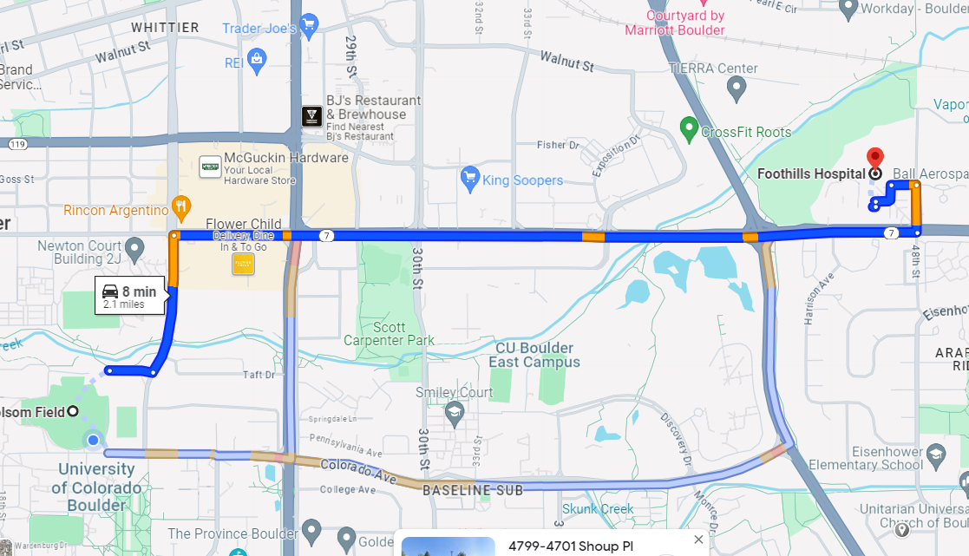

1. Each emergency will be assessed on a case-by-case basis. Injuries should be treated at the lowest level possible and will be categorized into tiers. The tiers will determine the protocol necessary to follow and how the overall meet will be affected.

Tier 1: Highest level emergency which requires flight for life, ambulance, or another equal medical procedure. Tier 1 injuries are not to be solved by anyone other than a licensed medical practitioner. In the case of a tier 1 injury, the event will be postponed indefinitely. All personnel involved in the event will evacuate indoor spaces, meet at a rendezvous point, and then meet at the Buffalo Statue on University of Colorado Main Campus to take accountability. The first responder at the scene will take command of the scene and direct emergency services.

Tier 2: The second highest level emergency which involves a loss of consciousness and justifies a hospital visit. Tier 2 injuries are not life threatening. The individual will be evacuated from the course or building and will be transported to the nearest medical facility via government vehicle, see above. In the case of major broken bones (i.e. femur, skull, ribs), the individual will be transported to the nearest hospital via ambulance.

Tier 3: The lowest level of emergency which does not require transportation to the hospital. Any tier 3 injuries can be treated on-scene with a first aid kit. There will be appropriate first aid supplies at each event and more extensive first aid supplies at the command center.

Emergency #: 911 CU Boulder PD: 303-492-6666 Boulder PD: 303-441-3333

Foothills Hospital: 303-415-7000

**Registration and Payment Procedure**

1. Go to <https://www.colorado.edu/nrotc/colorado-meet> and fill out the “Colorado Meet Registration Form.”
2. Send registration fees via check no later than 8 March 2025, or bring day of events made out to the following:

CU NROTC

Gate 5, Room 135

374 UCB

Boulder, CO 80309-0374

Or

Venmo @Cu_NROTC and under the description of payment include the following:

Unit Name

Each event the Unit intends to participate in

1. Once payment is received and confirmed, teams will receive an email confirming their attendance.
2. Event Pricing:
   1. Endurance Race: $90
   2. Pistol Competition: $200
   3. Rifle Competition: $200
   4. Color Guard: $90
   5. Iron 4/C: $0
   6. Knowledge: $90

**Opening Ceremony and Field Meet**

Each year, CU NROTC hosts an opening ceremony followed by an event to celebrate the Colorado Meet and allow teams to come together to socialize and foster camaraderie essential for the Fleet. All participating schools are invited to the social for a chance to meet midshipmen and staff from battalions across the nation, as well as relax with members of their own teams and battalion.

This year’s opening ceremony will be hosted on Farrand Field at 1430. Teams are expected to be formed by 1415 in 1 of 4 mass formations, see enclosure (9) for your placement. The uniform for this event is camouflage utilities. Schools are also highly encouraged to bring their unit flags for photos. This year’s social is a field meet consisting of a tug of war tournament to encourage friendly competition amongst schools, this is not a scored event for the Colorado Meet. See enclosure (9) for the tournament bracket. Schools will have teams of 10 prepared to participate, teams that do not have enough personnel will receive volunteers from the other 400+ students in attendance. The uniform will be boots and utes.

**Awards Ceremony**

The location of the Awards Ceremony is TBD. Schools will sit with their teams.

1545 – Prep room for ceremony

1600 – Schools are seated

1615 – Closing Ceremony Begins

1635 – Remarks from MIDN OIC, CO, and Guest of Honor

1705 – Present awards: Knowledge, Drill, Shooting, E-Race, Overall

1730 – Conclude ceremony with Anchors Away and Marines Hymn

The awards ceremony will be conducted in unit polos and khaki pants. If units do not have polos, then their uniform will be proper civilian attire. If a team has a time conflict from an event that does not allow time to change, camouflage utilities are authorized.

**Operational Risk Management (ORM)**

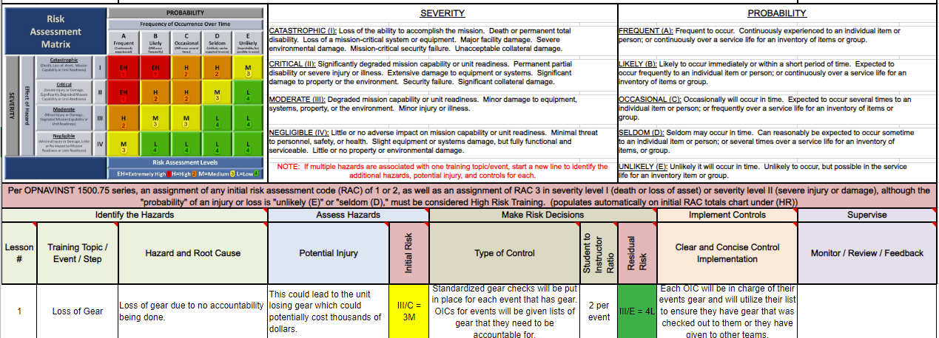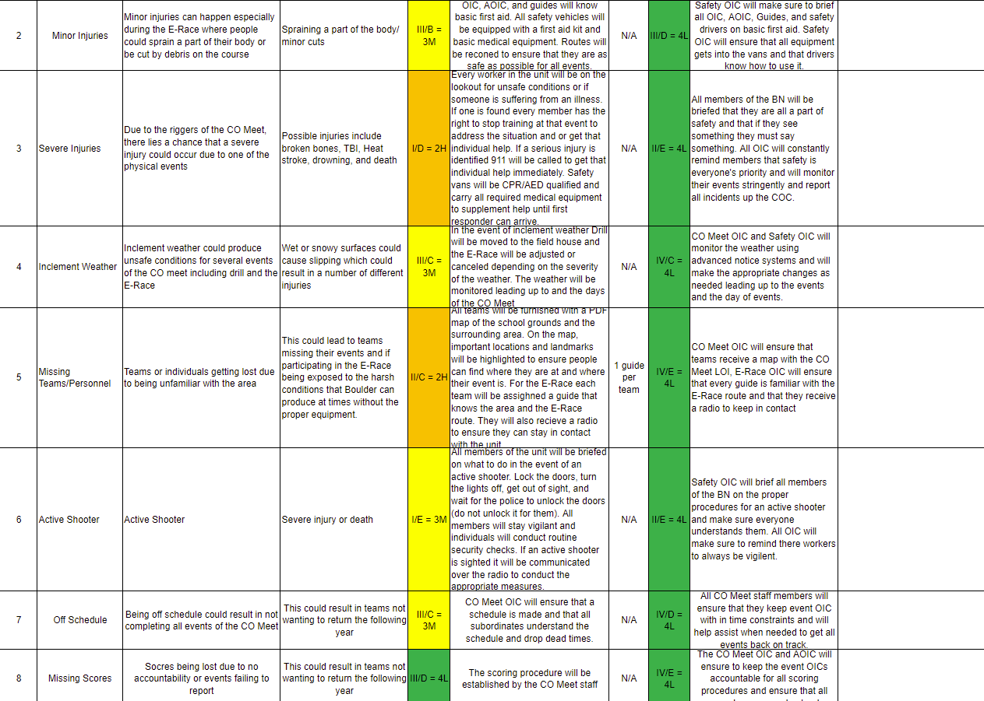

**CU CAMPUS MAP**

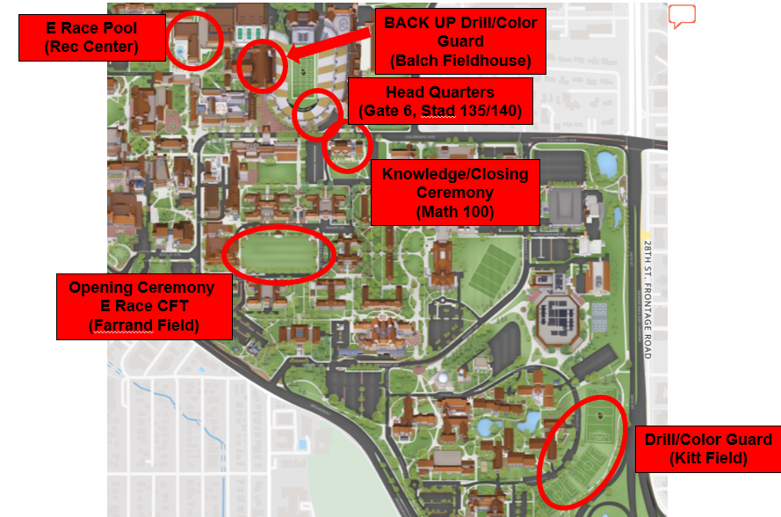

**Inclement Weather Guidelines**

* E-Race will be moved to the Inclement Weather plan when:
* Packed ice covers sidewalks between CU Campus and Chautauqua Park with no signs of melting or shrinking before sunrise; to be judged by CO Meet OIC and Staff OIC 12 hours prior to E-Race start.
* Forecasted weather includes the following:
  + Sustained winds greater than 25 MPH, gusting greater than 40 MPH and a wind chill of below 15 degrees Fahrenheit.
  + Precipitation/snow accumulation greater than 3 inches.

* This will all initially be judged 48 hours prior to event start, then again 24 hours and 12 hours prior by the CO Meet OIC and Staff OIC.

**Opening Ceremony Formation & Bracket**

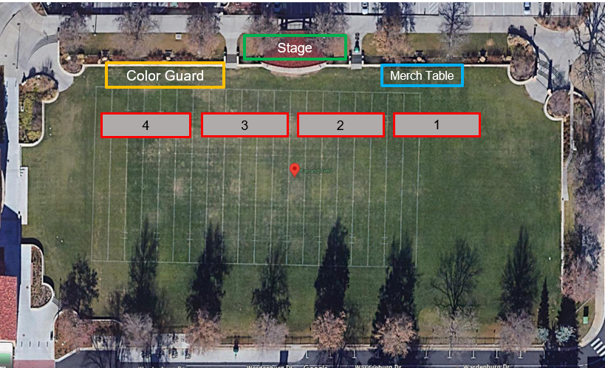

**AFTER ACTION REPORT:**

What did you like about the competition?

What did you not like about the competition?

If you were in charge of this competition, what would you change for next year?