Madeline Flanagan
February, 2024
My intended purpose for this project is to educate my readers on what ADHD actually is. There are many negative stereotypes surrounding ADHD and I want my project to try and help change them.
My intended audience for this project is those who judge and have negative stereotypes towards people with ADHD and learning disabilities. I am calling upon these people to attempt to change their opinions and become more accepting.
The genre of my project is an opinion/editorial (op/ed).

Opinion
Guest Essay

The Stigma Surrounding Attention Deficit Hyperactivity Disorder (ADHD)

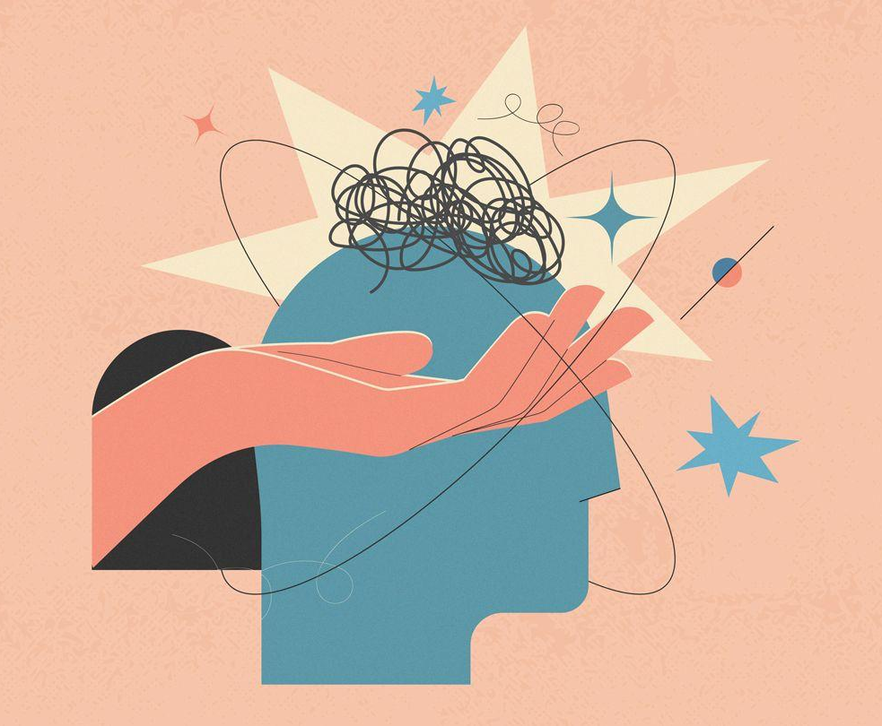
By Maddie Flanagan
Maddie Flanagan is a student at the University of Colorado Boulder studying communications.

Jane North, a 19 year old student at Indiana University, who suffers from ADHD, tells her stories about dealing with the stigma surrounding ADHD. She says, “ I’ve had ADHD all my life, and it has never been easy to deal with. People look at me as the dumb one in the friend group or think that I am annoying because I get random bursts of energy. They don’t understand that a lot of the time I can't help how I act and that I need to do things a specific way”. I asked her how she feels about the stereotypes surrounding ADHD and she said, “It makes me feel awful. People make assumptions about me that are absolutely wrong. It feels like my needs are being ignored”.
Jane's feelings are similar to others in the ADHD community, in that they are hurt by negative views of their disability. When society sees ADHD, they only see the tip of the iceberg.The obvious symptoms that everyone sees (inattention, hyperactivity, and impulsivity) are where the stereotypes come from.
The Attention Deficit Disorder Association lists internal and/or invisible symptoms as “poor emotional regulation, time blindness, decision paralysis, hypersensitivity, low self esteem, sleeping problems, weak executive functioning, and lack of motivation”. As I mentioned these are internal and cause a great deal of turmoil in many people.
It is very common in our world today to see incorrect representations of ADHD in pop culture. For example, cartoon characters such as Dug from the Pixar movie “Up”, or Tigger from “Winnie the Pooh” show signs of stereotypical ADHD. They are both hyper characters who have trouble focusing and are impulsive. These characters prove that the stigma surrounding ADHD is almost everywhere you could imagine.
Paul Bell, a licensed psychologist, defines learning disabilities as, “a variety of disorders involving the failure to learn an academic skill despite normal levels of intelligence, maturation, and cultural and educational opportunity”. Bell also states that individuals diagnosed with learning disabilities are considered to be a, “highly diverse group of individuals with a wide variety of characteristics”.
This is where the stigma is created. The fact that those with ADHD are all unique makes people doubt the legitimacy of a diagnosis or symptoms. Furthermore, there are layers to ADHD and symptoms to go along with each layer. There are basic similarities and things that need to be present to receive a diagnosis. To put it simply, different people experience ADHD in different ways.
In an interview with Professor Cinnamon Bidwell, an assistant professor at the University of Colorado Boulder in both the Department for Psychology and Neuroscience, as well as the institute of Cognitive Science, defines ADHD in her words. Bidwell says, “I'll call it a heterogeneous disorder, but there's a clear standard, a clear diagnosis in the DSM 5 that consists of symptoms of inattention and/or symptoms of hyperactivity and impulsivity”.
As Bidwell stated, there are three main categories that ADHD symptoms fall under; inattention, hyperactivity, and impulsivity. Robert Block, a licensed psychologist who specializes in treating children using cognitive and behavioral techniques, and his colleagues describe these categories in detail. They say, “those with strong inattention difficulties have a hard time focusing on things for long periods of time…Hyperactivity takes the form of fidgeting, excessive talking, difficulty sitting still, and restlessness. Similarly, impulsivity looks like speaking at inappropriate times or interrupting, acting without thinking, and similar behaviors to hyperactivity”.
Despite the challenges that people with ADHD face, it is imperative that we understand the “strengths and abilities” that they possess, especially academically, says Emma Climie, the director of the Strengths in ADHD Research Lab at the University of Calgary. Children in particular who have been diagnosed with ADHD, are not bad kids. It is necessary to make the distinction between behaviors people can control and behaviors that people can not control and address a problem based on that.
According to the National Center for Learning Disabilities, one in five children in the United States have learning and attention issues. Attention Deficit Hyperactivity Disorder is one of the most common learning disabilities. Despite the large number of our population who struggle, attention deficit hyperactivity disorder carries a stigma. Many people perceive ADHD symptoms as laziness, lack of work ethic, or bad behavior and do not recognize that it is actually much deeper than just behavior.
Anna Mueller and colleagues write about research they conducted about the stigmas surrounding ADHD. They discovered different categories for existing stigmas, such as, children, adults, relatives or people close to someone affected by ADHD, and the influence of stigma on attitudes toward those affected. They discovered that people’s doubts concerning the soundness of a diagnosis, age, gender, and ethnicity of an individual, and treatment doubts all contribute to the criticism of ADHD. ADHD affects multiple aspects of social life. As a result, those who are diagnosed constantly face negativity.

“Children and Adults with Attention-Deficit/Hyperactivity Disorder (CHADD) was founded in 1987 in response to the frustration and sense of isolation experienced by parents and their children with ADHD. At that time, one could turn to very few places for support or information. Many people seriously misunderstood ADHD. Many clinicians and educators knew little about the disability, and individuals with ADHD were often mistakenly labeled “a behavior problem,” “unmotivated,” or “not intelligent enough””.

CHADD is an organization whose goals are to inform, support, and advocate for those with ADHD.

Children and Adults with Attention Deficit/Hyperactivity Disorder (CHADD)
Some common myths about ADHD are that only kids can have ADHD, people with ADHD are just lazy, people with ADHD are not smart, children always outgrow ADHD, and that kids with ADHD will never learn how to combat their symptoms.
Despite these myths, people who have ADHD have many resources. Examples include support groups, academic accommodations, individual education programs, special help programs in school, and different forms of therapy.

“By law, the IEP must include certain information about the child and the educational program designed to meet his or her unique needs. In a nutshell, this information is: current performance, annual goals, special education and related services, participation in state and district-wide tests, specific dates and places, transition service needs, age of majority, and measuring progress”.

The United States Department of Education, gives information on IEPs in, A Guide to the Individualized Education Program.

Individualized Education Programs (IEP)
When people have a lack of understanding and play into misconceptions it hurts everyone involved. Taking the time to understand ADHD, and listen to people around you and their needs is an essential step in putting an end to the ADHD stigma.

References
American Psychiatric Association. (n.d.). DSM. Psychiatry.org - DSM. Retrieved April
20, 2023, from https://www.psychiatry.org/psychiatrists/practice/dsm
Bell, P. F., PhD. (2022). Learning disabilities. Magill’s Medical Guide (Online Edition).
Block, R. W., MD, Macdonald, N. E., PhD, & Piotrowski, N. A., PhD. (2022). Attention
deficit hyperactivity disorder (ADHD). Magill’s Medical Guide (Online Edition).
Disney. (n.d.). Tigger. Winnie the Pooh. Retrieved April 20, 2023, from
https://winniethepooh.disney.com/tigger
Luo, Y., Weibman, D., Halperin, J. M., & Li, X. (2019, February 11). A review of
heterogeneity in attention deficit/hyperactivity disorder (ADHD). Frontiers in
human neuroscience. Retrieved April 20, 2023, from
https://www.ncbi.nlm.nih.gov/pmc/articles/PMC6378275/
Merriam-Webster. (n.d.). Stigma definition & meaning. Merriam-Webster. Retrieved April
20, 2023, from https://www.merriam-webster.com/dictionary/stigma
Mueller, A. K., Fuermaier, A. B. M., Koerts, J., & Tucha, L. (2012, September). Stigma in
attention deficit hyperactivity disorder. Attention deficit and hyperactivity
disorders. Retrieved April 20, 2023, from
https://www.ncbi.nlm.nih.gov/pmc/articles/PMC3430836/
Pixar Wiki. (n.d.). Dug. Pixar Wiki. Retrieved April 20, 2023, from
https://pixar.fandom.com/wiki/Dug
Team, A. D. D. A. E. (2023, January 11). The ADHD iceberg: Exploring the seen and
unseen symptoms of ADHD. ADDA - Attention Deficit Disorder Association. Retrieved April 20, 2023, from https://add.org/adhd-iceberg/
United States Department of Education. (2019, August 30). Guide to the individualized
education program. Home. Retrieved April 20, 2023, from
https://www2.ed.gov/parents/needs/speced/iepguide/index.html

