**Do you want to start a bakery?**

*This blog is best paired with a warm brown butter chocolate chip cookie (recipe at the end).*

You know that little bakery you grew up going to, the one that made the best desserts and made you fall in love with baking? What if I told you it could be possible to have your own bakery?

Ever since I was a kid, baking became an outlet for me. Stressed? Bake some cookies. Bored? Bake some bread. Having a great day? Bake some cupcakes. No matter the occasion or mood, baking was there for me. It was not until college when I started to realize that my passion for baking could be a genuine career path. While it comes with its own set of challenges, becoming a bakery owner may be the outlet that you are looking for.

I hope you are a morning person, or else becoming a baker or owning a bakery may not be for you- you can probably stop reading now. In an article about being a [day in the life of a baker](https://www.careerglider.com/blog/day-in-the-life-of-a-baker/), the author mentions that “The average baker begins their day before 4 am so they can get a start on preparing the day’s bakery foods by 5 am”.

I spent hours debating if opening a bakery was a good idea. As a college student finishing up my junior year, all I can think about is whether the career that I go into will set me up for success. I began to research what it took to start a bakery. What resources would be needed? Where would I do this? How do I know that this will work?

The answer? It’s complicated.

**The Data Behind Bakery Life**

I began by collecting data on bakery life, not only owning one but what the specific jobs detailed, the prices of equipment and pay costs, as well as how many bakeries become successful. Let me tell you, this data… not easy to find. There really is not a lot of information on the internet pertaining to bakery start ups. However, the data that I did find was very helpful.

As I began to contemplate if starting a bakery was a good idea, I wanted to look at specific small businesses details that pertain to bakeries. When starting a business, you will need to pay for a lot of various things: employees, rent, legal fees, equipment, the list goes on and on. I knew that it would be expensive to do this, but did not know just how expensive it would actually be.

I started by looking at the cost of bakery position salaries in St. Louis, Missouri, Boulder, Colorado, and the national average pay. I limited myself to these two locations because they are the ones that I am most interested in living in after I graduate. I compiled data off of Indeed.com salaries on job postings and averaged multiple pays for the same job in the same location for both [St. Louis](https://www.indeed.com/career/baker/salaries/MO) and [Boulder](https://www.indeed.com/career/baker/salaries/CO). For the national average, I was able to find data online that stated the national pay average for various positions. I was curious specifically looking at the pay for a baker, pastry chef, manager, and cashier.

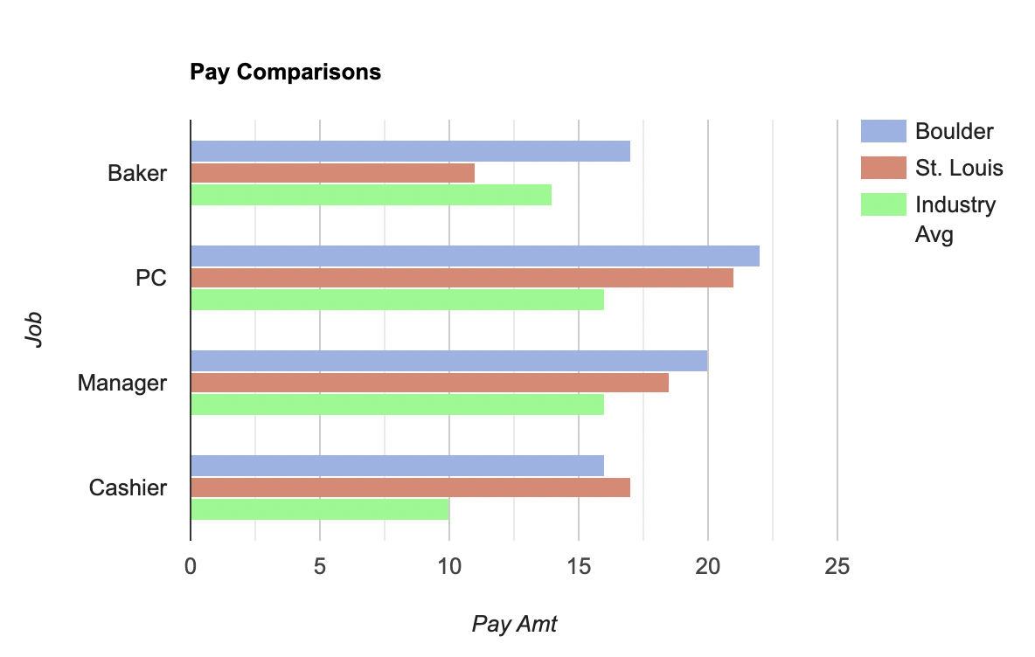

I found that the average salary for the nation/ industry was significantly less than the locations that I was looking at. Overall, it costs more to pay bakery employees in Boulder than it is in St. Louis. This is also due to the higher cost of living in Boulder compared to St. Louis. Based on this alone, it would be more cost efficient to open a bakery in St. Louis, or another location entirely. The national average pay for bakers alone has ebbed and flowed throughout the years, but is currently drastically increasing in the year 2023.

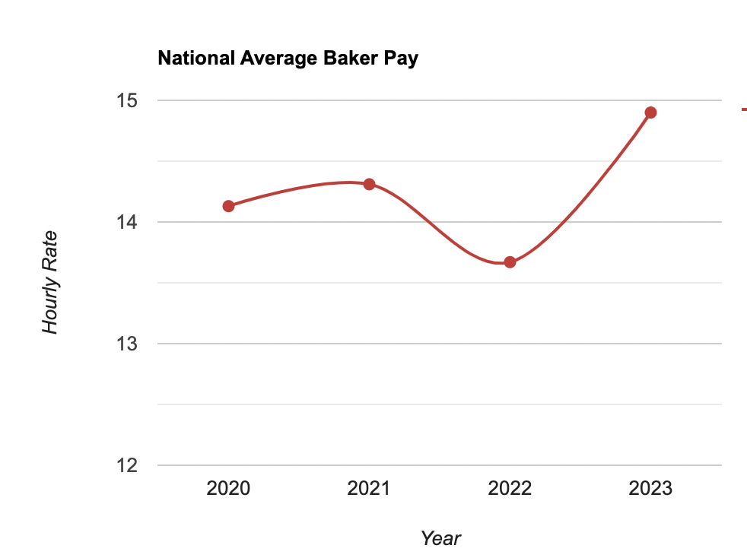

After looking at the pay averages for various positions, I began to look at how fast small businesses are growing within the United States. I found data on the US census from January of 2023, showing how many small business applications there were divided into regions. It was found that there were nearly 420,987 applications submitted. Breaking down the applications, a majority were applying to be in the south, with the west having the second largest application amount. In order to open a business, you must apply with an application. In some areas, like the south, there are more applicants than other regions. Applying to be a new business in an area with a lot of applicants, it may take longer to get a response, further delaying the opening of a business.

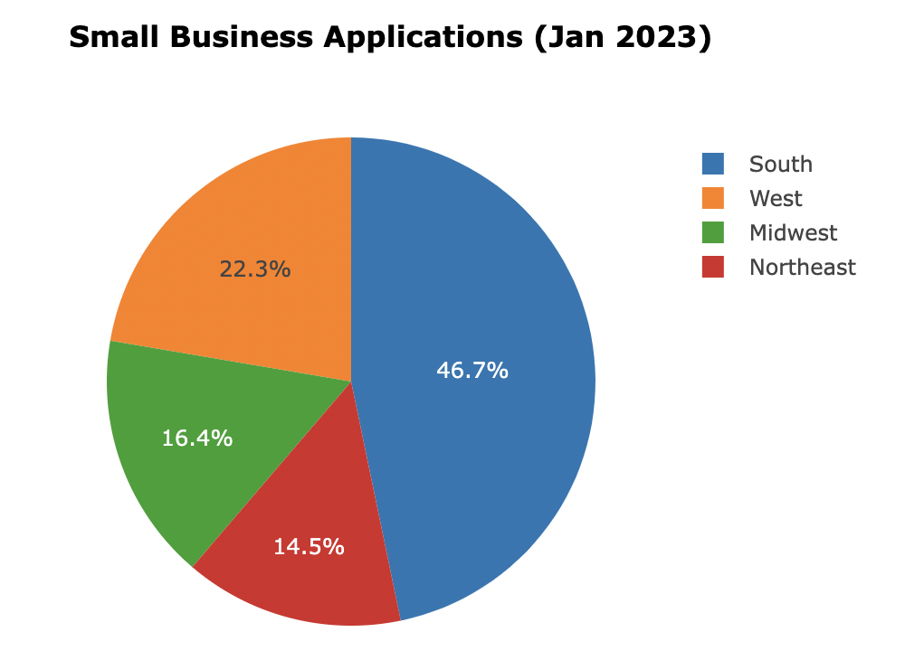

While this data may seem to be slightly discouraging in the sense that there isn't much to go off of- that is not the case. Bakeries are one of the fastest growing small businesses at the moment. Can you imagine a city without a bakery? No you can’t because bakeries are essential. Where else would you find the most decadent cakes and sweet treats? In an article by [TOAST](https://pos.toasttab.com/blog/on-the-line/bakery-industry-trends-and-statistics), the author mentions that, “The market size of the global bakery industry was [$331.37 billion in 2020,](https://www.expertmarketresearch.com/reports/bakery-products-market) and is projected to reach $436.91 billion by 2026. Across the world, major corporations are largely responsible for getting bakery products into the hands of hungry customers. In 2019, [retail bakeries made ~$3 billion in sales, while commercial bakeries sold over 10 times more, with $31 billion in sales](https://smallbusiness.chron.com/bakery-industry-analysis-64831.html)”. This just proves that bakeries are essential in our society.

After collecting the data, I decided that was not enough to go off of when making a final decision. I was just looking at numbers, statistics, there was no human element.

So what now? I needed people. Real people that have worked in the industry, who have tried and failed but ultimately succeeded. People who decided to follow their dream and start a business or decided to work as a full time baker.

**The People**

I began to compile lists of bakeries that I frequently visited as well as bakeries that I was familiar with. Originally, I compiled a list of bakeries near my school in Boulder, Colorado. I wanted to talk to people that started bakeries that were vastly different from each other. I decided to contact four or five bakeries, but found that a lot of them were a little too busy to talk to me. While this was super discouraging, I decided to go an alternative route.

Spring break was right around the corner so I decided to contact places back home in St. Louis, Missouri, and was able to connect with various people. As soon as I got home, I was able to set up dinner with my godfather, a former pastry chef who worked in a bakery as well as the head pastry chef on a small ship. My godfather is a brilliant baker, every time I see him he always brings a new sweet treat for me to try. He was the person who taught me how to bake and how to appreciate the art of baking- I owe him everything if I ever start a successful bakery.

While I always knew he was a successful baker, I had never had a full conversation with him about it. My godfather went to culinary school and found that he was successful with this career path. He worked in a local bakery, working his way up from being a baker to pastry chef in a couple of years. He was given a unique opportunity and began working for a company called Clipper Cruise Line as a pastry chef on the ships. It was a major adjustment for him to go from working in a large kitchen with unlimited supplies and equipment to a small kitchen with a very limited stock. He said that in the beginning, he spent hours meticulously planning the deserts, making sure every ingredient was accounted for. If something were to go wrong, he would not have enough ingredients to complete what he needed to bake. We spent hours talking about different obstacles that he came across as well as lessons he learned while being a pastry chef.

Before leaving dinner, he left me with one piece of advice. Do it. He told me that while the industry may not always be easy or forgiving to bakers, it is worth it. If he had never followed his passion, he would not be where he is today. I appreciated this comment so much because it is rare today to hear people say follow your passion, it is always follow the money.

Talking to my godfather was very helpful since he was in the industry. However, he does not currently own his own business. I decided to talk to my mom about what it is like to own and run her own business.

My mom has owned her own small business for photography since I was born. While she does not own a bakery, she does understand what it was like to start her own small business. My mom had previously been working for Intrav before I was born, she was paid to travel the world. However, when my mom had me she left the industry to focus on being a single mom and raising me. Once I got a little older, she decided to pursue being a professional photographer, taking night classes for photography to learn the business.

In 2007, her company was created. She told me that getting to the point of having her own company was not easy. There were a lot of obstacles that she did not expect to deal with, like trademarking the company name, legal fees, paying for a website, and more. This made starting her business a little more difficult than she expected, but she told me that was ok.

When talking to my mom, she said that what made her feel confident in starting her photography company was that she believed in herself and she had multiple people to give their perspectives. I think that believing in your own idea when it comes to starting a small business is key for success. If you are confident in the work that you are doing, people will respect that and follow.

I do believe that if I really put my time and energy into creating a bakery, it could be something successful. However, I think that opening a bakery store front is not my only option- there are a lot of successful home bakers that work part time.

Home baking was something that I also took into consideration, so I wanted to connect with someone who knew the ins and outs of being a successful home baker. Back home in St. Louis, I was able to connect with a part time home baker to get their perspective on the job. Shawna has a traditional 9-5 job during the week, but does home baking on the weekends as a side job. She always loved baking, but did not have the time or finances to run a proper bakery. She decided that the best compromise was to brand herself as a home baker. Her clients are mainly people that already know her with the occasional new person.

Her pricing of goods and salary is what she chooses as well as the times that she works. I was able to go to her house and see her kitchen and talk to her about what a typical weekend looked like for her. Shawna gets up around 4:45 am or 5:00 am on Saturdays to begin prepping things for the day. If they had been working on something like a bread dough the day before, that was the first thing they would pull out to start. That was followed by pre measuring ingredients for the other projects that they needed to accomplish like cookie or cake orders. She would get whatever orders took priority done first and then would continue this routine until Sunday.

I think that home baking is a great alternative to owning a bakery. There is much more flexibility when it comes to home baking as well as relieves you of the stress of having to buy more equipment, pay employees, or pay rent for a shop.

If it does not work out for me to open up an actual bakery, I could fully see myself taking something like this on. In a sense, I am already doing it. My friends will ask me to bake them various breads in return they would buy the supplies. I really love being able to make things for my friends and family, so no matter where this research leads me I will forever do that.

My last stop was to go to a local bakery and learn about their process and what working in a small owned bakery is like. Pharaohs Donuts is one of my favorite bakeries in St. Louis. It is locally owned and will put Voodoo Donuts to shame. I knew that they would be one of the best bakeries to talk to because they have been so open about what it was like to survive covid right after opening.

I was hoping to have a lot of time to discuss with one of the employees about their job, but was only able to get fifteen minutes. I was able to learn about how one of the employees got the job at Pharaohs. He had worked in a bakery before with no experience, but got really good at his job fast. He knew the people opening this bakery and was able to join the team when it first opened. I asked him about what his favorite part of the job was, his response was trying new flavor combinations as well as trying to develop vegan and gluten free options that mimic their normal donuts. I learned a lot about the process of making donuts as well because I have never attempted to make them- grease fires are a big possibility with making donuts.

I was not able to get much more information than that, I learned that it is really hard to get more than fifteen minutes of a baker's time to discuss the job. Since they begin working so early in the morning, by the time it is afternoon all they want to do is go home- I would feel the same way.

**What Next?**

So now what? That is the question that both you and I are asking. Throughout this process, I have learned a lot about what it takes to own a bakery. But there are a few main takeaways that I found to be helpful through research and interviews.I still think that opening a bakery would be a really interesting path for me to go on, but at the moment I think that becoming a home baker is a good first step. This way I have time to develop recipes, connections, and get used to the hours that the job requires. No matter what happens, I will always love baking and will continue to do so.

1. You have to be a morning person.
2. It is going to be expensive. Be prepared to spend a lot of money, you may not see it again for a long time.
3. Where you decide to start a bakery will influence your success. It costs more to open one in a city that has higher costs than somewhere more rural.
4. You’re probably going to fail at some point, but you can’t give up.
5. If it is truly your dream- go for it.

**The Best Brown Butter Chocolate Chip Cookie Recipe (you’re welcome)**

Ingredients:

* Wet Ingredients
  + 227g (2 C) plus of unsalted butter
  + 100g (½ C) of granulated white sugar
  + 250g (1 ¼ C) of packed dark brown sugar
  + 2 eggs plus 1 egg yolk
  + 2 ¼ tsp vanilla extract
* Dry Ingredients
  + 190g (1 ½ C) of all purpose flour
  + 127g (1 C) of bread flour
  + ¼ tsp baking powder
  + 1 tsp baking soda
  + 1 tsp salt
* Chocolate
  + 225g (1 ½ C) semisweet chocolate chips
  + 140g (1 C) chopped up semi sweet chocolate bar

1. Heat a small saucepan to medium. Add butter to the saucepan, swirling occasionally to ensure the butter is evenly cooking. The butter should start to foam and you will hear crackling. When you hear this, be sure to keep your eyes on the butter.
2. Stir and swirl the butter until there are light brown bits at the bottom of the pan, it should smell nutty. This happens 2-3 minutes after the butter begins to crackle.
3. Remove the butter from heat and pour into a mixing bowl to cool.
4. As the butter is cooling, combine all dry ingredients into a separate bowl.
5. Once the butter is cooled, add in the sugars. Stir until completely combined.
6. Add in the eggs and vanilla until combined. Be sure the butter and sugar mixture is cool so the eggs do not cook.
7. Slowly fold in the dry ingredients into the wet ingredients until just combined.
8. Add in the chocolate chips and chopped chocolate.
9. Chill dough in the fridge for 12-24 hours.
10. Heat oven to 350°F.
11. Scoop dough into 3 tablespoon sized balls and place onto a baking dish.
12. Bake for 11-13 minutes or until golden brown. Rotate the baking sheet half way through cooking to ensure an even bake.
13. Place onto a wire cooling rack to cool for 5 minutes.
14. Enjoy :)

**References**

Boyarsky, K. (2023). *Bakery Industry Trends and Statistics in 2023 - On the Line*. Toast. Retrieved April 18, 2023, from https://pos.toasttab.com/blog/on-the-line/bakery-industry-trends-and-statistics

Parker, D. (2022, November 18). *Day in the Life of a Baker*. Career Glider. Retrieved April 18, 2023, from https://www.careerglider.com/blog/day-in-the-life-of-a-baker/