2415 Yukon Drive
Longmont, CO 80504
fernando.contrerasacosta@colorado.edu
May 30, 2023

Gavin Newsom
United States Governor of California
1021 O Street, Suite 9000 Phone: (916) 445-2841

Dear Governor Newsom,

Under Plyler v. Doe, 457 U.S. 202, (1982) the Supreme Court ruled in favor of undocumented immigrants and reserved to them the same educational rights to attend public institutions as permanent residents and U.S. citizens from K-12th grade. Being a first generation college student, child of undocumented immigrants, and a Peer Supervisor of the Office of Financial Aid at the University of Colorado Boulder; I have a passion for pursuing equality and fairness regardless of legal status in all public establishments for all students. This is in hopes of obtaining a safe and unprejudiced environment in our public institutions via enforcement of Plyler v. Doe, 457 U.S. 202, (1982) for young adults that are either part of the Deferred action for Childhood Arrivals program or other undocumented immigrants.

The purpose of this study is to analyze the dangers and limitations of students’ legal status as required knowledge to universities to obtain financial aid as well as call to attention an increase in equal rights for undocumented students. I will begin this report by presenting evidence of failures of the United States Department of Education to both protect the educational rights of immigrant students to attend public institutions and enforce the same legal protections/rights granted to U.S. citizens and permanent residents for public education. From there we will discuss how these failures have affected immigrants’ aspirations for public secondary education as well as the induced stresses and fears of studying in public schools.

As previously stated I will argue for equality and fairness regardless of legal status in all public universities for all students when pursuing financial aid. This is an important issue especially to you; California is one of the states with the highest deportation rate and is the leading state with the largest DACA recipient population(United States Immigration and Customs Enforcement). In your communities thousands of illegal immigrants are reported and deported; causing both fear and anxiety to undocumented students, based on their legal status. The pressures and prejudice administered to these people affect their attendance as well as their effectives to obtain a public education. It is important to remember that Plyler v. Doe, 457 U.S. 202, (1982) as well as the precedent set to protect the educational rights of illegal immigrants from indirect as well as direct pressures is only reserved to undocumented children K-12th grade. I hope that this study will push you to strive for equality and fairness for students in public institutions across the country, especially those feeling the pressures of their admissions and enrollments not protected to them by the United States Supreme Court. My detailed analysis subsequently enclosed.

Thank you,
Fernando Contreras Acosta

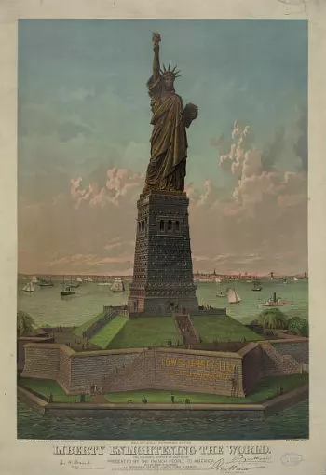

Figure 1 Liberty Enlighten the World Poster
Equality in our Schools
Fernando Contreras Acosta
Jun 1, 2023

Introduction
“Give me your tired, your poor, Your huddled masses yearning to breathe free, The wretched refuse of your teeming shore. Send these, the homeless, tempest-tost to me, I lift my lamp beside the golden door!"(National Parks Service) These welcoming words have been inscribed on a bronze plaque at the foot of the Mother of Exiles, the Statue of Liberty. Displayed for the world to see, the Statue of Liberty holds up a torch guiding the ships full of new immigrants to a land equal and free for those bold enough to get here. Today, the United States has taken a different stance on its immigration policy than what was seen when the Statue of Liberty was assembled. Moreover, some of these immigrants lack the same equal rights as US citizens and permanent residents especially when it comes to education.
The Deferred Action for Childhood Arrivals, or DACA, was a monumental law passed in 2012 to provide eligible young adults temporary protection from deportation and work authorization. While many DACA recipients, Dreamers if you will, have had the ability to obtain a public education they have limited resources to get a secondary education. These immigrants aren’t the only group with need; many Young Dreamers, immigrant children that don’t qualify for DACA, also have heavy restrictions placed on them and bear the weight of deportation at any minute. The system of oppression must end, Dreamers should be given more resources to receive a secondary education and a future plan to residency while Young Dreamers should have the opportunity to have temporary protections from deportation and resources to attain a primary or secondary education. If nothing is to be done then the bronze plaque in which the poem ,“The New Colossus”,is etched, should be melted down. Lest fuel false dreams meant to deceive new immigrants to an unequal land.

Facts
Legally speaking all children regardless of immigration status have the same equal rights as US citizens and permanent residents to attend public schools K-12 due to Plyler v. Doe, 457 U.S. 202, (1982). Unfortunately, this court case had ambiguity when it came to young immigrant adults trying to get a secondary education. This ambiguity was cleared up due to the Illegal Immigration Reform and Immigrant Responsibility Act (IIRIR, 1996), an act targeted to restrict and enforce laws against immigrants and their immigration status. This law appropriated more funding towards border security, made it more difficult for immigrants to obtain residency, and undocumented students became ineligible for in-state-tuition and federal funding at public universities.(TheBestSchools) This bill influenced individual states to pass immigration protection laws that allowed for students to receive in-state as well as state financial aid. California, having the highest DACA recipient population, passed the California Dream Act & State-Based Financial aid in 2011 to provide state financial aid and in-state-tuition to qualifying students.(csac.ca) Qualifying students are but limited to: DACA recipients, undocumented students that are residents in the state of California, and undocumented students that graduated from a California high school.(csac.ca) The requirements for immigrants to qualify for the Deferred Action for Childhood Arrivals (DACA, 2012) are: been under the age of 31 as of June 15, 2021, entered U.S. Before 16 birthday, have continuously resided in the U.S. Since June 15 2007 up to present time, be physically present in the country on June 15 2012 and when you apply, have had no lawful status on June 15, 2012, currently enrolled in school (or have returned to school), graduated, obtained certificate of completion (e.g. GED) OR be an honorably discharged U.S. veteran, and have not been convicted of a felony offense, a significant misdemeanor offense, multiple misdemeanor offenses, or otherwise pose a threat to national security or public safety.(USCIS)
Analysis
“Lla estas listo hijo? Lla nos vamos.” That’s your father making sure you're ready for the long and treacherous journey ahead. Today is the day that you embark to the United States, a land unknown yet magical from what everything you have been told. You're going to be 14 years old in a few months, but you're sad since everyone and everything that you have ever known is in Mexico. You are unsure whom or what is waiting for you up north, but you know that you are leaving everything that you have ever known for a promise of opportunity. A promise of a better life. It's dark, your father is smart, deciding to leave when temperatures are cooler through the Sonoran Desert. You walk for miles carrying basically your whole life in a backpack along with three day old food and stale water. As the sun rises you are better able to see your surroundings, and you start to notice crosses atop the dirt. This troubles you since your father promised you that many have made this journey before, however the sight of these makeshift graves makes you question just how many of those people made it to the other side. With these feelings of uncertainty and anxiety you start to question if you will ever reach this magical place known as the United States. This is just one of the millions of stories of immigrant children that made it to the U.S.A.
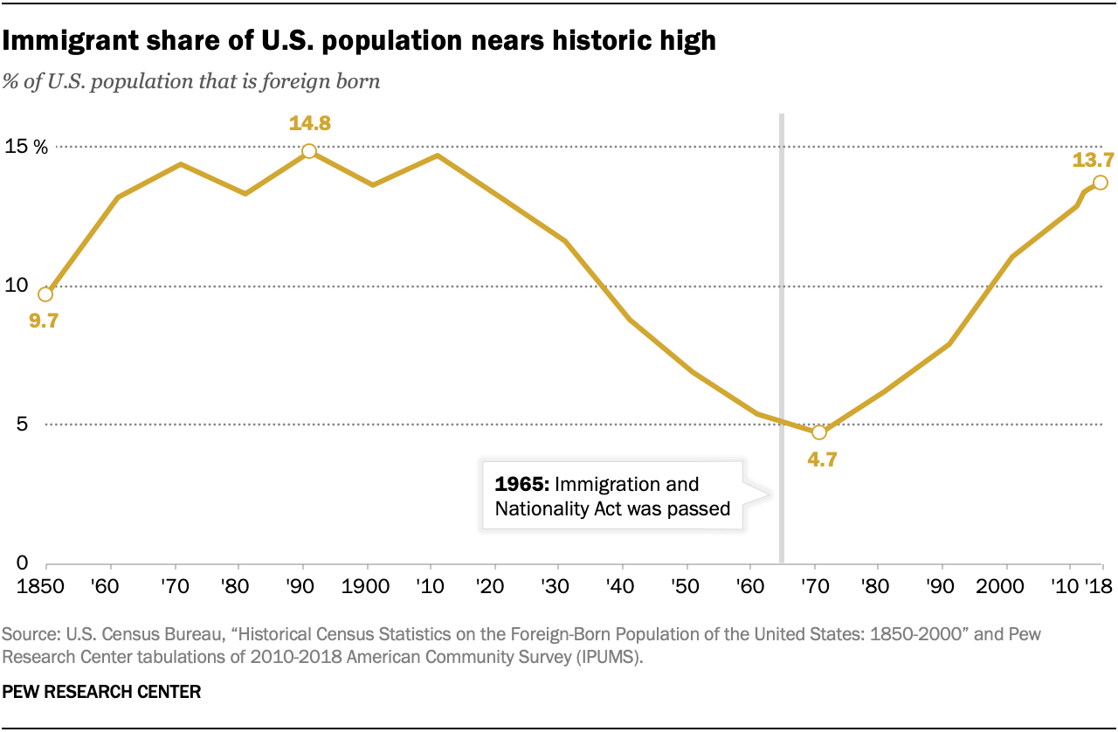
In recent years there has been a surge of immigration that has not been seen since the 19th century.(pewresearch) Millions of people in search of a better life not only bring their belongings but also their children so that they may achieve a pursuit of happiness offered nowhere else. Unfortunately this pursuit of happiness has been roadblocked in some states not allowing these people to pursue their dreams. For example, public school districts are prohibited from restricting a public education to immigrants regardless of their national status due to Plyler v. Doe, 457 U.S. 202, (1982). Nonetheless, school districts in the District of Columbia require proof of residency for families that are enrolling children into their schools. Many immigrants are unable to get a state I.D or a drivers license. Due to their immigration status they are basically ghosts. They have very little credit history, or for that matter an identity here in the U.S. Their lack of credit history sometimes hinders their ability to get a formal lease with a landlord to rent, thus they are unable to prove residency and their children are not able to begin school. In Virginia, there are districts that require proof of custody of a child, and for many immigrants they lack the necessary documents as well as ability to retrieve proof of custody documents.(americanbar) Even though the federal government has urged these districts to get rid of these loophole restrictions there is little enforcement of Plyler v. Doe, 457 U.S. 202, (1982). This is similar to the failures of enforcement by the Supreme Court after Brown v. Board of Education, 347 U.S. 483 (1954). The inability to get DACA status due to entering the country after June 2007, puts Young Dreamers at the chopping block of the U.S. Immigration and Customs Enforcement(ICE for short). These people are able to be deported at any moment since they don’t have temporary protection from deportation. So deportation, language barriers, and financial hardships-due to no work authorization- are just a few of the deprivations to these people.
The precursors of these Young Dreamers, DACA recipients or Dreamers, have more temporary rights but miss out as well. Even though Dreamers are offered temporary protection from deportation and the ability to get an SSN for work authorization they don’t have the ability to receive federal financial aid nor in-state-tuition at public universities at the national level.(studentaid) Instead it comes down to the state itself to pass laws protecting the rights of these immigrants to get in-state-tuition classifications as well as ONLY state financial aid. California was one of the first states to pass the California Dream Act & State-Based Financial aid in 2011 to grant qualifying students, such as Dreamers and other immigrants that are California residents, in-state-tuition and state financial aid.(csac.ca) Today there are only 17 states that have similar programs as California to qualify for state financial aid, and only 23 states with tuition equality for immigrants.(usnews) Dreamers seeking a secondary education in a public institution miss out on tens of thousands of dollars of federal financial aid; depending on the state, they also miss out on either state financial aid and in-state-tuition or both due to the IIRIR act passed in 1996. Financial hardships are not the only stressors for these dreamers but also a direct barring of enrollment for undocumented immigrants in Alabama and South Carolina from their graduate school programs.(bestcolleges)
Solution
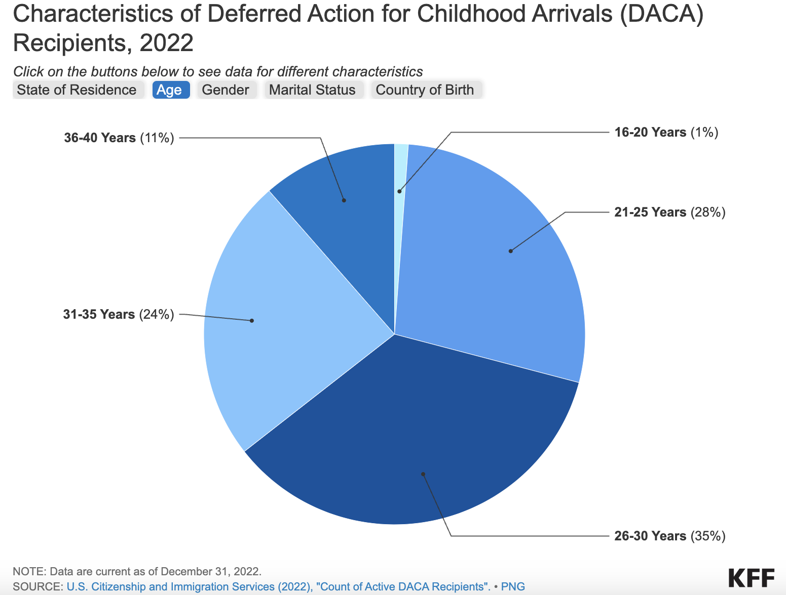
Every year there are fewer and fewer DACA recipients due to their qualification of entering the country before June 2007, and the average age for a Dreamer is now 26 years old.(KFF) While lobbying for the Dream Act, an act intended to protect Young Dreamers by having them become new Dreamers, would help new immigrants pursue their dreams so long as they maintain the same DACA guidelines. What of the immigrants that have DACA status? While they already have temporary protections against deportation as well as the ability to get an SSN for work authorization, they have no meaningful path to citizenship. A path to citizenship would help these Dreamers from applying for DACA status every two years to being permanent residents lifting the burden of deportation for good. Having them be eligible for federal financial aid would also be realistic and justified. Why? DACA has been a huge success: over half of DACA recipients are employed, around ⅔ of these people are enrolled in a university, $6.2 Billion in federal taxes, and $3.3 Billion in state and local taxes each year from DACA recipient households, and there is only over 900,000 Dreamers in the U.S.(usnews) This program has been a success not only for immigrants but for the nation as a whole. These people have earned the right to federal financial aid. Finally, having a nationwide program similar to California’s Dream Act, so that if the Dream Act never goes through at least undocumented immigrants looking to get a secondary education not having a DACA status are able to get aid.
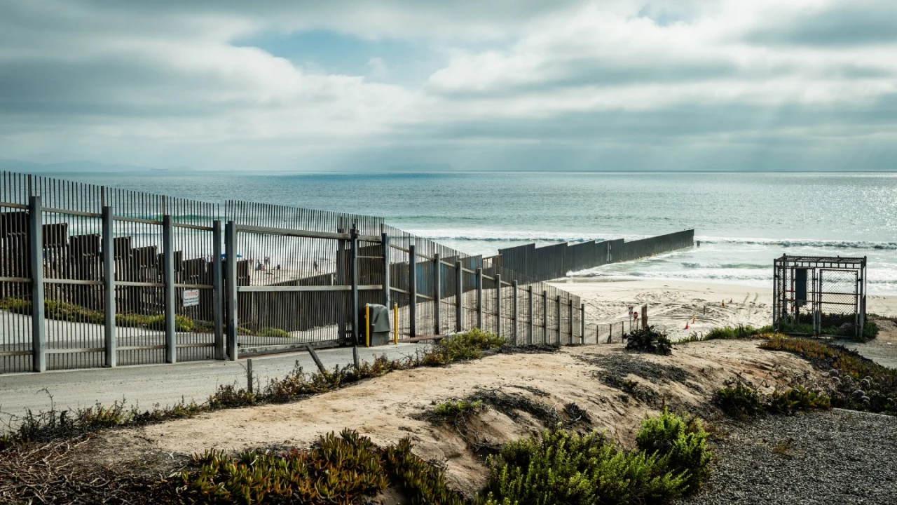
This solution is not perfect, having more students receive federal financial aid; one of the key groups affected will be U.S. citizens and permanent residents. With more people receiving federal aid it will most likely cause the government to restrain its funding making it less funding for all thus decreasing federal aid for students with need that are U.S. citizens and permanent residents. Many will be unhappy seeing their financial aid packages lower than past years, however, how much longer will DACA students be exploited? How much longer should Young Dreamers live in fear of their dreams being unattainable? This isn’t the best solution for one group but instead the solution best for all. If this solution were to be implemented key planning and enforcement would need to be in place so it doesn’t collapse. An increase to border security along the Mexican American Border would most likely be needed, funding set aside for an increase to the number of students that will need federal and state funding, and paths of citizenship planned out for DACA and Young Dreamers. Again, this is not a call to action for a lax immigration policy, instead a call to legally make the educational system equal for all.
Conclusion
When the founding fathers of this nation were constructing the U.S. Constitution the words that have resonated throughout the halls of history are, “Life, Liberty, and the Pursuit of Happiness.”(whitehouse) So are these basic human rights granted only to those that were born on the right side of our borders? This inequality of education is understood, Illegal Immigration should be dissuaded. There is a legal path for those with patience to follow so that they may be legal immigrants. In spite of that, children should not be judged based on the sins’ of their fathers. These children, as different as their languages that they speak, the color of their skin, the religion that they entrust, the sex of their bodies, or the original nation from whence they came are no less American when it comes to wanting to pursue their dreams. If anything it makes them more American for being bold enough to break their chains of oppression in search of a better life.

Works Cited
www.uscourts.gov/educational-resources/educational-activities/access-education-rule-law. Accessed 2 June 2023.
The Hill, 1 Nov. 2021,thehill.com/changing-america/resilience/refugees/579388-group-of-migrants-attempts-to-swim-around-us-mexico/.
www.americanbar.org/groups/public_interest/child_law/resources/child_law_practiceonline/child_law_practice/vol-36/mar-apr-2017/protecting-immigrant-childrens-right-to-education-/. Accessed 2 June 2023.
USCIS, 3 Nov. 2022, www.uscis.gov/DACA.
The White House, 20 Jan. 2021, www.whitehouse.gov/about-the-white-house/our-government/the-constitution/.
Center for American Progress, 24 Nov. 2021, www.americanprogress.org/article/the-demographic-and-economic-impacts-of-daca-recipients-fall-2021-edition/.
American Immigration Council, 20 Aug. 2021, www.americanimmigrationcouncil.org/research/documented-dreamers-overview#:~:text=Due%20to%20their%20lawful%20status,June%2015%2C%202012.%E2%80%9D%20By.
National Immigration Forum, 25 Oct. 2022, immigrationforum.org/article/fact-sheet-on-deferred-action-for-childhood-arrivals-daca/#:~:text=Because%20DACA%20required%20children%20to,growing%20number%20have%20become%20parents.
studentaid.gov/understand-aid/eligibility/requirements/non-us-citizens. Accessed 2 June 2023.
BestColleges.Com, 24 Mar. 2023, www.bestcolleges.com/resources/undocumented-students/graduate-school-guide/#:~:text=Yes.,can%20apply%20to%20graduate%20school.
www.usnews.com/education/best-colleges/paying-for-college/articles/how-undocumented-students-can-get-college-financial-aid. Accessed 2 June 2023.
www.ice.gov/news/releases/ice-releases-fy-2022-annual-report. Accessed 2 June 2023.
Pew Research Center, 19 Aug. 2020, www.pewresearch.org/short-reads/2020/08/20/key-findings-about-u-s-immigrants/ft_2020-08-20_immigrants_01/.
Migrationpolicy.Org, 26 Jan. 2018, www.migrationpolicy.org/research/profile-current-daca-recipients-education-industry-and-occupation.
TheBestSchools.Org, 18 Apr. 2023, thebestschools.org/resources/undocumented-students/daca-laws/.
National Parks Service, www.nps.gov/stli/learn/historyculture/colossus.htm#:~:text=%22Give%20me%20your%20tired%2C%20your,refuse%20of%20your%20teeming%20shore. Accessed 2 June 2023.
www.kff.org/racial-equity-and-health-policy/fact-sheet/key-facts-on-deferred-action-for-childhood-arrivals-daca/#:~:text=For%20this%20analysis%2C%20undocumented%20individuals,having%20entered%20the%20U.S.%20prior.
www.kff.org/racial-equity-and-health-policy/fact-sheet/key-facts-on-deferred-action-for-childhood-arrivals-daca/#:~:text=The%20Deferred%20Action%20for%20Childhood,authorization%20for%20temporary%2C%20renewable%20periods.
www.csac.ca.gov/sites/main/files/file-attachments/quick_guide_to_college_access_for_undocumented_students_in_ca.pdf. Accessed 3 June 2023.
IMMIGRANTS RISING, immigrantsrising.org/resource/steps-to-apply-for-daca-for-the-first-time/. Accessed 2 June 2023.
Pew Research Center’s Hispanic Trends Project, 5 Feb. 2019, www.pewresearch.org/hispanic/interactives/u-s-unauthorized-immigrants-by-state/.

Figure 2 Graph Showing Immigration by pewresearch
Figure 3 Showing Age Distribution of Dreamers KF
U.S. Mexican Border Picture by The Hill
Klk Figure 2 Age Distribution of Dreamers by KFF

