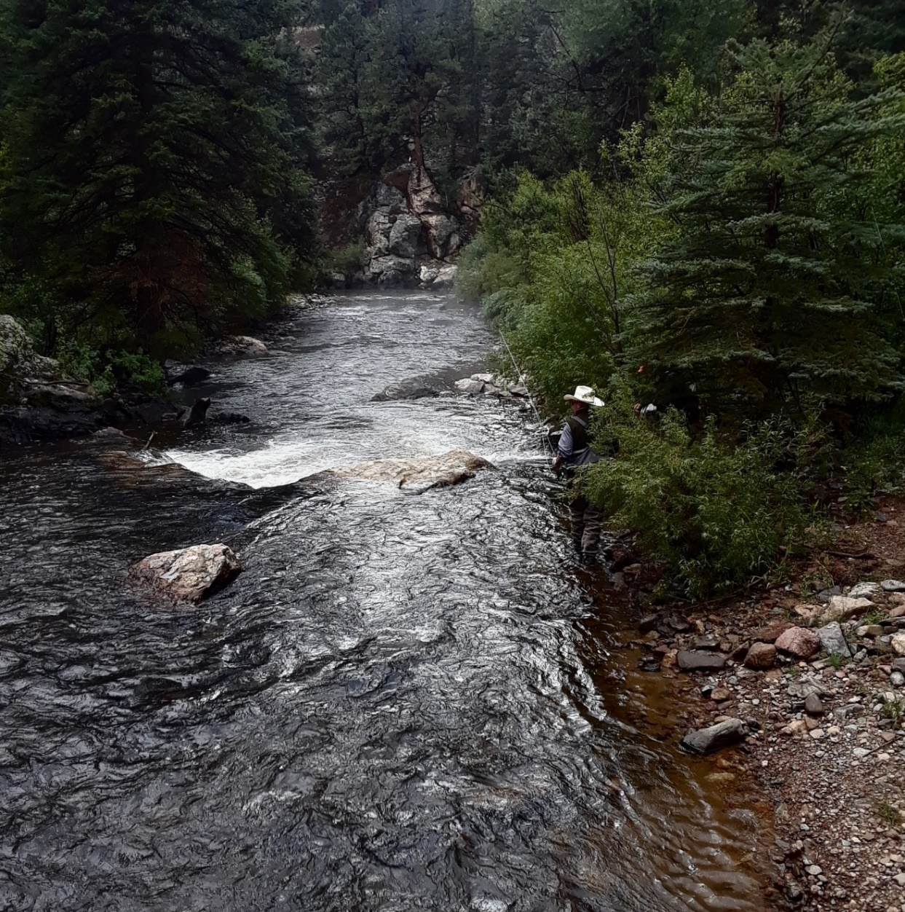
My father fishing (August 2017)

From Sport to Concern

A Fisherman’s Perspective on Climate Change
Luke Calvin
It was a crisp September morning on the Tarryall River. An eleven-year-old and his father set off on one of their many adventures. The air was alive as the sky filled with hues of amber from an arising sun and the soft-gentle song of awakening birds. The boy found himself drawn to the stillness of the air and the soft pitter-patter of the flowing stream. Amidst the often taken for granted Colorado setting, the two stood side by side in eager anticipation to share this cherished tradition. For the father, this teaching transcended generations. He carefully unwound the line, each coiled loop unfolding like a ribbon. The fly, an exquisite imitation of the fishes’ natural prey, dangled from the tip of the line, its color and intricate detail capturing the eye. The boy watched in awe at the delicate ballet of the rod, his father, and the water. It seemed as though the rod was an extension of his father’s arm, his movements analogous to a rhythmic poem, a harmony of fluid motion and concentrated focus. The young boy, who had some past fly-fishing experience, began to mirror his father’s movement in a shared moment of quiet understanding and unspoken lesson.
Then the stillness broke. The boy’s line stretched out as a tug pulled from the other end. Would his patience pay off or would the line zip through the water with a sudden release of tension? This was no humbling experience though, as in a rush of pure exhilaration the boy caught his first ever brown trout. By day's end the boy had caught and released a brown, a rainbow, and a brook trout, his father calling this a fisherman’s dream, the trifecta. The boy could not wait to tell his mother and friends of his achievement, yet just before leaving, his father set a few final casts. In a visceral experience connecting the father to nature, he reeled in the final fish of the day, a wild cutthroat trout. Catching a native fish was something of a spiritual experience for him, and as the boy watched and became a participant in the ancient art of catching fish, he was hooked.
Since that day when I was a young boy my love for fishing has only grown. With an understanding of the natural habitat and fish behavior, I have noted drastic changes in population, location, and behavior of Colorado fish, yet there has to be an explanation for these changes. To solidify my concern, I turned to the man who knows more about fishing than I ever could, my father. I asked if he shared this concern and he answered in a long-drawn-out explanation, yes. With his support and a paper needing to be written, I began a journey to find answers. Although I am no expert, my research focuses on the dramatic effects of climate change on our state’s rivers and streams and how this and other factors have greatly impacted our trout.

Drought and Stream Temperature
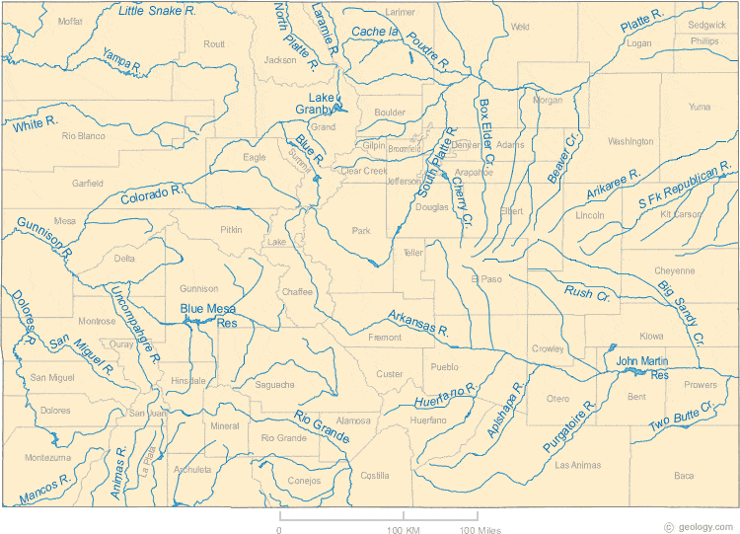
For years scientists have been trying to find a solution as to why there has been a steady decrease in water levels across the state. The fact of the matter is that there is no single answer to this question, and reporting the findings includes an understanding of the uncertainties. One of the most studied and understood topics is climate change. Over the past century there has been a decline in water levels in the Colorado River Basin, which accounts for nearly all streams and sources in western Colorado. The causes and effects of this drought have been studied and reviewed by published author and meteorologist, Martin Hoerling, a researcher for NOAA/Earth System Research Laboratory Physical Sciences Division in Boulder, Colorado. In his paper, “Causes for the Century-Long Decline in Colorado River Flow,” published in the Journal of Climate he hypothesizes reasons for an estimated 20-24% decline in water flow since the early 1900s. The report reads, “Using a high-resolution multimodel approach, we demonstrate that climate change forcing has acted to reduce streamflow from the Upper Colorado River basin during this period by about 10%” (Hoerling et al., 2019, p. 1896). As the estimated reduction in water flow is 20-24% his prediction suggests that about half, or approximately 10%, of the decline in water levels has been caused by climate change.
Colorado Lakes, Rivers, and Water Resources (Geology, n.d.)
Hoerling further argues that rising temperatures have had a notable impact on drought and will continue to impact it, as he modeled that over the last century surface temperatures have increased by approximately 1.2℃ corresponding to a 3% decrease in precipitation (Hoerling et al., 2019, p. 1896). Although we cannot say with certainty that temperature will continue to linearly increase at the same rate, Hoerling’s study suggests that with an additional 2℃ there would be an estimated 5% decrease in streamflow (Hoerling et al., 2019, p. 8197). It is unpredictable as to how soon this temperature increase will come. However a one-hundred-year period does not only suggest an anomaly, it suggests a pattern. Therefore, we can expect that temperatures will increase, and stream flow will continue to decrease.
With Hoerling’s temperature model predicting surface temperature increase, does this lead to an increase in stream temperature? Research by author James Roberts, affiliated with the Department of Fish, Wildlife, and Conservation Biology and the Graduate Degree Program in Ecology at Colorado State University, published in the journal Global Change Biology suggests, “… little change in either stream temperature metric by 2040, but by 2080 these temperature metrics are predicted to increase 0.3–1.8°C” (Roberts et al., 2013, p. 1391). Relating these two studies unfolds a bigger picture that both surface temperatures and water temperatures are rising.
However, Roberts and Hoerling are not the only concerned researchers, Jay Chancellor the Southwest Regional Director of the Angler Conservation Program at Trout Unlimited notes several concerning analytics in his article “Climate change puts the squeeze on trout, anglers and communities in Colorado.” Colorado's mountains receive substantial snowfall during the winter months. This snow accumulates and forms a snowpack in high-altitude regions. The snowpack by the end of the winter plays a critical factor in stream and river flow. In the article Chancellor states, “… warmer spring temperatures are increasing the speed of early snowmelt in the Rocky Mountains. Snow is melting between 15-30 days earlier than it was 25 years ago, which is leading to increased flooding and erosion and resulting in extended periods of summer drought. Scientists say snowpack in the Southern Rockies will drop 50 percent by the end of this century” (Chancellor, 2021). Notice that Chancellor does not mention that the state is getting less snow, he is pointing to the fact that the snow is melting much faster and streams are facing the repercussions of this.
All of these research results can be summarized into key points: future surface and stream temperatures will increase, water levels will continue declining, and a decrease in the main source of stream water, snowpack, could be catastrophic to the health of our beloved natural habitats. With these important takeaways, we must consider the accuracy of these predicted models. As a reader and concerned party we must note and heed the concerns of the scientists themselves, as Hoerling stated, “The current study cannot be viewed as comprehensive or as providing a definitive explanation for the decline in the Colorado River over the instrumental period. It does, however, offer a physically based explanation for the observed century-long decline in Colorado River streamflow within a new framework of the river’s sensitivity to meteorological change” (Hoerling et al., 2019, p. 8199-8200). Although the hypothesized reasons for drought and the predicted future of Colorado streams must be taken with a grain of salt, being given accurate data and analysis gives concrete evidence to continue research and focus on the areas of concern that have been highlighted in the studies.

Colorado Trout
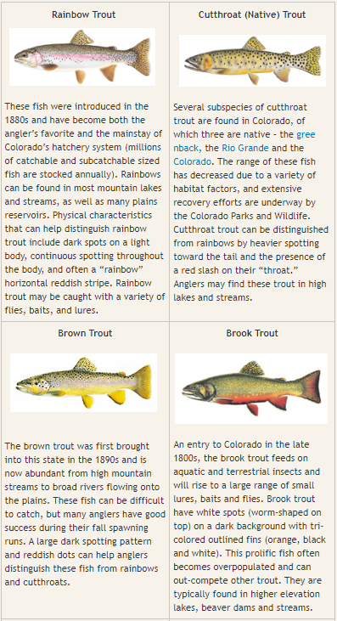
Colorado is known around the world for its natural beauty and abundance of outdoor recreation. Part of this is world class fishing. Trout species such as the rainbow, brook, and brown make the state famous for its fishing, yet it is uncommon knowledge that none of these species are native to Colorado and were actually introduced in the late 1800s to early 1900s (Myrick, 2015). The native species are the cutthroat trout, some of which are still present in streams today: Colorado River cutthroat, the greenback cutthroat, and the Rio Grande cutthroat trout. In fact, the greenback cutthroat was made into the state fish in 1994 (Myrick, 2015), hence leading to specific concentration in the scope of this research as populations and habitats are constantly shifting. The native and introduced species have a storied history and a bitter relationship as the introduced species have caused stressful changes to the native’s natural habitats and have for several decades negatively impacted the health and survivability of the cutthroat. The challenging aspect of this relationship is a collective desire to protect both the native and non-resident species as they are of huge importance to Colorado conservationists and the enhancement of recreational fishing.
Fish Species Identification (Colorado Parks and Wildlife, n.d.)

How do climate changes affect trout populations?
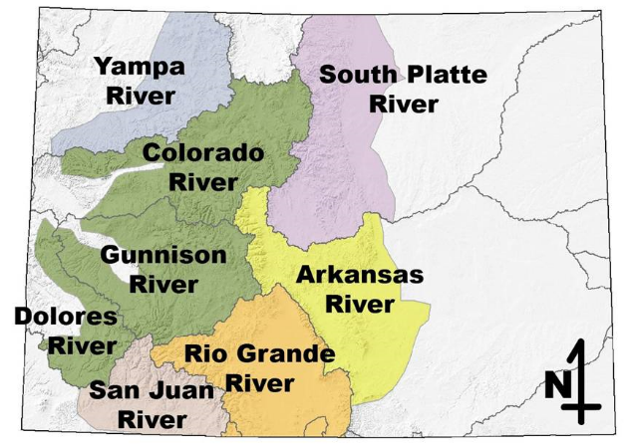
The aforementioned study results and speculated future of Colorado streamflow is quite concerning and logically a reduction of flow and increased temperatures cannot positively impact wildlife, habitat health, water quality, and much more. These results show that seasonal tendencies have been accurately reported, and we can link the climate change debate to changing habitats and behaviors of Colorado fish.
Ranges of Native Cutthroat Trout (Rogers, n.d.)
As a cold water salmonid, a trout species habitat is considered healthy for growth and spawning between a summer temperature threshold of about 9 to 18°C, with an increased mortality rate above 26°C (Roberts et al., 2013, p. 1387). By noting these metrics as ideal and a predicted increase in stream temperature, the aforementioned researcher, James Robberts, further notes the effects this may have on trout (specifically the Colorado cutthroat trout which was the subject of concern in his studies), “…results indicate that high temperatures are unlikely to cause widespread outright mortality, or even low growth, by 2080” (Roberts, 2013, p. 1391). These are positive results, yet does the research from 2013 still hold true or are these predictions outdated?
Roberts in 2023 collaborated with authors Chenchen Ma, Ryan Morrison, and Daniel White, members of the Civil and Environmental Engineering program at Colorado State University, to publish research in the journal: River Research and Applications. In the article they show that warmer temperatures have been shifting precipitation patterns which has resulted in lower base flows in late summer months in turn reducing the stream habitat and affecting cold water fish. Additionally, warmer temperatures have substantially decreased streamflow (Ma et al., 2023, p. 978). The overall results indicate that decreased stream flows slowing stream velocities as a result of climate change are the main factors affecting cutthroat trout survivability and habitat health. With optimal habitat conditions having depths greater than 25cm and flow velocities between 20 to 40cm/s (Ma et al., 2023, p. 980). The research shows that less and less habitats fit within these bounds, causing a shared concern between the researchers that drastically reduced stream flows will result in heavily populated trout habitats becoming isolated and dry, in turn, affecting the growth and survivability of the fish (Ma et al., 2023, p. 980).
Therefore the research, although ten years apart, adopt and represent the same concerns, that climate change will continue to negatively impact cutthroat trout populations. Even though a direct warming of stream temperatures will not greatly impact the remaining trout habitats, an overall surface temperature warming causing decline in water levels and flow velocity will affect the survivability of these fish and continue to cause stress in their natural habitats.

The war between non-native and native trout
As I am proving the cause for concern with a changing climate, I would fail in my research by not mentioning the several other factors that have affected the health of our cutthroat trout populations. Although wildfires, parasitic disease, a demand for more urban and agricultural development, a growing Colorado population, and more are causing natural habitats to decline, one of the most important factors is the relationship between the non-native and the cutthroat trout.
“Although nonnative to Colorado, the introduced trout species flourished in rivers and streams that were once home to cutthroat trout, forming the basis of Colorado’s reputation as a state with world-class trout fishing” (Myrick, 2015).
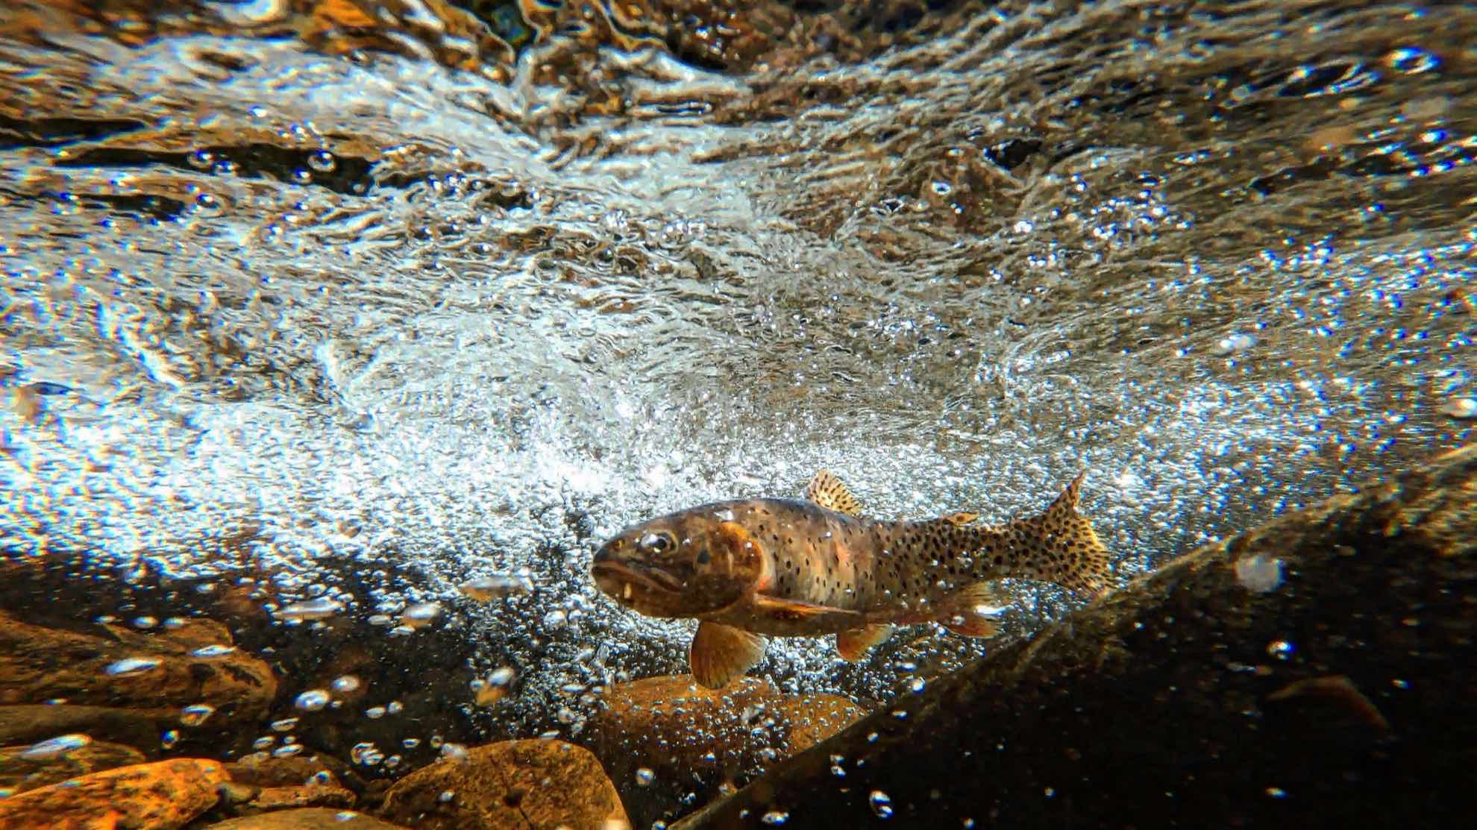
Since their introduction, non-native trout have drastically decreased the native ranges of the cutthroat trout, as rainbow trout have been known to hybridize with cutthroat trout, and brown and brook trout have been overpopulating and creating competition in their once habitable homes (Rogers, n.d.). In fact, Rio Grande cutthroat trout only reside in 12% of their historic habitats and are only found in the Rio Grande River (Chancellor, 2021). The greenback cutthroat trout that was thought to be extinct in 1937 then resurfaced in the late 1950s (Greenback Cutthroat Trout, n.d.), have been of huge conservation concern and only occupy one creek in their native range, Bear Creek, as a “genetically pure, self-reproducing population of GBCT (greenback cutthroat trout)” (Ma, 2023, p. 971). Overall, an estimated 65% of future habitats are predicted to be overrun by non-native trout that have already started invading or are expected to in the coming years (Rogers, n.d.). These startling numbers only voice a shared anxiety of losing more native cutthroat trout and finding them in fewer streams that are in harder to reach locations. Although the relationship between native and non-native trout is complex, the simple truth is that the native cutthroat trout cannot survive the competition created by the invasion of non-native trout in their once populated and healthy streams.
Greenback Cutthroat Trout (Guerrero, n.d.)

Conservation
Several of my favorite fishing locations throughout the state have fallen into the category of a once thriving habitat turned into a non-suitable environment. The aforementioned factors have forced cutthroat trout to migrate to suitable locations in order to survive. As my understanding of all the risks trout populations are facing my concerns are only proven by the data and models predicting the future health of their habitats, yet much is being done to ensure their long-lasting protection by various government organizations, non-profits, and individuals.
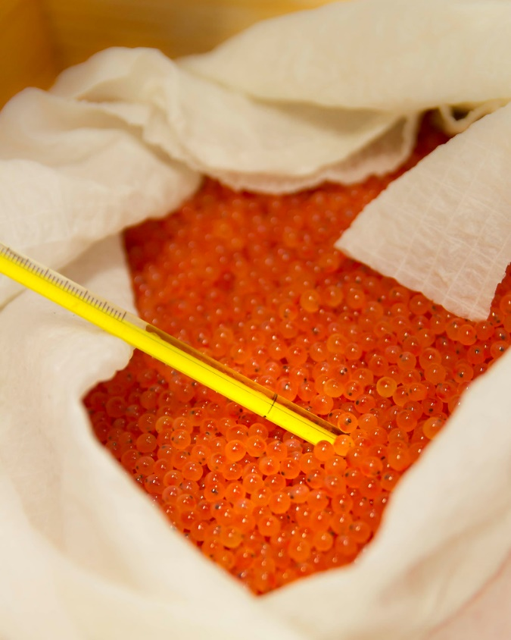
Implementation of conservation techniques such as stream management to trout hatcheries provide aid in the longevity of these species. Colorado, Parks, and Wildlife stock 2.5 million 10in rainbow trout into rivers and lakes each year (Fish Hatcheries, n.d.) for fishing purposes, yet for the cutthroat they need to get more creative. Another group from CPW has been collecting wild spawn eggs in an effort to relocate wild species and restore populations in streams that were once overrun with nonnative species yet have since been unburdened (Rogers, n.d). This effort depends solely on human interaction and concentrated stream management, yet human interaction has and can negatively impact the survivability of trout. Another researcher, Clay Ramey, suggested in an interview with Aspen Public Radio a more natural form of stream management. His words, summarized by author Caroline Llanes, note the benefit of beaver dams in natural fish habitats, “Beaver dams regulate the flow of water to stream ecosystems throughout the summer, making conditions better later on when flows are typically lower. Dams also help stabilize river banks and allow for trees to grow that create much needed-shade, which cools streams down. They also create beautiful, diverse fish habitats” (Llanes, 2023). The only aspect of beaver dams that humans can control is tearing them down. Although there are certain situations that require human interaction to go to the point of tearing these dams down, by simply letting nature work the way it is supposed to we can better counter the changes that habitats are facing.
Rainbow Trout Eggs (Stukel, 2019)

“It's just protecting and sustaining or reestablishing what was the natural order of things before we disturbed that” (Llanes, 2023).
These groups of people are working year-round to ensure that the worst-case scenario does not happen, extinction. However, with their efforts, there is a positive outlook on the future of the native cutthroat species. As climate change and other factors continue to burden their habitats, these groups will be responsible for adapting to the changes with continued research and prolonged stream management. In a sense, the solution to the problem is not as simple as beaver dams, yet the whole theme of protecting these fish is restoring the natural order of things, so if suggestions as out of the box as “beaver-related plans” (Llanes, 2023) could positively impact Colorado’s streams and rivers they must be considered.

What can anglers do?
Simplicity is key in the effort to ensure that anglers are taking the right steps to keep trout healthy and happy. As a sport and activity, we are privileged to take part in the ancient art of fishing. Therefore, we should do everything in our power to ensure this privilege lasts for generations to come. Before going fishing an angler should know the Colorado fishing laws set to protect both native and non-native fish. Laws include catching limits for different species, restrictions on bait and fishing methods, protected waters, and much more. Every year Colorado, Parks, and Wildlife will release a “2023 Fishing Regulation Brochure (state.co.us)” that can be referenced to ensure that you are following the proper techniques. Still, different problems arise when a fish is caught, so unless you are keeping the fish, ensure that it is released alive and with minimal human contact. The goal is to ensure that the fish survives the stress of the fight that had just taken place. Furthermore, know what conditions the stream is in before fishing it. As mentioned throughout the article, healthy fishing conditions are below 65℉ or 18℃ (Water Temps for Fishing, 2023). Using resources such as the Eagle River Watershed Council’s live river temperature gauges, anglers can ensure that they are fishing in non-stressful environments.
“It is up to us as anglers to adjust our fishing practices in a way that minimizes our impact on the fishery. Consider fishing at higher elevation lakes and streams, where environmental factors are much less severe and the flows remain higher” Eagle River Watershed Council, 2022)
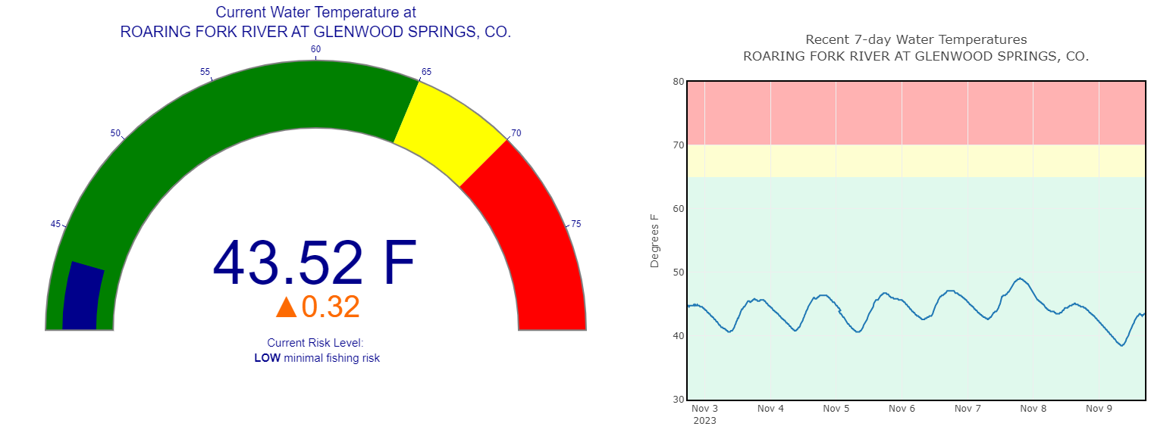
Live River Temperature Gauge (Eagle River Watershed Council, 2022)

Discussion
As an angler myself, I'm committed to practicing the techniques I preach and will continue researching the threats facing trout populations in Colorado. As an individual, I cannot fight climate change on the scale that it requires yet raising awareness is the first step. A future in which I cannot share a fishing experience with my children, like my father and I have, is one I refuse to accept. So, pick up your fishing rods, hiking boots, skis, or anything else connecting you to the great outdoors and find that link to nature, as fishing is for me. Our collective action matters, thus ensuring a Colorado future where the beauty of the outdoors and all that inhabit it, including our cutthroat trout, remain for generations to come by heeding the concerns of scientists and continuing to explore the constantly changing effects of climate change.

References
Chancellor, J. (2021, July 12). Climate change puts the squeeze on trout, anglers and communities in Colorado. Trout Unlimited. https://www.tu.org/magazine/conservation/climate-change-puts-the-squeeze-on-trout-anglers-and-communities-in-colorado/
(2023). 2023 Colorado Fishing [Fishing Regulation Brochure]. Colorado Parks and Wildlife. https://cpw.state.co.us/Documents/RulesRegs/Brochure/fishing.pdf
Eagle River Watershed Council. (2022, July 21). Live River temperatures [Live Data]. erwc.org. https://erwc.org/live-river-gauges/
(n.d.). Fish Species Identification [Trout Pictures and Details]. Colorado Parks and Wildlife. cpw.state.co.us. https://cpw.state.co.us/learn/pages/fishid.aspx
(n.d.). Fish Hatcheries. Colorado Parks & Wildlife. https://cpw.state.co.us/learn/Pages/Hatcheries.aspx
(n.d.). Greenback Cutthroat Trout. Colorado Parks & Wildlife. https://cpw.state.co.us/learn/Pages/ResearchGreenbackCutthroatTrout.aspx
Geology. (n.d). Colorado Lakes, Rivers and Water Resources [Map]. Geology.com. https://geology.com/lakes-rivers-water/colorado.shtml
Guerrero, A. (n.d.). Greenback Cutthroat Trout [Image]. Western Native Trout Initiative. https://westernnativetrout.org/greenback-cutthroat-trout/
Hoerling, M., J. Barsugli, B. Livneh, J. Eischeid, X. Quan, and A. Badger. (2019). Causes for the Century-Long Decline in Colorado River Flow. Journal of Climate, 32. (8181–8203). https://doi.org/10.1175/JCLI-D-19-0207.1.
Llanes, C. (2023, September 28). As the Roaring Fork and Colorado Rivers Heat up, managers try to keep Fish Cool. KSUT Public Radio. https://www.ksut.org/environment-climate/2023-07-18/as-the-roaring-fork-and-colorado-rivers-heat-up-managers-try-to-keep-fish-cool
Roberts, J. J., Fausch, K. D., Peterson, D. P., & Hooten, M. B. (2013). Fragmentation and thermal risks from climate change interact to affect persistence of native trout in the Colorado River basin. Global Change Biology, 19(5), 1383–1398. https://doi-org.colorado.idm.oclc.org/10.1111/gcb.12136
Rogers, K. (n.d.). Cutthroat Trout. Colorado Parks and Wildlife. https://cpw.state.co.us/learn/Pages/ResearchCutthroatTrout.aspx
Ma, C., Morrison, R. R., White, D. C., Roberts, J., & Kanno, Y. (2023). Climate change impacts on native cutthroat trout habitat in Colorado streams. River Research and Applications, 39(5). 970–986. https://doi.org/10.1002/rra.4122
Myrick, C. (2015, December 29). Colorado Fisheries. Colorado Encyclopedia. https://coloradoencyclopedia.org/article/colorado-fisheries
Neal, J. (n.d.). 11 Things You Didn't Know About Colorado's Fisheries. Colorado Parks and Wildlife.https://cpw.state.co.us/learn/Pages/11-Fishery-Facts.aspx
Stukel, S. (2018, April 11). Rainbow Trout Eggs [Picture]. Flickr. https://www.flickr.com/photos/usfwsmtnprairie/41393606921
(2023, August 10). Water Temps for Fishing. Colorado River Headwaters Chapter of Trout Unlimited. https://www.coheadwaters.org/water-temps-for-fishing

