Directions

The Challenge Course at CU Boulder is located near Baseline Rd. and 30th St. in Boulder, CO.

From Highway 36, take the Baseline exit and proceed east to the next intersection at 30th street.

Turn right (south) onto 30th street. After the road curves slightly to the left, turn left into lot 614.

Walk northeast from the parking lot along the sidewalk, between the buildings, to the large open field. Your facilitators will meet you at the west end of the field.

Parking

The fee for parking in this lot is $8 per vehicle, and can be purchased as an individual with a credit card using the pay stations at the lot. If you would like parking to be billed to your group invoice, this can be requested in advance by your group leader by emailing the Challenge Course Coordinator at challenge@colorado.edu . You will be provided with a parking code to use at the pay stations, and all vehicles parked with that code will be added to your final invoice.

If you require bus parking, please email the Challenge Course Coordinator to make arrangements.

Bus

RTD bus routes BOUND and 225 have stops at Baseline and 30th, see the RTD site for bus schedules.

Bicycle

Bear Creek bike path runs right along the east edge of the Williams Village field. Covered bike racks are available at lot 614, and there is a BCycle station at Williams Village just south of the Baseline and 30th st. intersection.

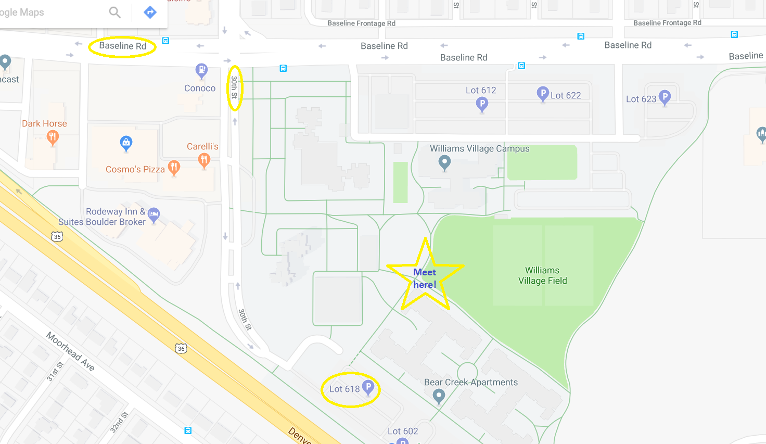
*Please note that lot 618 on this map has been since renamed to lot 614.

