- Unit Price

What is it?
Unit price is the most common payment strategy for highway projects that establishes a set monetary price for construction items in which the State Transportation Agency (STA) pays the unit price multiplied by the quantity installed (1). This is useful for projects where quantities are difficult to determine before the work begins. The contractor determines the quantities, the STA verifies the quantities, and then utilizes the unit price to find the total cost.

Why use it?
A unit price agreement provides several advantages, among which are:
- The STA pays only for the actual quantities performed, supplied, or constructed on the project (2). If estimated quantities result to be larger than what is actually used, the STA pays only those used quantities,
- It may help reduce some general contingency that protects the contractor from inaccurate quantity estimates (2), and
- The STA saves the time that otherwise it would spend detailing plans and specifications with exact quantities for a lump sum contract (3)

What does it do?
This type of provision works well when the actual quantities or number of units are undetermined or unknown. With this provision, the contract establishes unitary costs for each item included in the scope of work and the STA reimburses the contractor only for the actual units of every item that the contractor provides, installs, or constructs on the project (2). The work done under a unit-price contract typically is not made up of a large variety of items. Instead, this provision is adequate for projects where there is a relatively small number of items but in large quantities, such as highway projects (4).

How to use it?
The first step when developing a successful unit price contract is to prepare general designs and drawings along with estimates of quantities so that bidders can get an idea of the scope of the project. Upon contract letting, supplementary drawings can be prepared far enough ahead to allow contractor to secure all the necessary information in time for obtaining materials, making detail drawings, and doing the actual work.
During the construction phase both contractor and STA need to keep detailed computations and bookkeeping of the job. Both parties usually have personnel making estimates of the amount of materials used and the work completed during the preceding period, basing their number on field measurements or data obtained from the drawings, shipping bills, and similar information. These estimates are compared and if discrepancies occur, calculations are reviewed and a quantity is determined and agreed upon as a basis of payment.
In project where there is are several small items, these are usually not included in the unit price contract. The STA should try not to include a large number of unit price items, as this makes a unit price provision impractical. The units of payment established in the contract should be definite and measurable. One issue with unit price contracts is that since quantities are not contractually defined, sometimes the initial estimates can be so far off reality, or considerable changes occur that the initial unit price set for an item becomes inapplicable. Therefore, one last consideration, is to include a contract clause that states the quantity thresholds that would allow and activate a change in the unit prices (4).

When to use it?
Unit price provisions are commonly used in the highway construction industry as the items used on this type of projects are usually few and in large quantities. However, items with small quantities should be avoided as they can make the process cumbersome.

Limitations
The main risk with Unit Price provisions is in that serious errors or inaccuracies may occur in the estimating phase. Under this provision the STA retains the risk for any quantity variations and when errors or significant changes occur the STA can end up paying more than expected, and causing project delay as a result of lack of funding (4, 5). In addition, considerable changes in the scope of work may lead to renegotiations with the contractor on the unit prices pre-established (4).
One final issue with unit price contracting is that the overall process can be cumbersome. On large construction projects processing approvals, measuring work, and calculating quantities consumes time and resources (5).

Who uses it?
All STAs have used unit price for contracting payment provisions.

Example
Every STA has their own guidelines, formats, and worksheets that are provided to contractors in order to establish the unit prices to be used in the construction of a project. The quantities are added as they become known. As an example, The Missouri Department of Transportation used the following pricing page to establish aggregate unit prices per the unit of measurement. This pricing page was used in the procurement of a job-order contract to provide aggregate on an as needed basis for MoDOT across the state of Missouri. The example document below details the pricing page for MoDOT district 1.
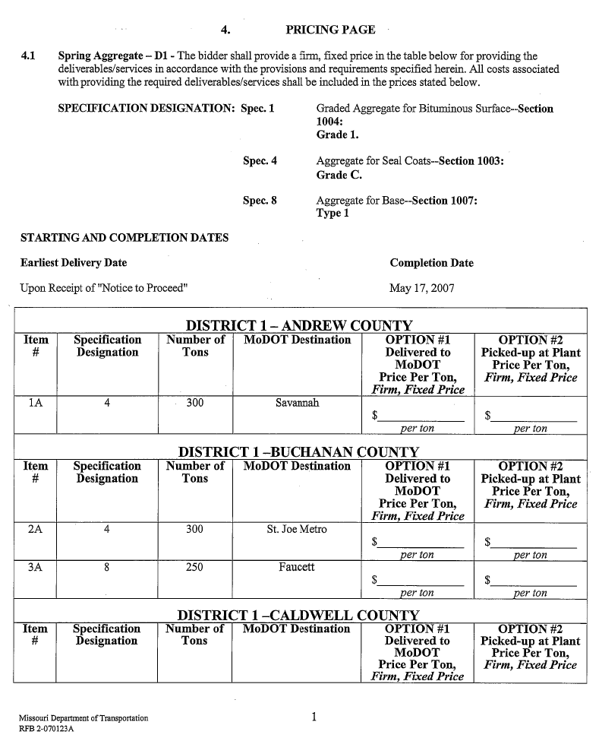
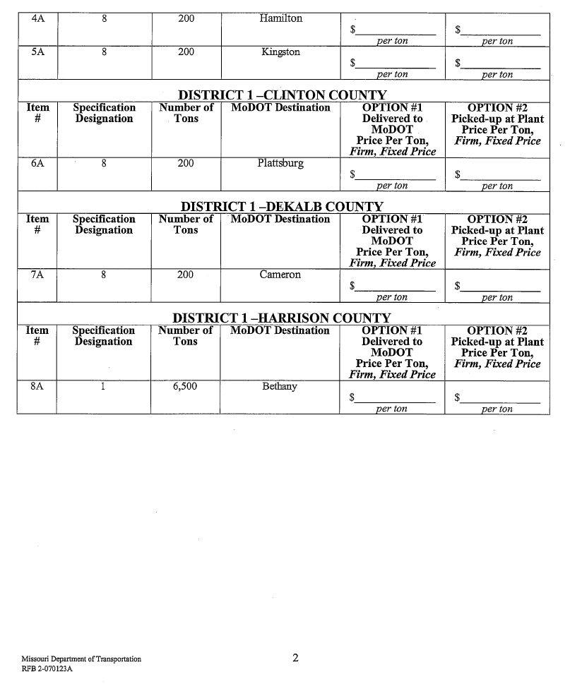

References
- Knutson, Kraig, Cliff J. Schexnayder, Christine M. Fiori, and Richard E. Mayo. Construction Management Fundamentals, 2nd ed., McGraw-Hill, New York, NY, 2009.
- Handfinger, A. Understanding Contractual Pricing Arrangements – Fixed Price, Cost-Plus, and Guaranteed Maximum Price. Pecker and Abramson P.C. http://www.pecklaw.com/images/uploads/communications/Client_Alert-Understanding_Contractual_Pricing_Arrangements.pdf [Accessed: March 17, 2014].
- Dunham, C.W. Dunham and Young’s Contracts, Specifications, and Law for Engineers. McGraw-Hill, New York, 1986.
- Collier, K. Construction Contracts. Merrill/Prentice Hall, Upper Saddle River, New Jersey, 2001.
- Scott, Sidney and Kathryn Mitchell. Alternative Payment and Progress Reporting Methods: Task #2. Trauner Consulting Services, Inc. FHWA Construction Management Expert Technical Group, Federal Highway Administration, Washington, DC, 2007.

