- Price Adjustment Clause
Also known as Economic Price Adjustment, Cost Adjustment, Escalation Clauses, Price Indexing

What is it?
Economic Price Adjustment consists of providing contractors with protection against materials, and fuel price increases that may occur during the execution of the work through the use of Price Adjustment Clauses (PACs). Under these provisions, the STA accepts the risk for increasing prices by offering a PAC that will compensate the contractor for any increase above the bid price or a trigger amount of a specific material (1).

Why use it?
According to Price Indexing in Transportation Construction Contracts (2), a NCHRP research study on the use of PACs in the transportation construction industry, this type of provision has the following benefits:
- Lower bid prices
- Increased number of bids and fewer bid retractions
- Better market stability
- Increased reliability in the supply chain
- Consistent contractor profit margins

What does it do?
PACs help in addressing the issues caused by commodities with volatile prices. The uncertainty about future costs bring large risks to the construction contracting industry. As a result, under regular payment provisions, contractors try to include risk premiums to their bids to ensure profitability through unforeseen circumstances causing overall higher bid prices. In addition, for the case of long term projects, changing prices result in much higher risks as the changes increase with time resulting in unrealistic bid prices (1). By transferring the risks from the contractor to the DOT, the need for these contingency costs is eliminated resulting in better bid prices. In addition, by eliminating the risks, PACs shield construction firms from large losses on single contracts. PACs help reduce the number of firms that exit the market and provide better market stability (2).

How to use it?
The NCHRP report 20-07/274 (2), provides guidelines for the implementation of a PAC program in STAs, which includes the following four sections:
- Criteria for Implementing a PAC Program - In this stage, the STA should perform a risks and benefits analysis to assess the need of a PAC program. Among the benefits are improved market stability, better bid prices, increased number of bidders, less bid retractions, and a reduced risks for contractors. Among the risks are political barriers, increased power of suppliers in the supply chain, start-up costs, and increased administrative costs.
- Criteria for selecting materials to include in a PAC program – Here, the STA should analyze which materials are adequate to combine with PACs. The Price Indexing in Transportation Construction Contracts (2) provides the following material selection framework:
  - Availability of price index – Find a material specific price index that can be used to monitor price changes. Materials with readily available price indices are more suitable for PACs.
  - Validity of the chosen index – Assess the reliability of the price index chosen. Materials for which the prices are easily accessible at any time have better price indices and are therefore better for PACs.
  - Method for measuring material quantities used - Determine the method for measuring and calculating the material quantities (e.g. An STA can use fuel usage factors for the case of diesel fuel, and pounds for structural steel). In this case, materials that can be easily measured are preferred.
  - Impact of changing prices - The impact of the changing prices on the overall project cost comes from the volatility of the material price and the quantity of material to be employed in the project. Materials that are required in larger quantities and have very volatile prices will have larger impacts on overall project cost and are more suitable for PACs.
  - Contractor's ability to control price - For some materials contractors can secure constant prices from suppliers for the duration of a project, or they can store large material reserves. However, other materials are hard to procure at a constant rate or store for long periods of time. This last type of material is preferred for PACs.
  - Program setup and administration - Assess the cost of implementing and maintaining a PAC program for the material.
STAs use PACs for a variety of materials such as fuel, liquid asphalt, cement, structural steel, aggregates, and pipes. However, based on this framework the two materials that get the most benefits from PACs are fuel (Gasoline and Diesel), and liquid asphalt as they have very volatile prices, and can have large impacts on overall project costs.
- Criteria for selecting a PAC program method - At this point, the STA should select how it will compute the cost difference. Methods used by the STAs are indexed material use per unit, percent of cost method, bid item method, invoice method, and specified total fuel requirement. The most used method is the indexed material use per unit, as it is hard to manipulate to the advantage of the contractor or STA, and it only requires one input, the material quantity.
- Criteria for selecting the attributes of a PAC program – Here, the STA needs to define attributes of the PAC program such as:
  - Trigger value - This defines how much the prices can change before the PAC applies. It is important to consider that the lower the trigger value the higher the risk the STA is assuming, but the bid price will be lower as the contractor's contingency to cover for material price changes will be reduced as well. The opposite is true for higher trigger values. Usual values range from 0% to 10%.
  - Opt in/opt out option - STAs can provide the option to opt out of a PAC provision if the contractor can secure pricing from a supplier or storage material for the duration of the project.

When to use it?
PACs are heavily dependent on project duration. In shorter duration projects it is easier to forecast the price of materials until the end of the project as there will be small variations in time. In longer duration projects however, it is harder to forecast these prices as they can vary greatly over time resulting in higher risks. The NCHRP report 20-07/274 (2) suggests that PACs should be used in projects with a duration of 6 months or longer.

Limitations?
Some of the risks of using PACs are:
- Accuracy of indices (1) – Can affect the overall performance and effectiveness of PACs
- Program Start-up costs (2) – Cost of purchasing indexes, setting up resources and procedures, and developing computer programs among others.
- Price adjustment payouts (1) – If prices change considerably the STA may be forced to pay more through PACs than it would by using non-adjusted prices.
- Increased power of suppliers in the supply chain (2) – Suppliers have increased power as contractors do not have any motivation to negotiate lower prices.
- Increased administrative costs (2) – The STA may incur in higher administrative costs when maintaining a PAC program.

Who uses it?
The American Association of Highway and Transportation Officials (AASHTO) conducted a survey on the use of PACs in 2009. According to this survey only Arkansas, Michigan, and Texas do not use PACs. Furthermore, fuel and asphalt cement are the two most used material with 41 STAs and 40 STAs respectively (3).

Examples
Example 1) Tennessee Department of Transportation
The following is an example of a fuel price adjustment clause from the Tennessee Department of Transportation special provisions using the fuel use per unit method (4):
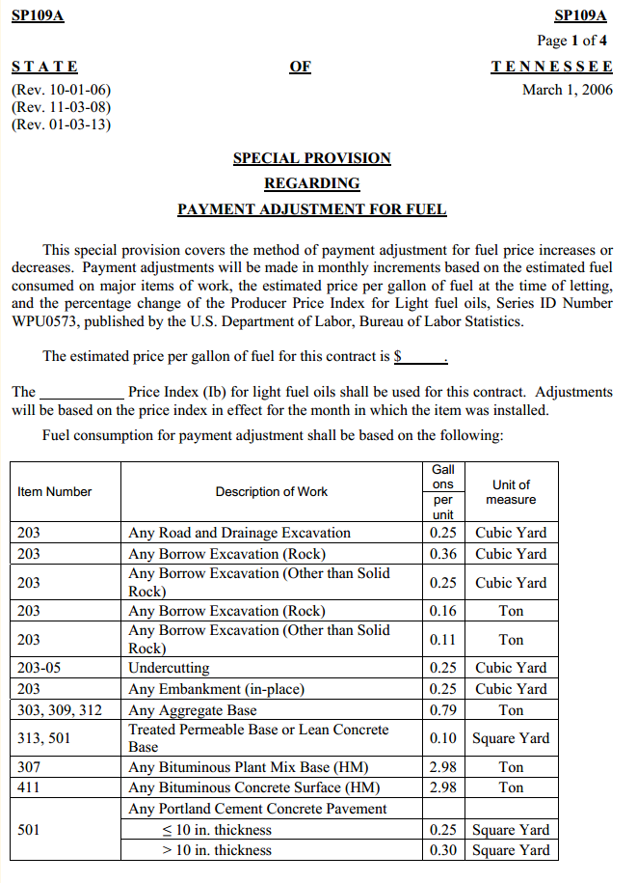
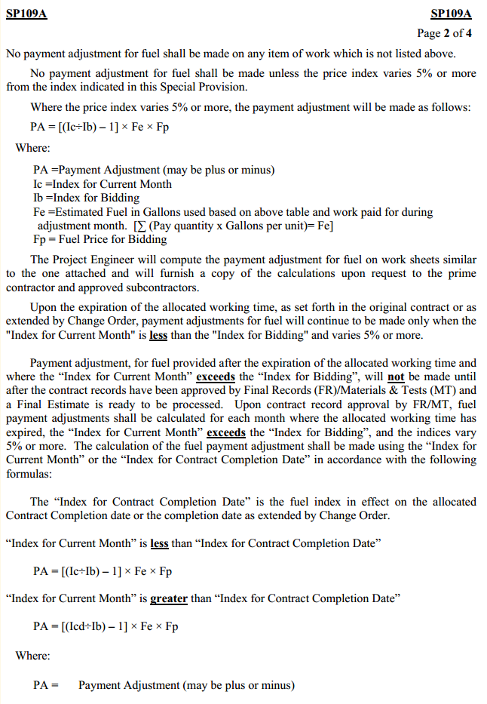
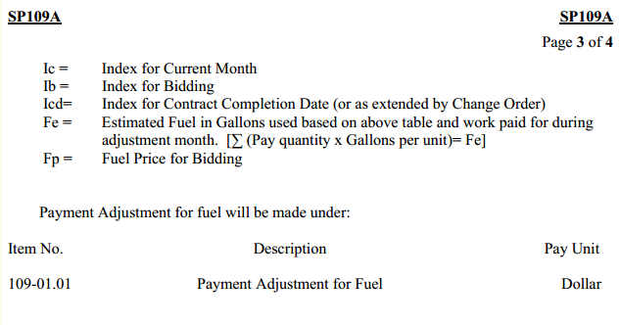
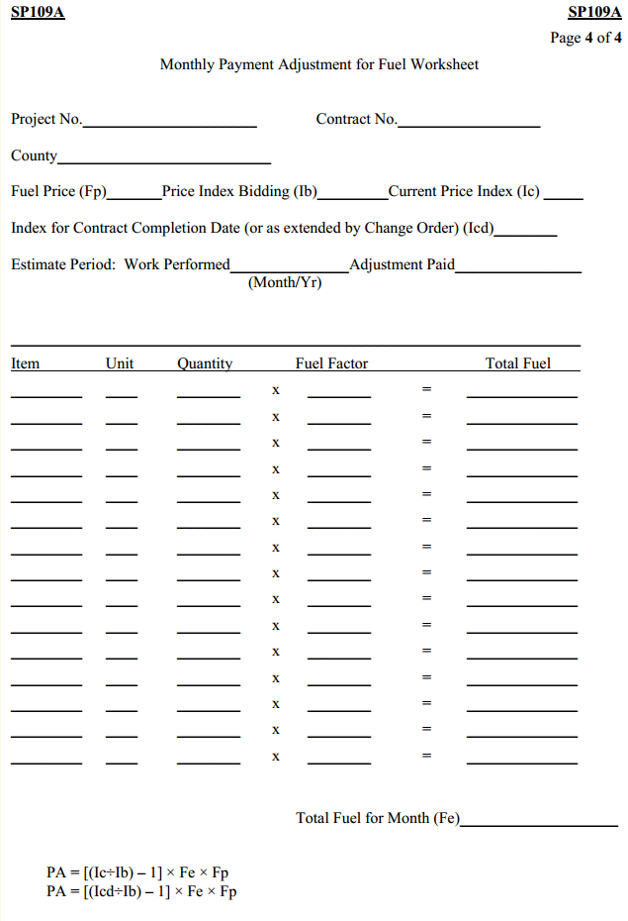
Example 2) Federal Highway Administration
The Office of Federal Lands from the Federal Highway Administration has the following price adjustment clauses for asphalt cement and fuel (5):
ASPHALT CEMENT PRICE ADJUSTMENT PROVISION
GENERAL The Asphalt Cement Price Adjustment Provision provides for a price adjustment in the form of a payment to the Contractor or a rebate to the Government for fluctuations in the cost of asphalt cement used in the performance of applicable construction work. The price adjustment provisions are applicable only to the asphalt cement, as defined in Subsection 702.01, and incorporated in the following eligible contract pay items:
- 40101 Superpave pavement
- 40102 Superpave pavement, wedge and leveling course
- 40201 Hot asphalt concrete pavement, Marshall or Hveem test
- 40202 Hot asphalt concrete pavement, Marshall or Hveem test, wedge and leveling course
- 40301 Hot asphalt concrete pavement
- 40302 Hot asphalt concrete pavement, wedge and leveling course
- 40501 Open-graded asphalt friction course

Select appropriate eligible pay items and delete those that do not apply. For each of the eligible contract pay items chosen above, a corresponding statement should be added to the applicable SCR payment subsection, which indicates that “A price adjustment will be made for fluctuations in the cost of asphalt cement used in the performance of any eligible pay items according to Subsection 109.06 Pricing of Adjustments Asphalt Cement Price Adjustment Provision.” See end of provision for additional direction.

The price adjustment provisions are also applicable when the Government adds extra work to the eligible pay items already existing under the Contract.
The provision will remain in effect throughout the duration of the contract. Enactment of the Asphalt Cement Price Adjustment Provision will only be considered when the increase or decrease in the price of asphalt cement as defined herein exceeds 10 percent.
The Asphalt Cement Price Adjustment Provision is intended to reduce but not eliminate the cost effects of price uncertainty to the Contractor and the Government for asphalt cement used in the construction of this contract. It provides for sharing by the Government in a portion of the Contractor’s risk, which could result from unusual price fluctuations. The provision is not intended to compensate the Contractor for normal day-to-day fluctuations and seasonal changes or to serve as a guarantee of full compensation for asphalt cement price fluctuations.
EFLHD will revise the following policy/procedures.
The Construction Branch is responsible for (1) purchasing the Asphalt Weekly Monitor (AWM) newsletter; (2) selecting the applicable region and states; (3) calculating and posting price indexes on an accessible web page and; (4) calculating and paying price adjustment compensations. In order to establish a reference for the base and monthly performance price indexes, the Poten and Partners, Inc newsletter (i.e. Asphalt Weekly Monitor) should be surveyed and an applicable region and state inserted below. A website address must also be inserted below where the Contractor and other interested parties can check Government postings of monthly price indexes. There could potentially be one web page for each project unless projects are in the same state. The Base and Monthly Performance Price Indexes for Asphalt Cement must also be calculated using weekly high and low selling price data obtained from the Asphalt Weekly Monitor for the applicable state. Weekly high and low selling price data from four consecutive reports will be averaged to obtain a Base Price Index as well as a Monthly Performance Price Index. The Base Price Index (BPI) must be inserted below by Acquisitions in the conformed set. The Monthly Performance Price Index must be posted monthly by Construction on the website.

PRICE INDEXES The Government will generate a monthly performance price index for asphalt cement using price data obtained from Poten and Partners, Inc. (PPI), which publishes a weekly report (Asphalt Weekly Monitor) on high and low selling prices for states in five regions throughout the United States including the East Coast/Northeast, the Mid-Continent/Midwest, the Gulf Coast/Mid-South, the Rocky Mountains and the West Coast/Northwest. Weekly high and low selling price data reported for (insert the applicable region and states) will be averaged and used to establish a base price index, BPI, for this project and a monthly performance price index, MPPI, for the duration of the contract. These indexes are defined as follows:
- BASE PRICE INDEX The base price index, BPI, is the price index determined by the arithmetic average, as specified above, shown in the four weekly publications immediately preceding the bid opening. The BPI will be provided by the Government after contract award. It is as follows:

BASE PRICE INDEX (BPI) FOR ASPHALT CEMENT
PER SHORT TON (TON) (or PER METRIC TON) = $
- MONTHLY PERFORMANCE PRICE INDEX The monthly performance price index, MPPI, is the monthly price index at the time of performance of applicable work as determined by the arithmetic average, as specified above, shown in the four weekly publications issued prior to the last Wednesday of the month (i.e. the monthly performance price index during which asphalt cement is used in the performance of applicable construction work).

PRICE ADJUSTMENTS Price adjustments are calculated by the Government for average conditions and are not intended to reflect the Contractor’s actual purchase price. The ratio of the monthly performance price index and the base price index (MPPI/BPI) is calculated and used to determine price adjustments for eligible pay items as follows:
- No Price Adjustment – When the ratio MPPI/BPI falls within the range of 0.90 to 1.10, no price adjustment will be made for any asphalt cement used in construction work performed during the relevant month.

- Government Rebate – When the ratio MPPI/BPI is calculated to be less than 0.90, the Government is due a rebate determined in accordance with the following formula:
Government Rebate = [0.90 – (MPPI/BPI)] (BPI) (Q)
- Contractor Payment – When the ratio MPPI/BPI is calculated to be greater than 1.10, the Contractor is due additional payment determined in accordance with the following formula:
Contractor Payment = [(MPPI/BPI) – 1.10] (BPI) (Q)
The following definitions are applicable to both the Government Rebate and the Contractor Payment formulas:
MPPI = Monthly Performance Price Index for the month during which asphalt cement is used in the performance of applicable construction work.
BPI = Base Price Index that is established immediately preceding the bid opening.
Q = Quantity in tons of asphalt cement for eligible pay items that were used on the project during the progress payment period. The quantity will be calculated using the asphalt content of the approved mix design and the following formula:
Q = Asphalt Concrete Pavement tons placed x (% Asphalt/100)
PRICE ADJUSTMENT COMPENSATION Monthly adjustments will be accrued. The final price adjustment will be paid, or rebated, after completion of all work for eligible pay items. The Contractor may request in writing a partial price adjustment payment once every 12 months, or when the unpaid accrued increase exceeds $10,000. The Government will take a rebate when the deductive accrual exceeds $10,000.
No price adjustments will be made for work performed beyond the Government-approved Contract completion date.
The maximum allowable monthly and final price adjustment to the Contractor or rebate to the Government is limited to a (MPPI/BPI) ratio of 1.6 and 0.4, respectively.
401.19. 402.19. 403.19. 405.13. Add the following:
A price adjustment will be made for fluctuations in the cost of asphalt cement used in the performance of any eligible pay items according to Subsection 109.06 Pricing of Adjustments Asphalt Cement Price Adjustment Provision.
FUEL PRICE ADJUSTMENT PROVISION
GENERAL The Fuel Price Adjustment Provision provides for a price adjustment in the form of a payment to the Contractor or a rebate to the Government for fluctuations in the cost of diesel fuel consumed in the performance of applicable construction work. The price adjustment provisions are applicable only to those contract items listed as eligible pay items in Table 1 below, if diesel is used as the primary fuel in the production of the affected items.
The price adjustment provisions are also applicable when the Government adds extra work to the eligible pay items already existing under the Contract.
The provision will remain in effect throughout the duration of the contract. Enactment of the Fuel Price Adjustment Provision will only be considered when the increase or decrease in the price of diesel fuel as defined herein exceeds 10 percent.
The Fuel Price Adjustment Provision is intended to reduce but not eliminate the cost effects of price uncertainty to the Contractor and the Government for diesel fuel consumed in the construction of this contract. It provides for sharing by the Government in a portion of the Contractor’s risk, which could result from unusual price fluctuations. The provision is not intended to compensate the Contractor for normal day-to-day fluctuations and seasonal changes or to serve as a guarantee of full compensation for diesel fuel price fluctuations.
EFLHD will revise the following policy/procedures.
The Construction Branch is responsible for (1) purchasing the Oil Price Information Service (OPIS) newsletter; (2) selecting the applicable region and city; (3) calculating and posting price indexes on an accessible web page and; (4) calculating and paying price adjustment compensations. In order to establish a reference for the base and monthly performance price indexes, the Oil Price Information Service (OPIS) newsletter should be surveyed and an applicable region and city inserted below. If possible, the city should be a large metropolitan area (i.e. a state capital) near the project site. A website address must also be inserted below where the Contractor and other interested parties can check Government postings of monthly price indexes. There could potentially be one web page for each project unless reference cities can be strategically selected to serve more than one project site. The Base and Monthly Performance Price Indexes for Low Sulfur No. 2 Diesel Fuel must also be calculated using weekly average rack price data obtained from OPIS for the applicable city. Weekly average rack price data from four consecutive reports will be averaged to obtain a Base Price Index as well as a Monthly Performance Price Index. The Base Price Index (BPI) must be inserted below by Acquisitions in the conformed set. The Monthly Performance Price Index must be posted monthly by Construction on the website.

PRICE INDEXES The Government will generate a monthly performance price index for Ultra Low Sulfur, No. 2 Diesel Fuel using price data obtained from the Oil Price Information Service (OPIS), which publishes a weekly report on gasoline and distillate reseller prices for major cities in five regions throughout the United States including the East Coast (PADD 1), the Midwest (PADD 2), the Gulf Coast (PADD 3), the Rockies (PADD 4) and the West Coast (PADD 5). Weekly average rack price data reported for (insert the applicable region and city) will be averaged and used to establish a base price index, BPI, for this project and a monthly performance price index, MPPI, for the duration of the contract. These indexes are defined as follows:
- BASE PRICE INDEX The base price index, BPI, is the price index determined by the arithmetic average, as specified above, shown in the four weekly publications immediately preceding the bid opening. The BPI will be provided by the Government after contract award. It is as follows:

BASE PRICE INDEX (BPI) FOR ULTRA LOW SULFUR, NO. 2 DIESEL FUEL
PER GALLON = $
- MONTHLY PERFORMANCE PRICE INDEX The monthly performance price index, MPPI, is the monthly price index at the time of performance of applicable work as determined by the arithmetic average, as specified above, shown in the four weekly publications issued prior to the last Wednesday of the month (i.e. the monthly performance price index during which diesel fuel is consumed in the performance of applicable construction work).

PRICE ADJUSTMENTS Price adjustments are calculated by the Government for average conditions and are not intended to reflect the Contractor’s actual purchase price. The ratio of the monthly performance price index and the base price index (MPPI/BPI) is calculated and used to determine price adjustments for eligible pay items as follows:
- No Price Adjustment – When the ratio MPPI/BPI falls within the range of 0.90 to 1.10, no price adjustment will be made for any diesel fuel consumed in construction work performed during the relevant month.
- Government Rebate – When the ratio MPPI/BPI is calculated to be less than 0.90, the Government is due a rebate determined in accordance with the following formula:
Government Rebate = [0.90 – (MPPI/BPI)] (BPI) (Q) (FUF)
- Contractor Payment – When the ratio MPPI/BPI is calculated to be greater than 1.10, the Contractor is due additional payment determined in accordance with the following formula:
Contractor Payment = [(MPPI/BPI) – 1.10] (BPI) (Q) (FUF)
The following definitions are applicable to both the Government Rebate and the Contractor Payment formulas:
MPPI = Monthly Performance Price Index for the month during which diesel fuel is consumed in the performance of applicable construction work.
BPI = Base Price Index that is established immediately preceding the bid opening.
Q = Quantity of work on the project during the progress payment period for eligible pay items shown in Table 1 below. The Government will convert work quantities, as necessary, to agree with the units associated with the applicable Fuel Usage Factor.
FUF = Fuel Usage Factor shown in Table 1 below applicable to both diesel and gasoline.
Table 1 – Eligible Pay Items For Price Adjustments and Associated Fuel Usage Factors
Eligible Pay Items | Fuel Usage Factor  U.S. Customary Units | Fuel Usage Factor  Metric Units
Earthwork:
Section 204 – Excavation and Embankment  20401 Roadway excavation  20402 Sub-excavation  20403 Unclassified borrow  20410 Select borrow  20411 Select borrow  20415 Select topping  20416 Select topping  20420 Embankment construction  20421 Rock excavation | 0.30 gallons per cubic yard | 0.39 gallons per cubic meter
Aggregate Courses:
Section 301 – Untreated Aggregate Courses  30101 Aggregate base  30102 Aggregate base*  30103 Aggregate base*  30105 Subbase  30106 Subbase*  30107 Subbase*  30110 Aggregate Surface Course  30111 Aggregate Surface Course* | 0.70 gallons per ton | 0.77 gallons per metric ton
Section 302 – Treated Aggregate Courses  30201 Treated aggregate course  30202 Treated aggregate course* | 0.70 gallons per ton | 0.77 gallons per metric ton
Section 304 – Aggregate Stabilization  30401 Aggregate stabilization imported aggregate  30402 Aggregate stabilization imported aggregate*  30405 Aggregate stabilization in-place aggregate*  30410 Aggregate stabilization imported surface  course aggregate*  30411 Aggregate stabilization imported surface  course aggregate* | 0.70 gallons per ton | 0.77 gallons per metric ton
Section 309 – Emulsified Asphalt Treated Base Course  30901 Emulsified asphalt treated aggregate base  30902 Emulsified asphalt treated aggregate base*  30903 Emulsified asphalt treated aggregate base* | 0.70 gallons per ton | 0.77 gallons per metric ton
Asphalt Pavements:
Section 401 – Superpave Hot Asphalt Concrete Pavement  40101 Superpave pavement  40102 Superpave pavement wedge and leveling  Course | 2.40 gallons per ton | 2.65 gallons per metric ton
Section 402 – Hot Asphalt Concrete Pavement by Hveem or Marshall Mix Design Method  40201 Hot asphalt concrete pavement, Marshall or  Hveem test  40202 Hot asphalt concrete pavement, Marshall or  Hveem test, wedge and leveling course | 2.40 gallons per ton | 2.65 gallons per metric ton
Section 403 – Hot Asphalt Concrete Pavement  40301 Hot asphalt concrete pavement  40302 Hot asphalt concrete pavement, wedge and  leveling course | 2.40 gallons per ton | 2.65 gallons per metric ton
Section 405 – Open-Graded Asphalt Friction Course  40501 Open-graded asphalt friction course | 2.40 gallons per ton | 2.65 gallons per metric ton
Section 408 – Cold Recycled Asphalt Base Course  40801 Cold recycled asphalt base course  40802 Cold recycled asphalt base course* | 0.70 gallons per ton | 0.77 gallons per metric ton
Section 416 – Continuous Cold Recycled Asphalt Base Course  41602 Continuous cold recycled asphalt base  Course | 0.15 gallons per square yard | 0.18 gallons per square meter
Section 418 – Foamed Asphalt Stabilized Base  Course [not in FP - called out by Special Contract Requirements]  41801 Foamed asphalt stabilized base course | 0.30 gallons per square yard | 0.36 gallons per square meter
Concrete Pavements:
Section 501 – Rigid Pavement  50101 Reinforced rigid pavement  50102 Plain rigid pavement | 0.60 gallons per square yard | 0.72 gallons per square meter
* The Government will convert work quantities, as necessary, to agree with the units associated with the applicable Fuel Usage Factor.

Select appropriate eligible pay items and delete those that do not apply. For each of the eligible contract pay items chosen above, a corresponding statement should be added to the applicable SCR payment subsection, which indicates that “A price adjustment will be made for fluctuations in the cost of diesel fuel consumed in the performance of any eligible pay items according to Subsection 109.06 Pricing of Adjustments Fuel Price Adjustment Provision.” See end of provision for additional direction.

PRICE ADJUSTMENT COMPENSATION Monthly adjustments will be accrued. The final price adjustment will be paid, or rebated, after completion of all work for eligible pay items. The Contractor may request in writing a partial price adjustment payment once every 12 months, or when the unpaid accrued increase exceeds $10,000. The Government will take a rebate when the deductive accrual exceeds $10,000.
No price adjustments will be made for work performed beyond the Government-approved Contract completion date.
The maximum allowable monthly and final price adjustment to the Contractor or rebate to the Government is limited to a (MPPI/BPI) ratio of 1.6 and 0.4, respectively.

204.17. 301.10. 302.11. 304.12. 309.10. 401.19. 402.19. 403.19. 405.13. 408.10. 416.12. 418.xx. 501.17. Add the following:
A price adjustment will be made for fluctuations in the cost of diesel fuel consumed in the performance of any eligible pay items according to Subsection 109.06 Pricing of Adjustments Fuel Price Adjustment Provision.

References
- Newcomb, David E., Russel Lenz, and Jon Epps, Price Adjustment Clauses: Report, Texas A&M Transportation Institute, Texas Department of Transportation, Federal Highway Administration, June 2013.
- Skolnik, Jonathan, Price Indexing in Transportation Construction Contracts, AASHTO Standing Committee on Highways, Transportation Research Board, Jan. 2011.
- American Association of State Highway and Transportation Officials (AASHTO). Survey on the Use of Price Adjustment Clauses, Fall 2009. http://www.fhwa.dot.gov/programadmin/contracts/aashto.cfm [Accessed: November 4, 2013].
- Tennessee Department of Transportation. Special Provision Regarding Payment Adjustment for Fuel, Mar. 2006. http://www.tdot.state.tn.us/construction/Special%20Provisions/109A.pdf [Accessed: November 4, 2013].
- Eastern Federal Lands Highways. Library of Specifications. Federal Highway Administration. http://www.efl.fhwa.dot.gov/contracting/library-specs.aspx [Accessed: February 16, 2014].
- Pierce, Charles E., Nathan N. Huynh, and Paulo Guimaraes, Cost Indexing and Unit Price Adjustments for Construction Materials, South Carolina Department of Transportation, Federal Highways Administration, Oct. 2012.

